Contents

Analyze resource utilization and consumption 4

Types of Platform Logs 4

Activity Logs : 4

Diagnostic Logs / Resource logs: 4

Azure Active Directory Log: 5

Application Logs (Not part of standard logging ) 5

Azure Monitor 5

Metrics 6

Logs 6

Data Sources 6

Data Platform 6

Azure Monitor logs aka Log Analytics 7

Log Analytics Workspace 7

Log Analytics 9

Workspace Data Sources 9

Advanced Settings 11

Solutions 13

Management Tools 13

View Designer 14

Alerts 14

Alerts rate Limiting 15

Azure Action Group 15

List of Notifications: 15

List of actions: 15

Diagnostic Settings 16

Autoscale with Azure Monitor 16

Application Insights 16

Application Map 16

Availability 17

Smart Detection 17

IT Service Management Connector 17

Azure Monitor Data retention: 18

Azure Activity logs (Azure Monitor): 18

Quick Insights 19

Azure Cost Management 20

RBAC roles for accessing ACM 21

Billing and Management hierarchy 21

Billing and entity hierarchy 22

Management group hierarchy 22

Access Control 22

Cost Analysis 22

Cost Alerts 23

Budget alerts 23

Credit alerts 23

Department spending quota alerts 23

Budgets 23

Manage costs with Azure Budgets 23

Azure Advisor (Advisor Recommendations) 24

Cloudyn 24

Azure Invoices 24

Azure spending limit 24

Recovery Services Vault (Backup & Site recovery) 25

Glossry: 25

**RTO**: 25

**RPO**: 25

Business Continuity & Disaster Recovery (BCDR) 26

Disaster Recovery 26

Backup 26

Azure Backup vs. Azure Site Recovery 26

Create Recovery Services Vault 27

Backup 28

Site Recovery 28

Azure Paired Regions 29

Region 30

Azure Backup 30

What can I back up? 31

MARS (Microsoft Azure Recovery Service) 32

MABS (Microsoft Azure Backup Server) 33

Backup Consistency 35

Crash Consistent 35

App consistent 35

Instant Restore 36

Creating Backup from VM 37

Restore VM 38

RBAC and Privileged Identity Management 39

Security and Alerts 40

Azure Site Recovery 41

Glossry: 41

Enable Replication 43

Failover/Test Failover 47

Disaster recovery of on-premises VMs 48

Azure Migrate 49

Azure File Recovery 59

# Analyze resource utilization and consumption

<https://www.youtube.com/watch?v=zzRPC8uApM4>

<https://www.youtube.com/watch?v=kF2rUzPIAP8> -- good

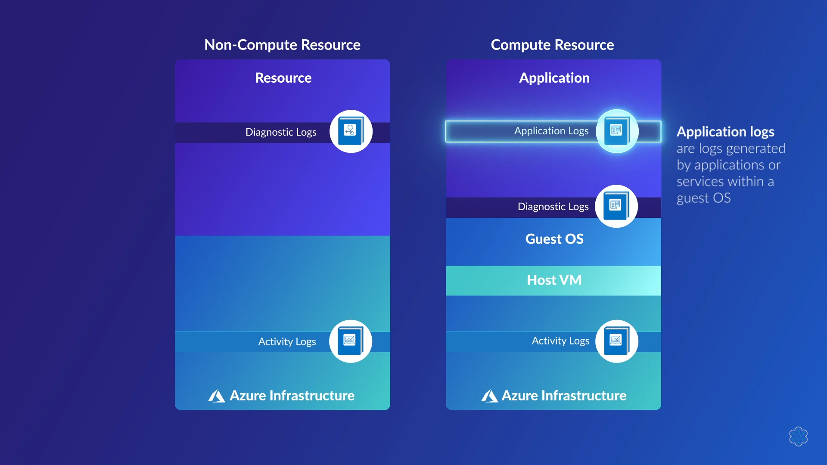

## Types of Platform Logs

<https://docs.microsoft.com/en-us/azure/azure-monitor/platform/platform-logs-overview>

### Activity Logs :

Provides insight into the operations on each Azure resource in the subscription from the outside (the management plane) in addition to updates on Service Health events. Use the Activity Log, to determine the what, who, and when for any write operations (PUT, POST, DELETE) taken on the resources in your subscription. There is a single Activity log for each Azure subscription.

### Diagnostic Logs / Resource logs:

Provide insight into operations that were performed within an Azure resource (the data plane), for example getting a secret from a Key Vault or making a request to a database. The content of resource logs varies by the Azure service and resource type.  
  
**Resource logs were previously referred to as diagnostic logs.**

<https://docs.microsoft.com/en-us/azure/azure-monitor/platform/diagnostic-settings>

<https://www.youtube.com/watch?v=iRgHXimHfj8>

### Azure Active Directory Log:

Contains the history of sign-in activity and audit trail of changes made in the Azure Active Directory for a particular tenant.

### Application Logs (Not part of standard logging )

# Azure Monitor

<https://docs.microsoft.com/en-us/azure/azure-monitor/terminology#august-2018---consolidation-of-monitoring-services-into-azure-monitor>

<https://www.youtube.com/watch?v=eSutaPE80PM>

10 Part series very nice covers up most stuff.

<https://squaredup.com/blog/from-zero-to-hero-my-azure-monitor-learning-path/>

Webinar based on above link

<https://www.youtube.com/watch?v=_MtrZOMQ18M>

**Log Analytics** and **Application Insights** have been consolidated into Azure Monitor to provide a single integrated experience for monitoring Azure resources and hybrid environments. No functionality has been removed from these services, and users can perform the same scenarios that they've always completed with no loss or compromise of any features.

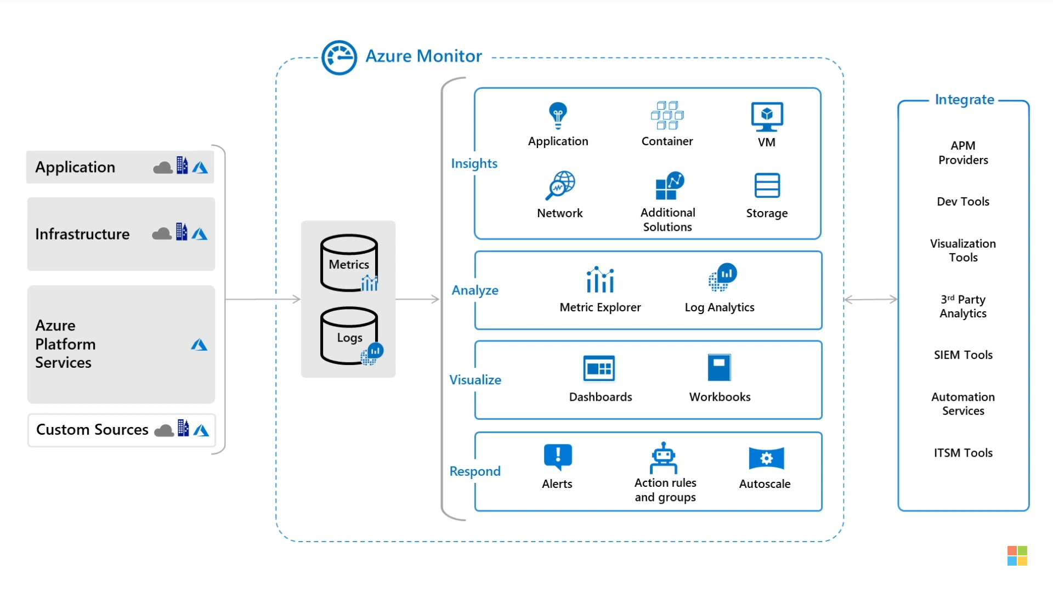

## Metrics

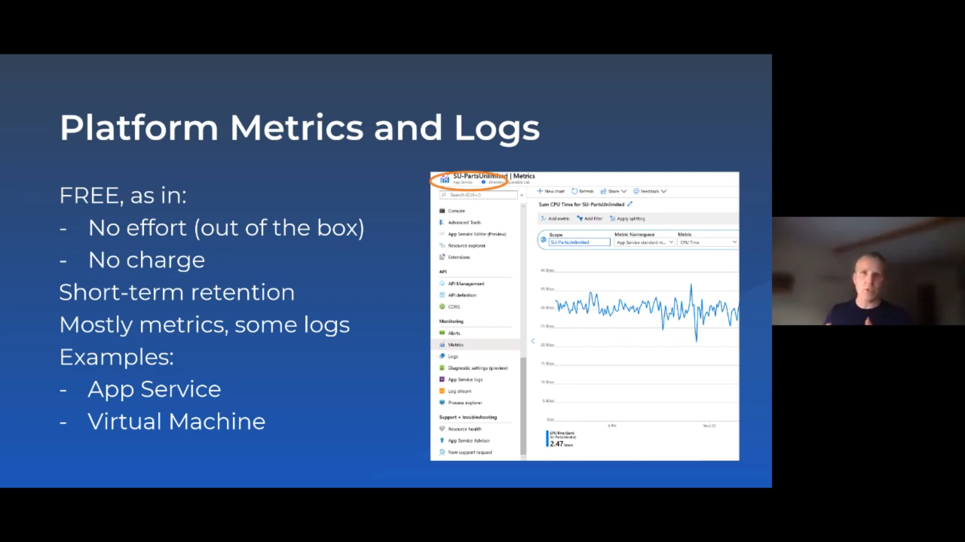

Metrics and Logs are mostly accessible in all the services blade but while metrics is fully functional in all the services Logs are not enabled by default. One would need to create a Log Analytics workspace in order to enable it.

## Logs

Logs are tables of records with various properties and metadata, similar in structure to your average SQL database. They may also contain numerical values like Metrics, but will generally also contain detailed text with more information. Events and traces are a good example.

Logs are generally a blob of data sporadically collected that needs to be manipulated to display something useful. You will need to extract the relevant data from logs using their native query language, known as the “Kusto Query Language” or KQL for short

## Data Sources

<https://docs.microsoft.com/en-us/azure/azure-monitor/platform/data-sources>

## Data Platform

<https://docs.microsoft.com/en-us/azure/azure-monitor/platform/data-platform>

## Azure Monitor logs aka Log Analytics

<https://docs.microsoft.com/en-us/azure/azure-monitor/terminology#log-analytics>

Log Analytics was earlier part of Operations Manager Suite (OMS) which has not been retired.

**Azure Monitor log** data is still stored in a **Log Analytics workspace** and is still collected and analyzed by the same **Log Analytics service**, but we are changing the term **Log Analytics** in many places to **Azure Monitor logs**.

The term **log analytics** now primarily applies to the page in the Azure portal used to write and run queries and analyze log data. It's the functional equivalent of **metrics explorer**, which is the page in the Azure portal used to analyze metric data.

"Diagnostic logs" were changed to "resource logs" to better match what is actually being collected. The term "diagnostic settings" remains the same.

<https://docs.microsoft.com/en-us/azure/azure-monitor/platform/data-platform-metrics>

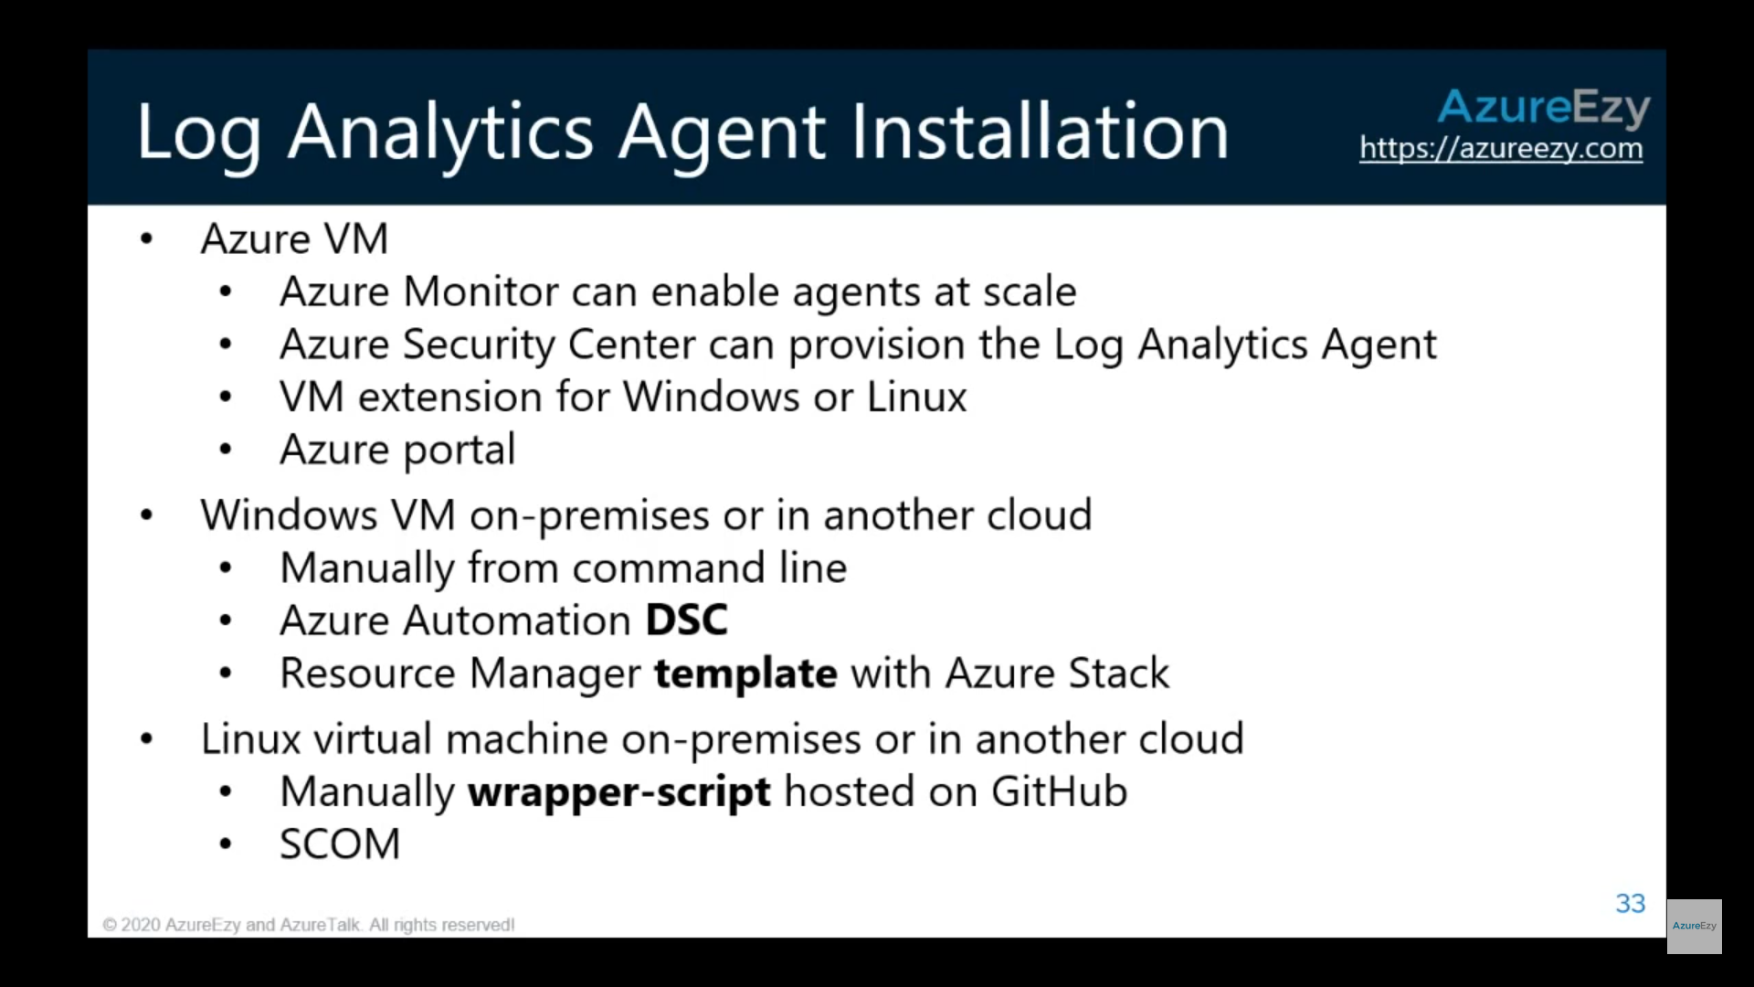

## Log Analytics Workspace

<https://www.youtube.com/watch?v=6yzPx983w9A>

<https://www.youtube.com/watch?v=Zoo-RsJGCu0> 🡪 More detailed

Click Azure Monitor and then in the blade choose Logs, which is actually is Log Analytics

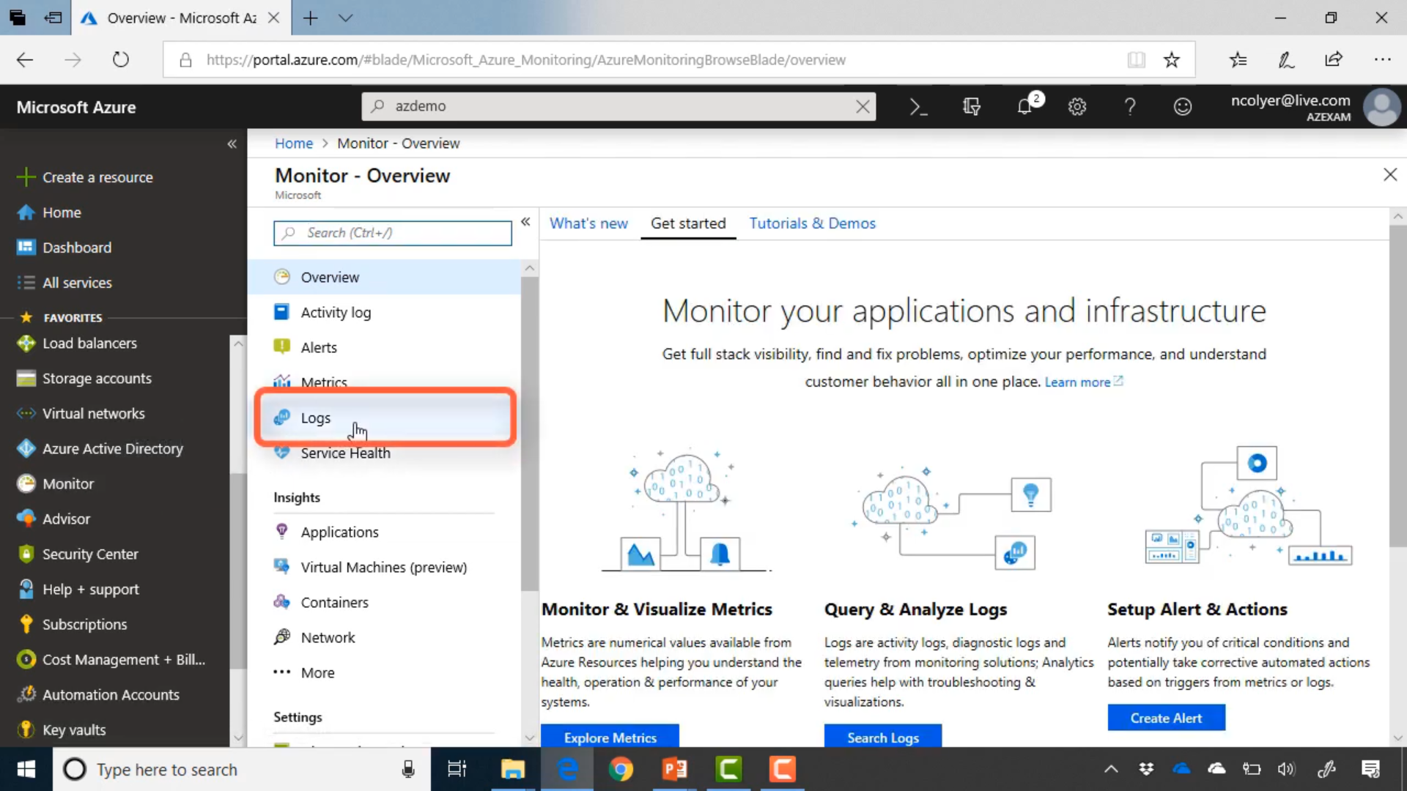

After clicking Logs, it takes you to Log Analytics and has a default workspace (red rectangle)

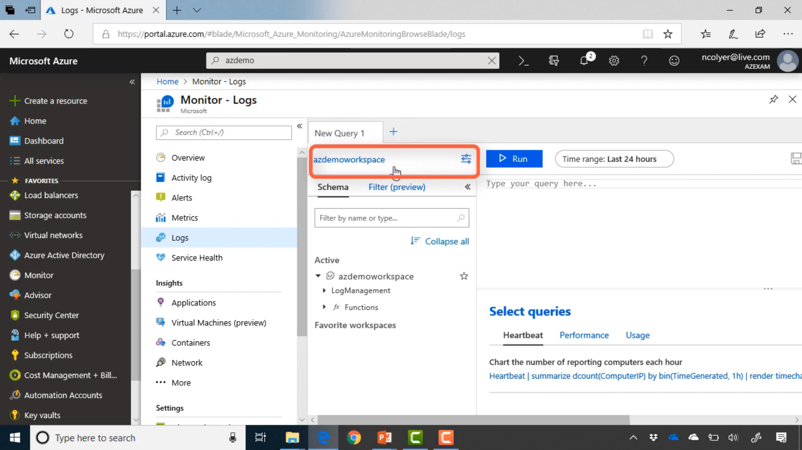

You can go and change the default subscription and workspace

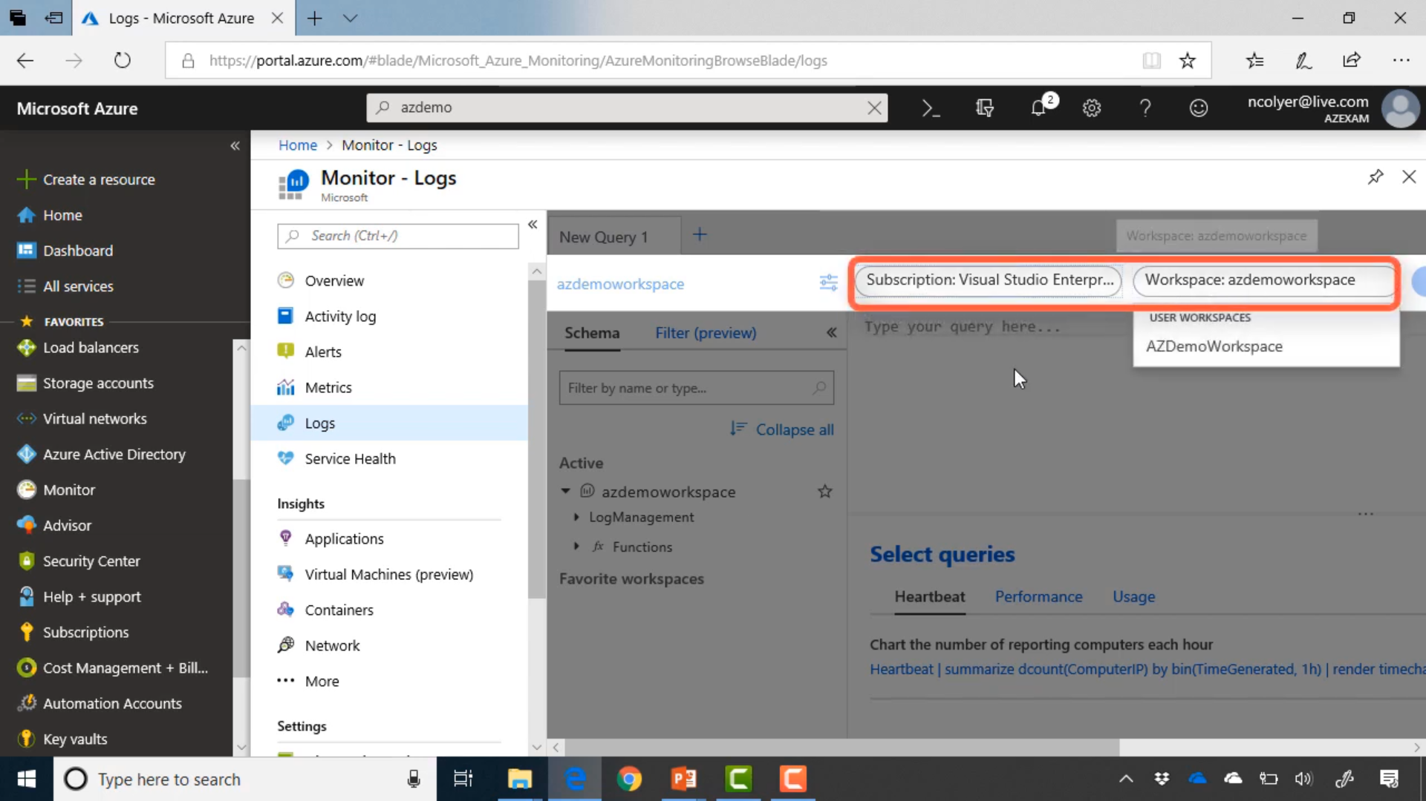

### Log Analytics

To start afresh search for a service **Log analytics** and create a new workspace which is associated with **subscription** and pricing is based on “**Per GB**”

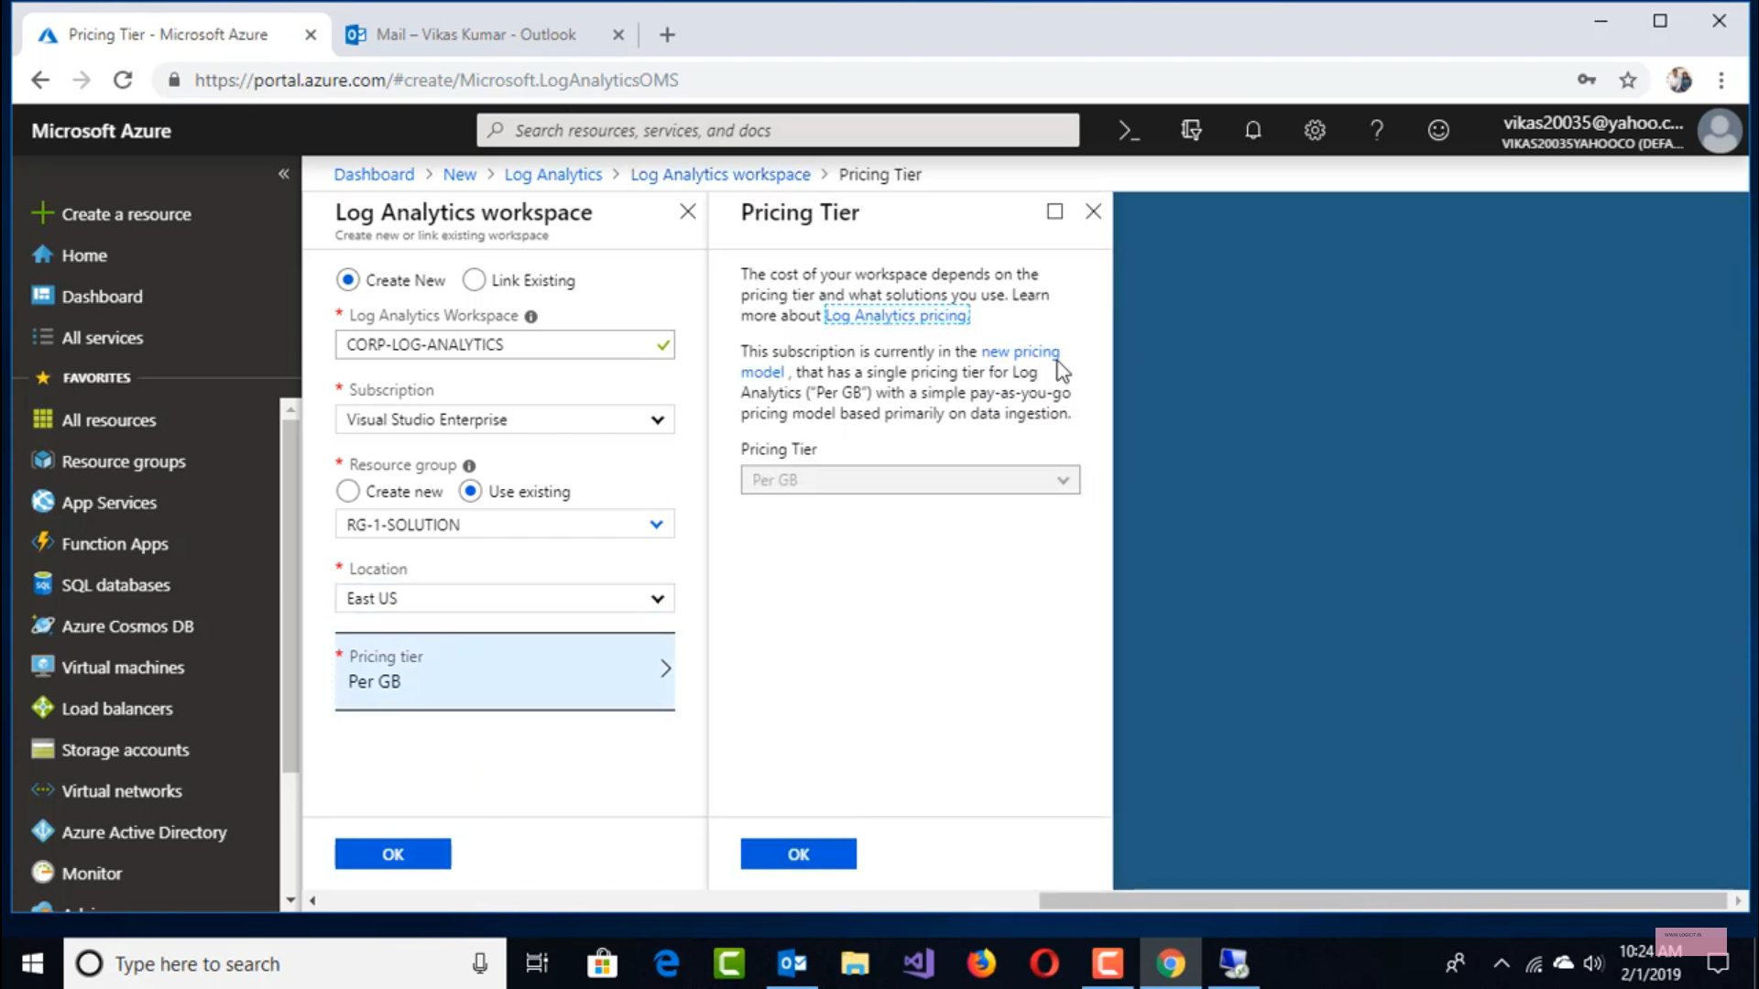

### Workspace Data Sources

After creating the Log Analytics Workspace, go to Azure Monitor and choose Logs and the workspace. Now in this workspace you will have to connect to various “Data srouces” from where you can collect logs.

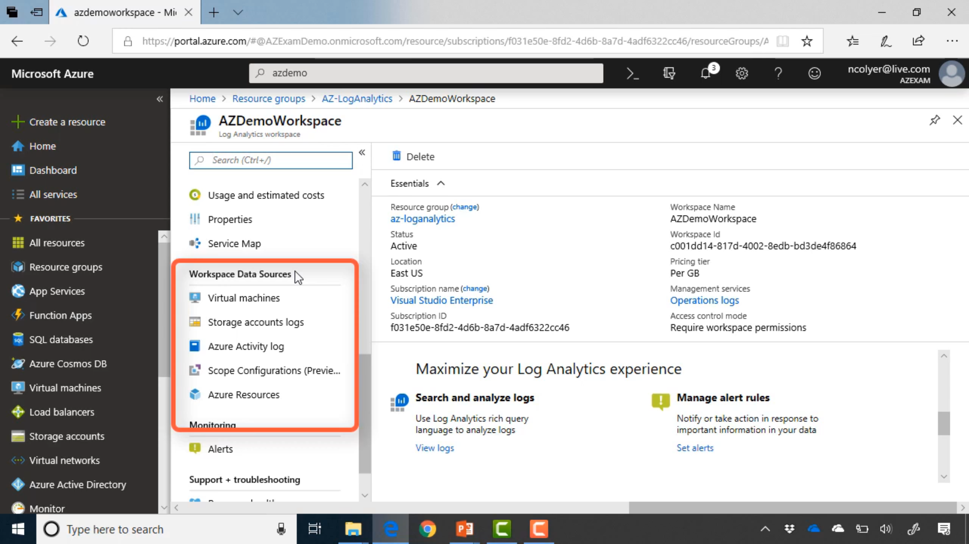

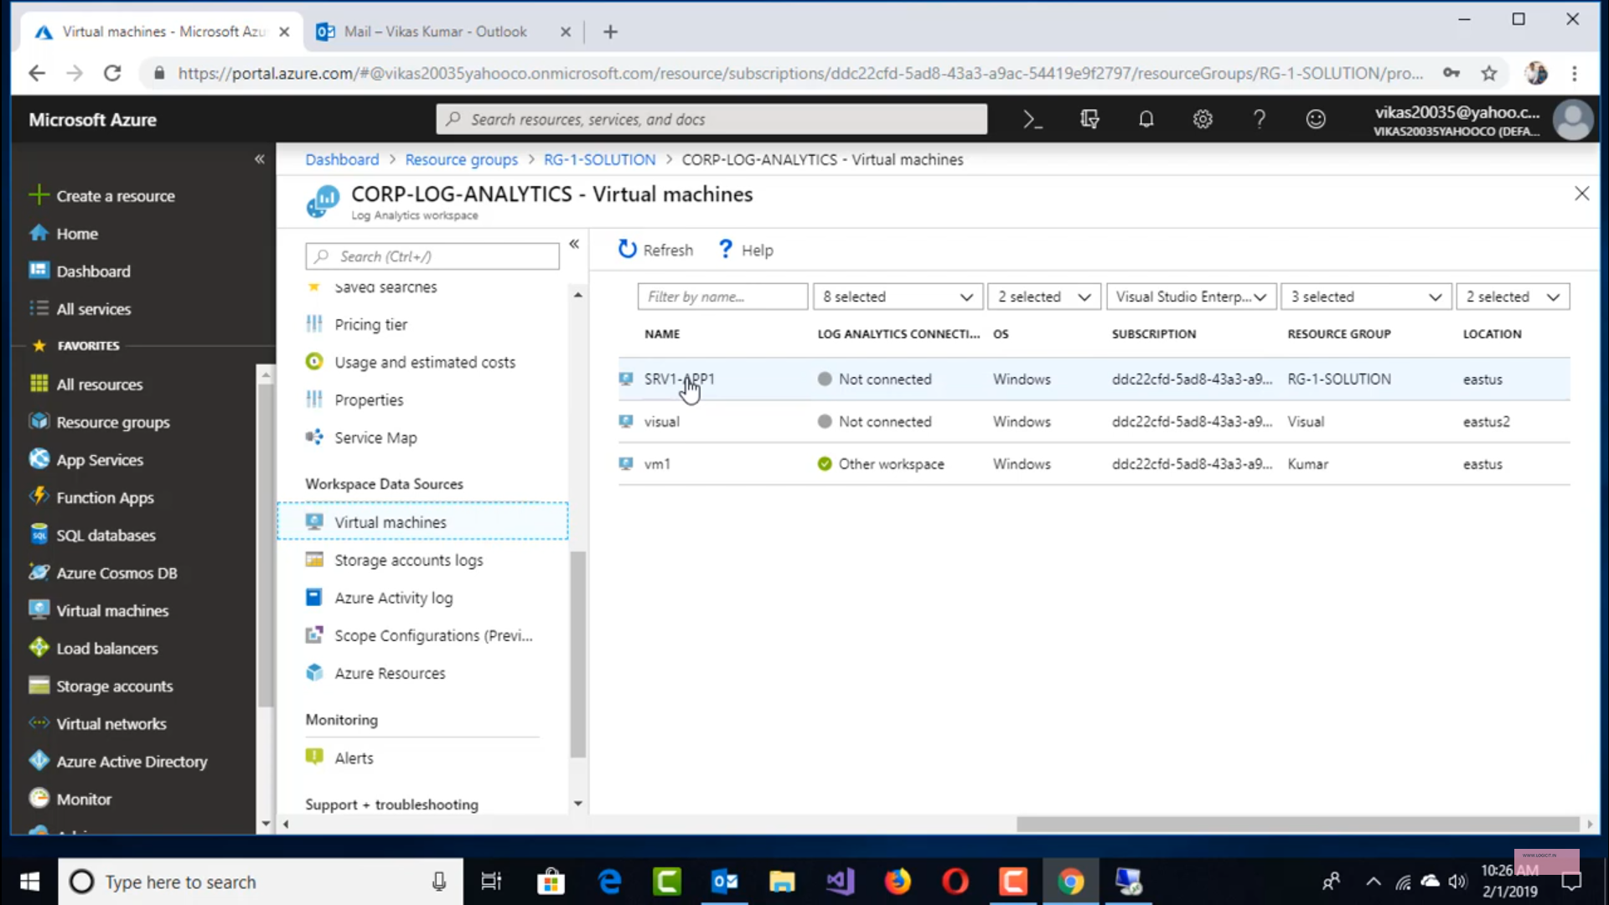

After you connect a VM to log analytics workspace a program/agent called “Microsoft Monitoring Agent” gets installed on the VM which then periodically send the log to Log analytics workspace.

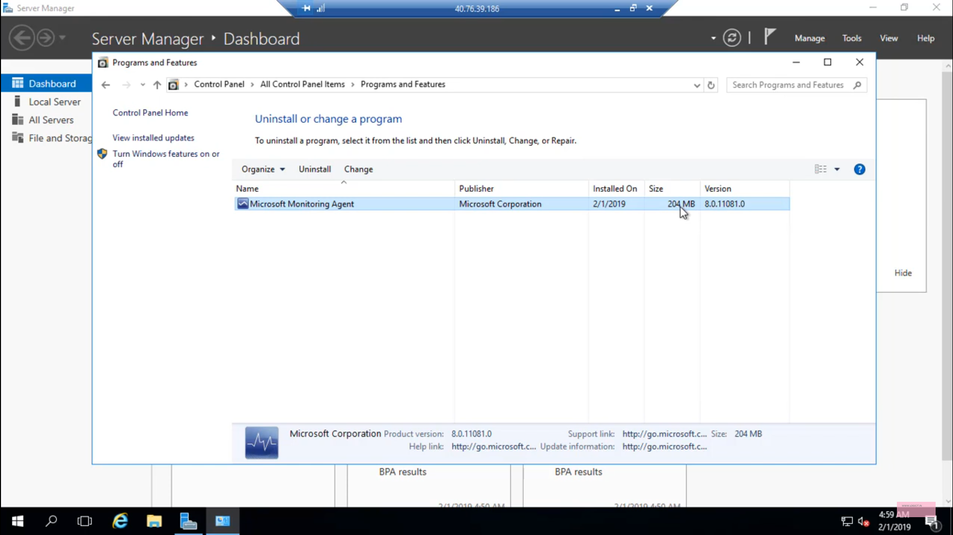

### Advanced Settings

One can go to **advanced settings** to choose various options to integrate log analytics such as it can be connected to on-prem servers by installing the agent and configuring it to send the information to Azure.

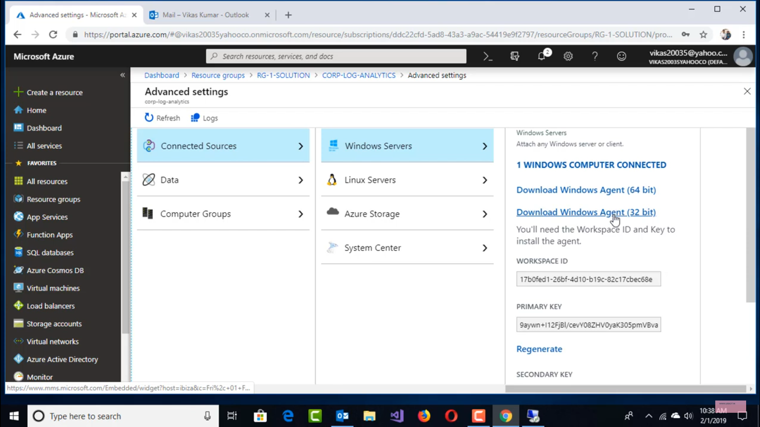

Similarly, in Data section one can choose from

* Windows Event Logs
* Windows Performance Counters
* IIS Logs
* Custom Logs
* Syslog

The format and field values that are being collected of all connected device can be modified from Data section.

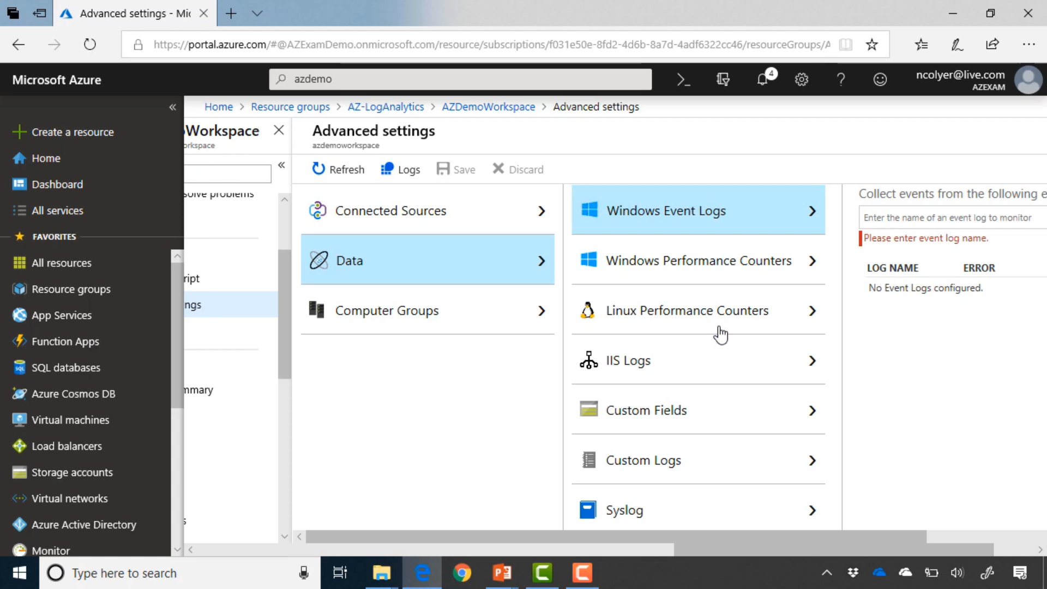

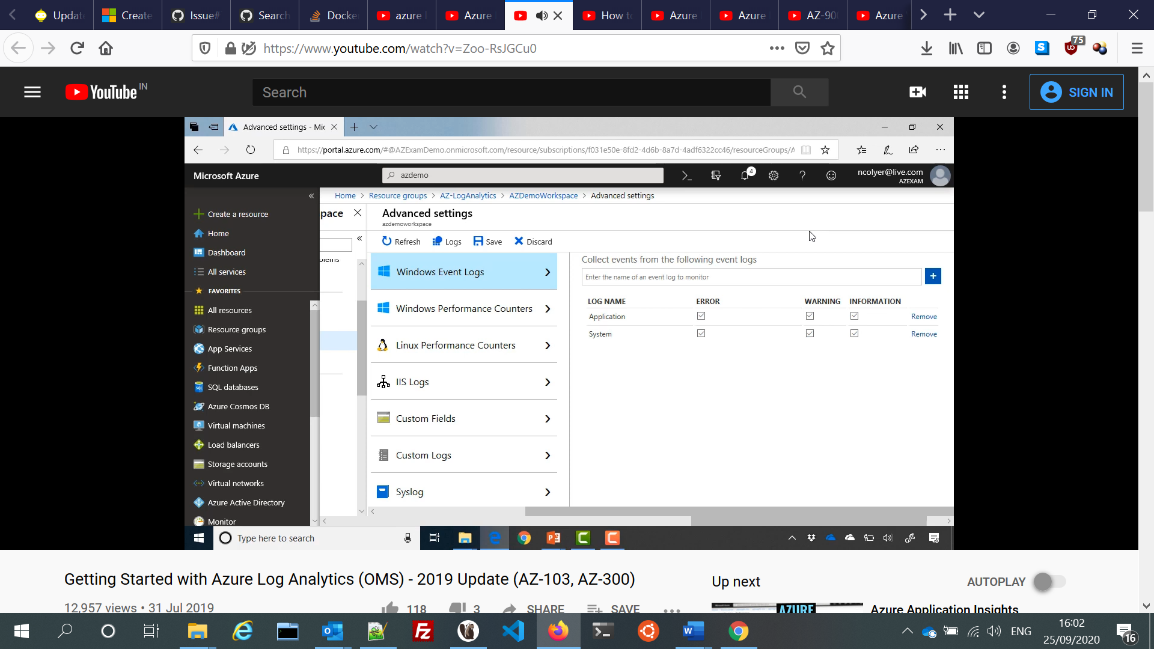

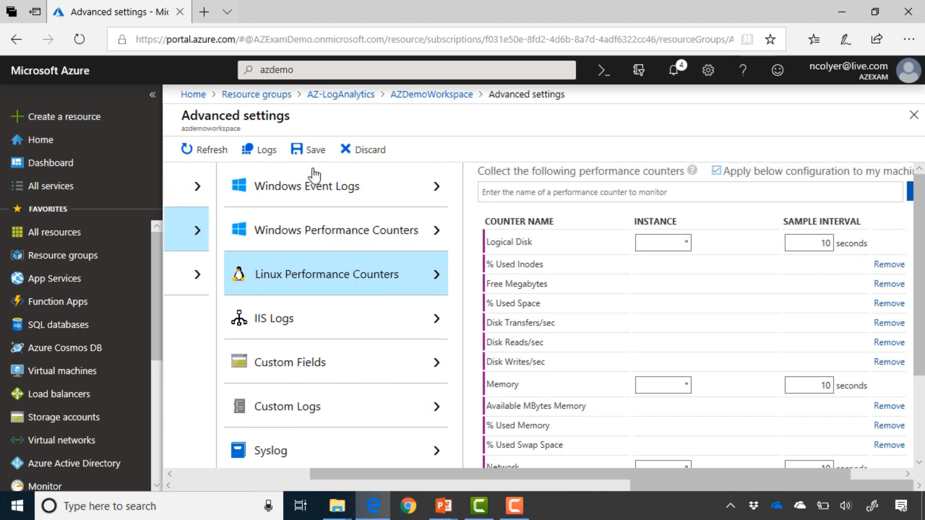

### Solutions

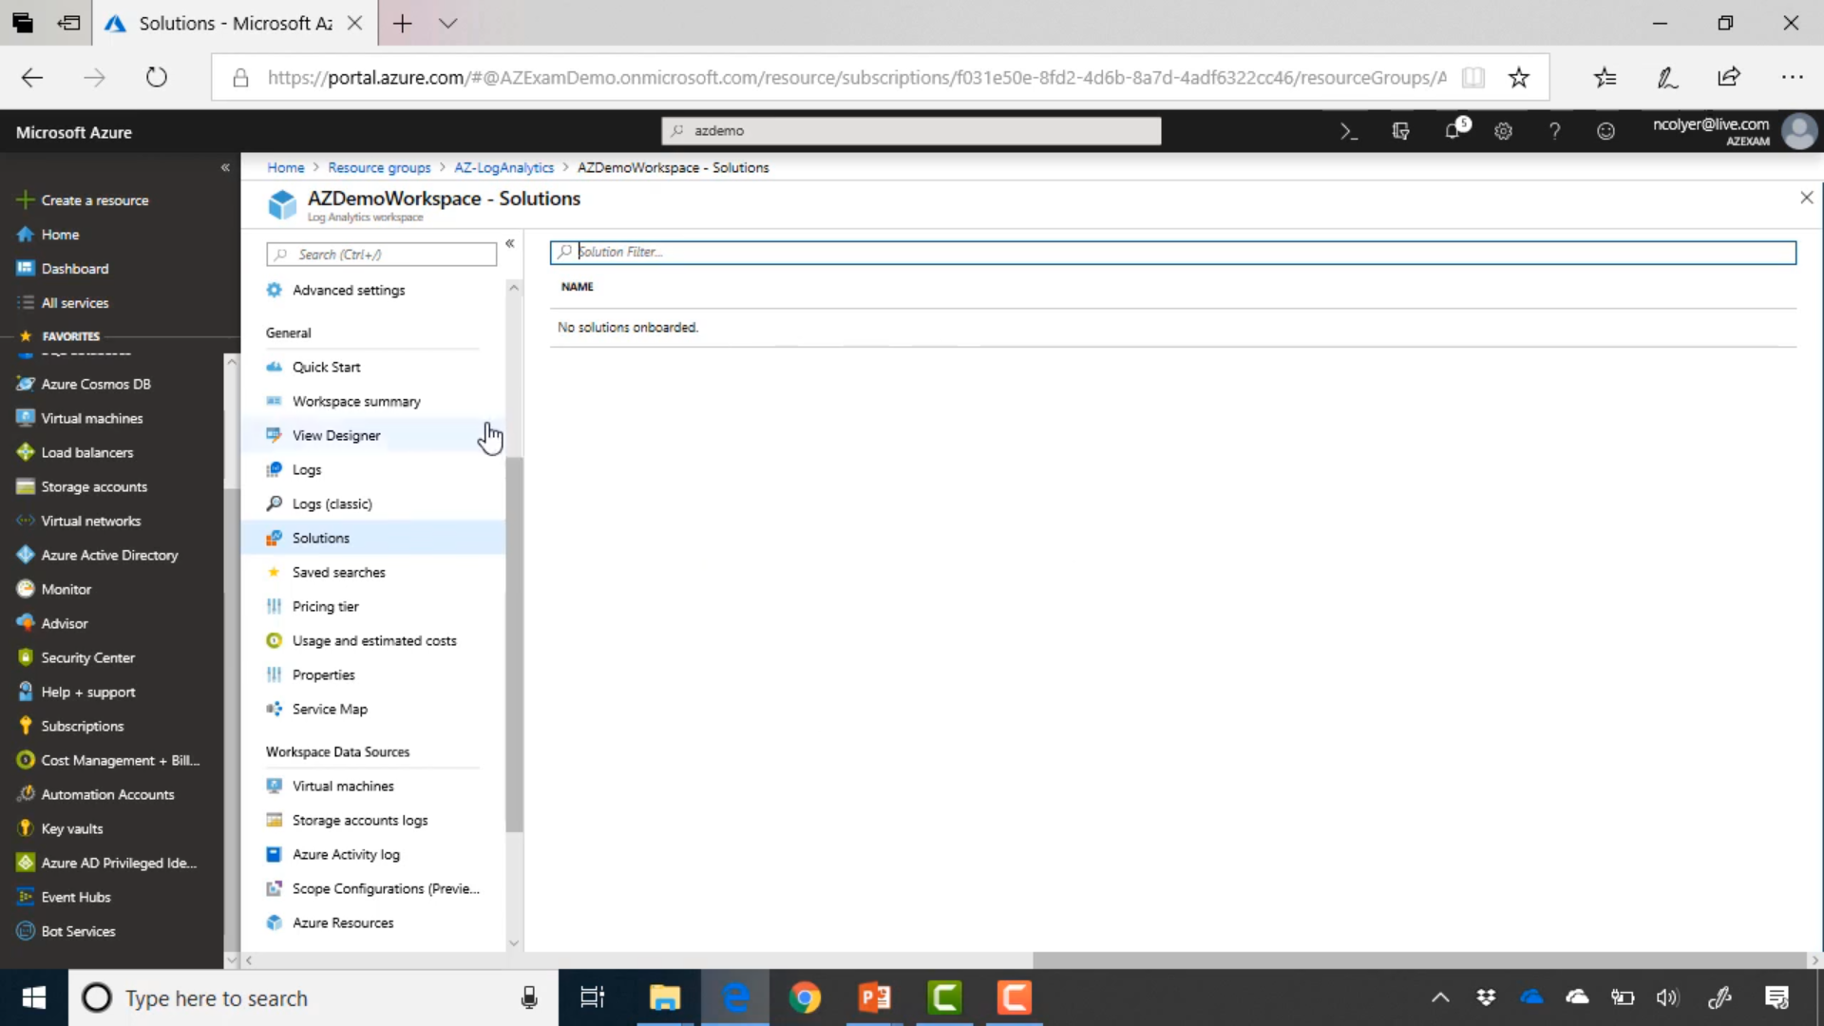

### Management Tools

This workspace is usually blank, and we need to choose tools from ***Marketplace-> Management Tools*** to integrate the services we want in solutions tab. One of the common service is **Security & compliance**.

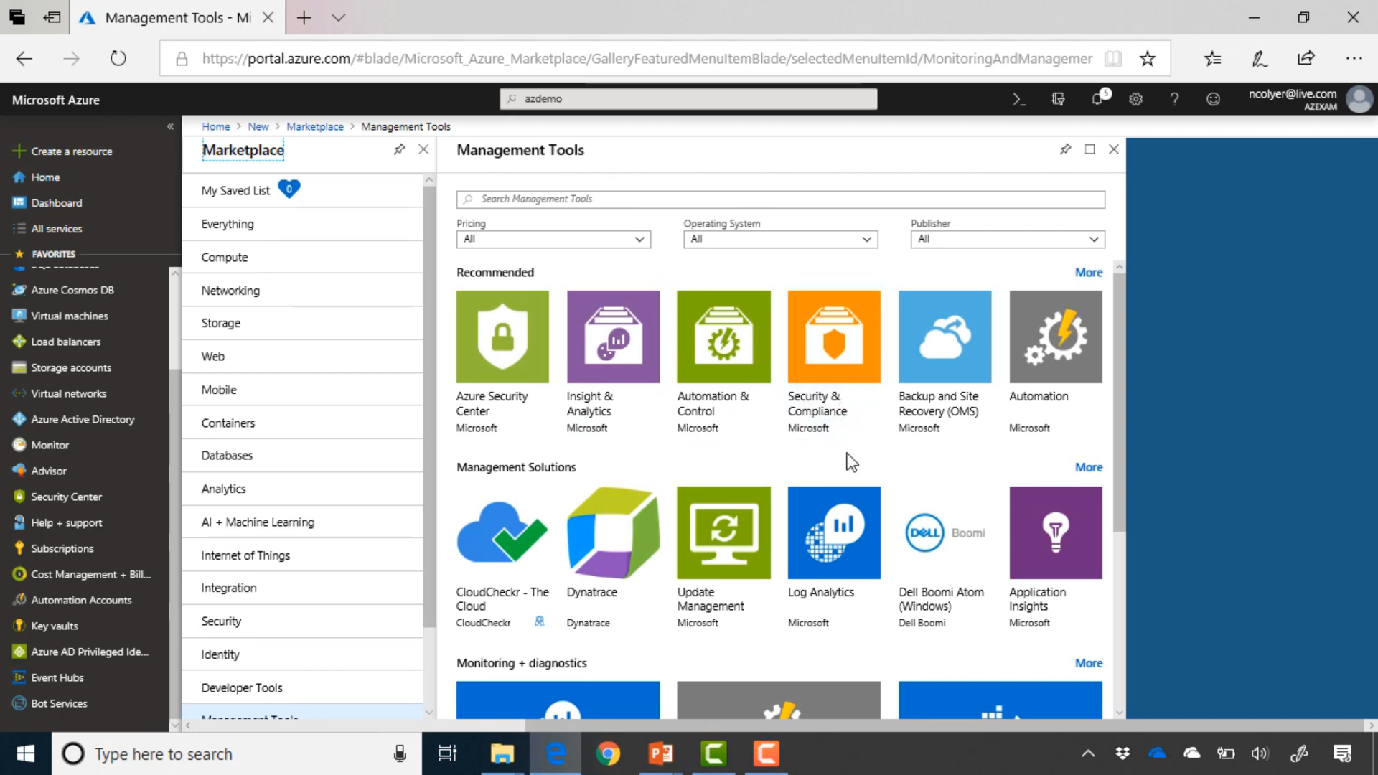

### View Designer

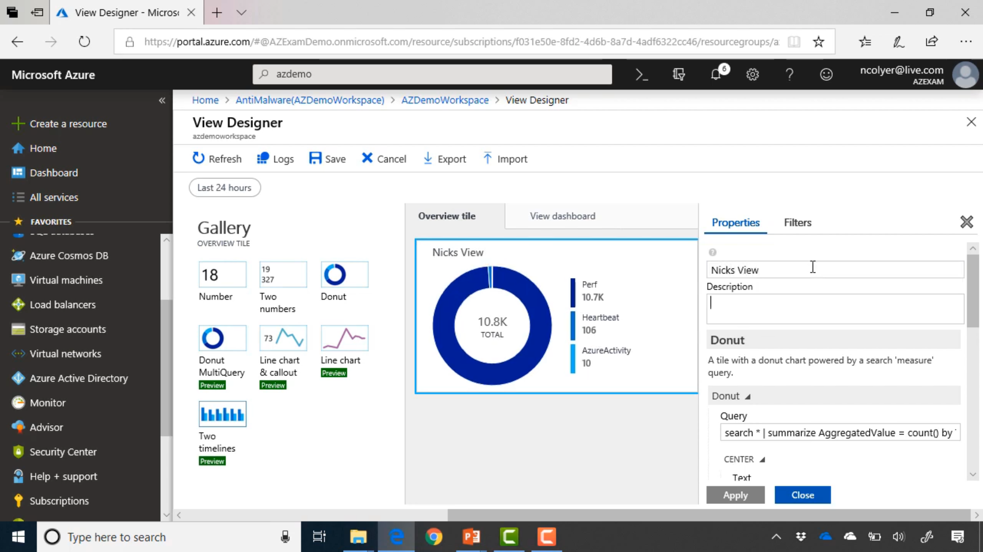

## Alerts

### Alerts rate Limiting

<https://docs.microsoft.com/en-us/azure/azure-monitor/platform/alerts-rate-limiting>

The rate limit thresholds are:

* SMS: No more than 1 SMS every 5 minutes.
* Voice: No more than 1 Voice call every 5 minutes.
* Email: No more than 100 emails in an hour.
* Other actions are not rate limited.

## Azure Action Group

<https://docs.microsoft.com/en-us/azure/azure-monitor/platform/action-groups>

An action group is a collection of notification preferences defined by the owner of an Azure subscription. Azure Monitor and Service Health alerts use action groups to notify users that an alert has been triggered.

### List of Notifications:

* **Azure app Push Notifications**: You may have a limited number of Azure app actions in an Action Group.
* **Email**
* **SMS**
* **Voice**
* **Email Azure Resource Manager Role**: Send email to the members of the subscription's role. Email will only be sent to Azure AD user members of the role. Email will not be sent to Azure AD groups or service principals.

### List of actions:

* **Automation Runbook**: You may have a limited number of Runbook actions in an Action Group.
* **Function**: Calls an existing HTTP trigger endpoint in Azure Functions.
* **ITSM**: ITSM Action requires an ITSM Connection.
* **Logic App**: You may have a limited number of Logic App actions in an Action Group.
* **Webhook**: Webhooks are processed using the following rules
  + A webhook call is attempted a maximum of 3 times.
  + The call will be retried if a response is not received within the timeout period or one of the following HTTP status codes is returned: 408, 429, 503 or 504.
  + The first call will wait 10 seconds for a response.
  + The second and third attempts will wait 30 seconds for a response.
  + After the 3 attempts to call the webhook have failed no action group will call the endpoint for 15 minutes.
* **Secure Webhook**: The Action Groups Webhook action enables you to take advantage of Azure Active Directory to secure the connection between your action group and your protected web API (webhook endpoint).

## Diagnostic Settings

<https://www.youtube.com/watch?v=iRgHXimHfj8>

## Autoscale with Azure Monitor

<https://www.youtube.com/watch?v=cn3lblf0rH4>

<https://docs.microsoft.com/en-us/azure/azure-monitor/platform/autoscale-get-started>

## Application Insights

<https://docs.microsoft.com/en-us/azure/azure-monitor/app/app-insights-overview>

Application Insights, a feature of [Azure Monitor](https://docs.microsoft.com/en-us/azure/azure-monitor/overview), is an extensible **Application Performance Management (APM)** service for developers and DevOps professionals. Use it to monitor your live applications. It will automatically **detect performance anomalies**, and includes **powerful analytics tools** to help you diagnose issues and to understand what users actually do with your app.

Just like Log Analytics Workspace, for using Application Insights one needs to create an instance of it. After this it becomes available both in Azure Monitor and the Insights tab of services which support Application Insights.

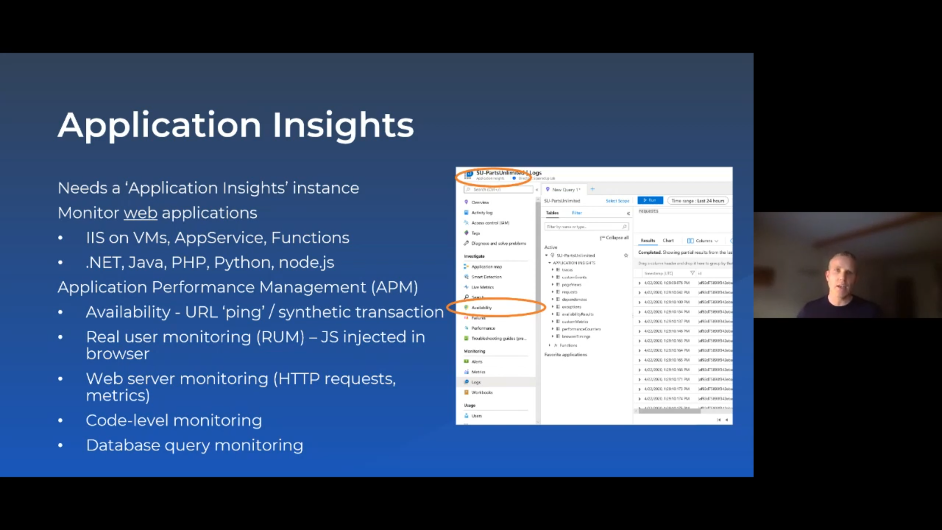

It helps in analysing :

1. Application exceptions and request at specific line of code
2. Analyse how many users return to the application and how often they select a particular dropdown value.

### Application Map

<https://docs.microsoft.com/en-us/azure/azure-monitor/app/app-map?tabs=net>

The **app map** finds components by following HTTP dependency calls made between servers with the **Application Insights SDK** installed.

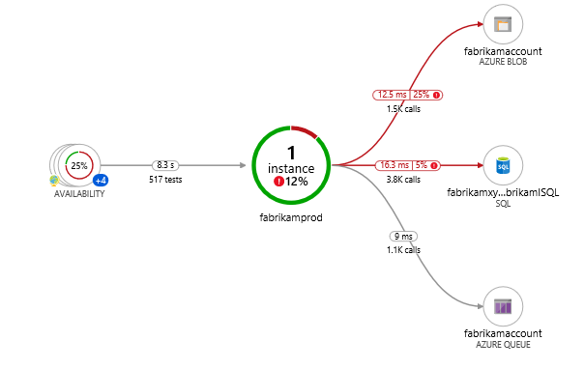

Note: Another competing service is called **Service Map** which too exist in **Azure Monitor** but for that **Application Insight** is not required.

## Service Map

<https://docs.microsoft.com/en-us/azure/azure-monitor/insights/service-map>

1. Enable the Service Map solution from the [Azure Marketplace](https://azuremarketplace.microsoft.com/marketplace/apps/Microsoft.ServiceMapOMS?tab=Overview)
2. [Install the Dependency agent on Windows](https://docs.microsoft.com/en-us/azure/azure-monitor/insights/vminsights-enable-hybrid#install-the-dependency-agent-on-windows) or [Install the Dependency agent on Linux](https://docs.microsoft.com/en-us/azure/azure-monitor/insights/vminsights-enable-hybrid#install-the-dependency-agent-on-linux) on each computer where you want to get data.

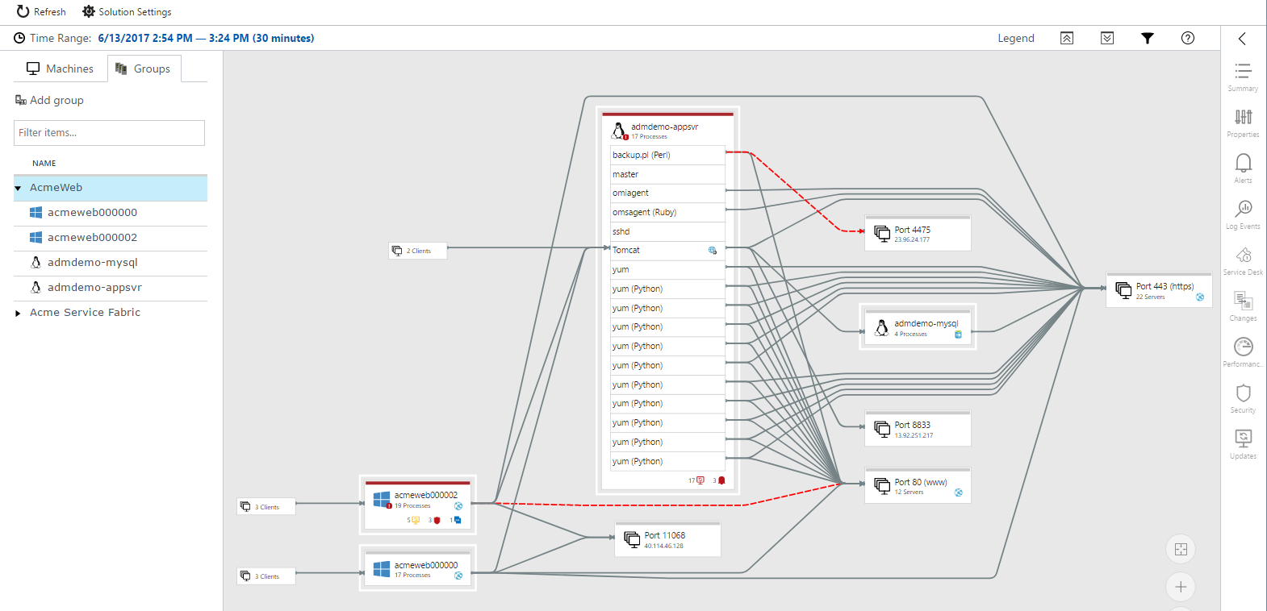

## Availability

It is used to test if the URL is available

### Smart Detection

<https://docs.microsoft.com/en-us/azure/azure-monitor/app/proactive-diagnostics>

Smart Detection detects and notifies about a variety of issues, such as:

* [Smart detection - Failure Anomalies](https://docs.microsoft.com/en-us/azure/azure-monitor/app/proactive-failure-diagnostics). We use machine learning to set the expected rate of failed requests for your app, correlating with load and other factors**. If the failure rate goes outside the expected envelope, we send an alert**.
* [Smart detection - Performance Anomalies](https://docs.microsoft.com/en-us/azure/azure-monitor/app/proactive-performance-diagnostics). You get notifications if response time of an operation or dependency duration is slowing down compared to historical baseline or if we identify an anomalous pattern in response time or page load time.
* General degradations and issues, like [Trace degradation](https://docs.microsoft.com/en-us/azure/azure-monitor/app/proactive-trace-severity), [Memory leak](https://docs.microsoft.com/en-us/azure/azure-monitor/app/proactive-potential-memory-leak), [Abnormal rise in Exception volume](https://docs.microsoft.com/en-us/azure/azure-monitor/app/proactive-exception-volume) and [Security anti-patterns](https://docs.microsoft.com/en-us/azure/azure-monitor/app/proactive-application-security-detection-pack).

## IT Service Management Connector

<https://docs.microsoft.com/en-us/azure/azure-monitor/platform/itsmc-overview>

The IT Service Management Connector (ITSMC) allows you to connect Azure and a supported IT Service Management (ITSM) product/service.

ITSMC supports connections with the following ITSM tools:

* ServiceNow
* System Center Service Manager ( By Microsoft )
* Provance
* Cherwell

## Azure Monitor Data retention:

<https://docs.microsoft.com/en-us/azure/azure-monitor/app/data-retention-privacy#how-long-is-the-data-kept>

Raw data points (that is, items that you can query in Analytics and inspect in Search) are kept for up to 730 days. You can [select a retention duration](https://docs.microsoft.com/en-us/azure/azure-monitor/app/pricing#change-the-data-retention-period) of 30, 60, 90, 120, 180, 270, 365, 550 or 730 days. If you need to keep data longer than 730 days, you can use [Continuous Export](https://docs.microsoft.com/en-us/azure/azure-monitor/app/export-telemetry) to copy it to a storage account during data ingestion.

Data kept longer than 90 days will incur addition charges.

Aggregated data (that is, counts, averages and other statistical data that you see in Metric Explorer) are retained at a grain of 1 minute for 90 days.

[Debug snapshots](https://docs.microsoft.com/en-us/azure/azure-monitor/app/snapshot-debugger) are stored for 15 days. This retention policy is set on a per-application basis.

# Azure Activity logs (Azure Monitor):

<https://docs.microsoft.com/en-us/azure/governance/management-groups/overview#audit-management-groups-using-activity-logs>

<https://www.youtube.com/watch?v=ACVpH6C_NL8>

Azure Activity Logs Keeps tracks of all activity of Azure resources and it can be accessed from Azure Monitor. It is also part of all resource’s blade and is usually placed at second position in each resource. These logs are kept for 90 days if stored for more than that then it is charged

Just like **Azure Cost Management, Azure Activity Logs** is available at all the levels and at each level a filter condition keeps getting added to show information at just that level.

**It basically answers questions like who, what and when something happened with any resources**.

https://docs.microsoft.com/en-us/azure/azure-resource-manager/management/view-activity-logs

## Quick Insights

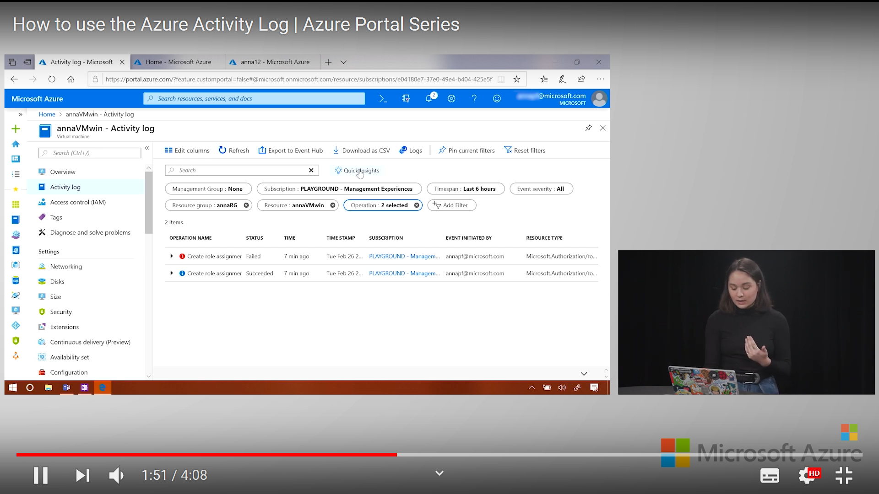

Quick Insights shows activity of last 24 hours categorised in various groups such as

* Errors
* Failed deployments
* Alerts fired
* Service Health
* Role assignment

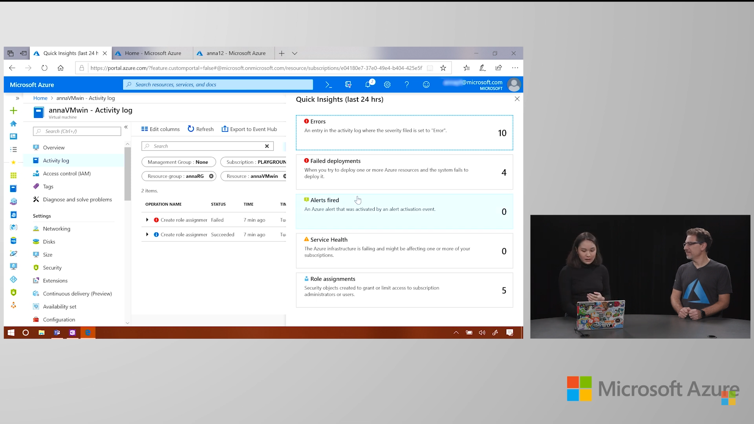

# Azure Cost Management

<https://www.youtube.com/watch?v=CXFWPI1qk_s>

<https://docs.microsoft.com/en-us/azure/cost-management-billing/cost-management-billing-overview>

Azure Cost Management Setup, Org. and Tagging

<https://www.youtube.com/watch?v=dVuwITdSAZ4>

<https://www.youtube.com/watch?v=n3TLRaYJ1NY>

<https://www.youtube.com/watch?v=_uQzQ9puPyM>

<https://www.youtube.com/watch?v=2Vx7V17zbmk>

Azure Cost Management works at all levels(Management Group, subscription, resource group, resource) that is you can set at what level you want to the cost analysis. And it is also available in side blade of all resources.

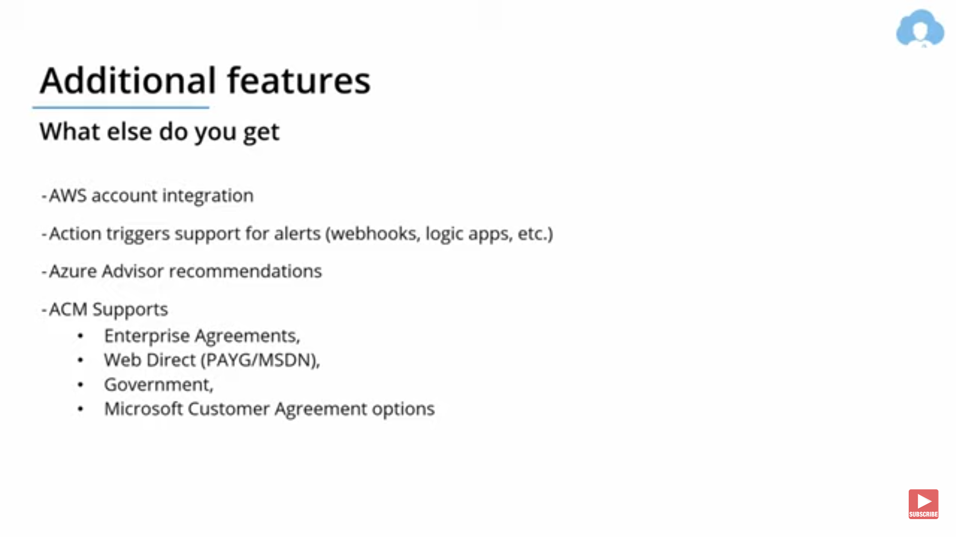

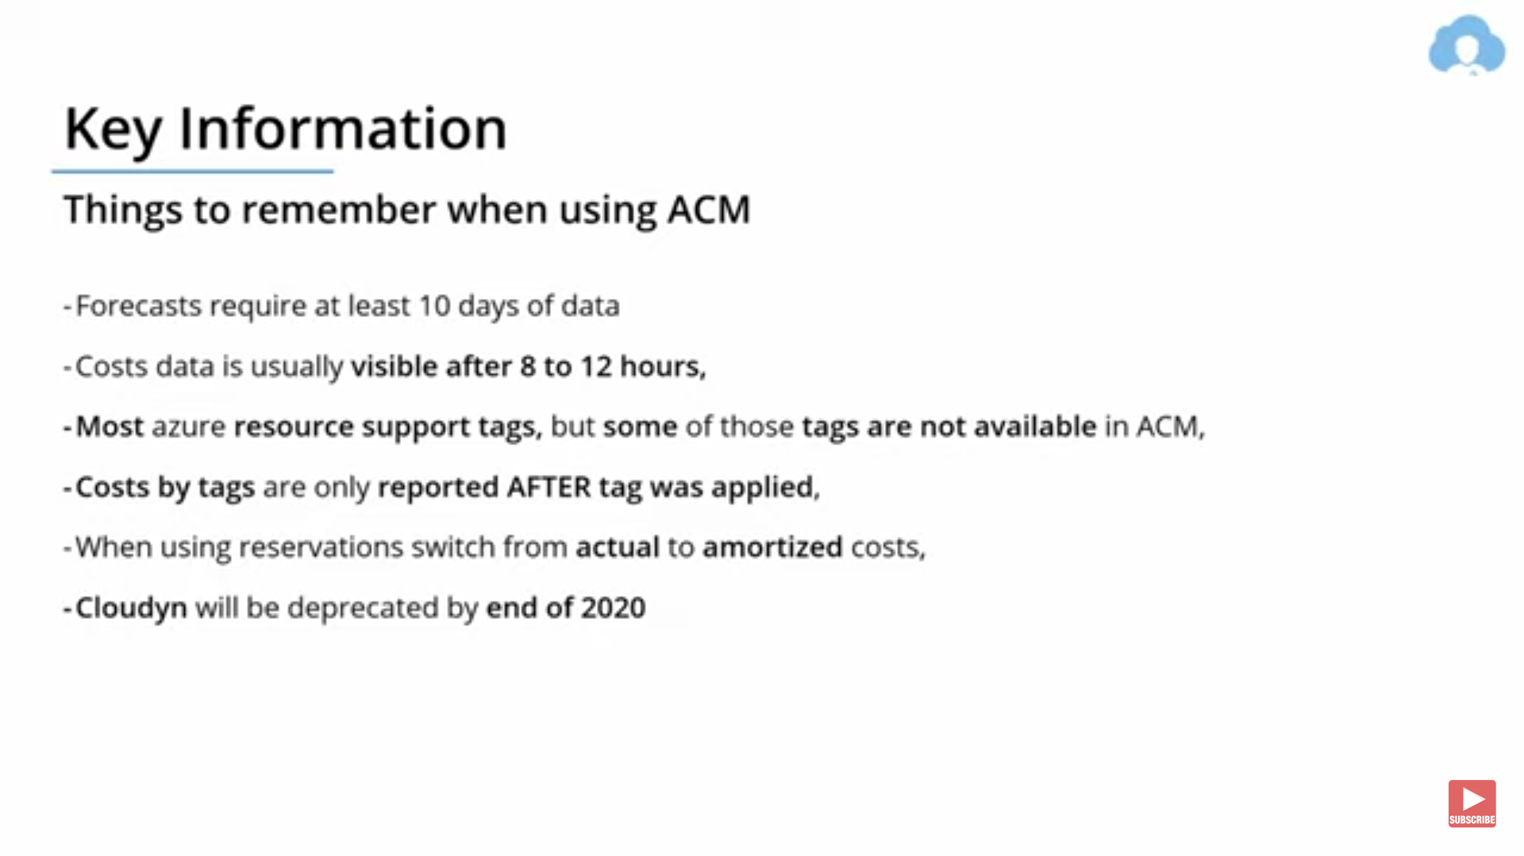

## RBAC roles for accessing ACM

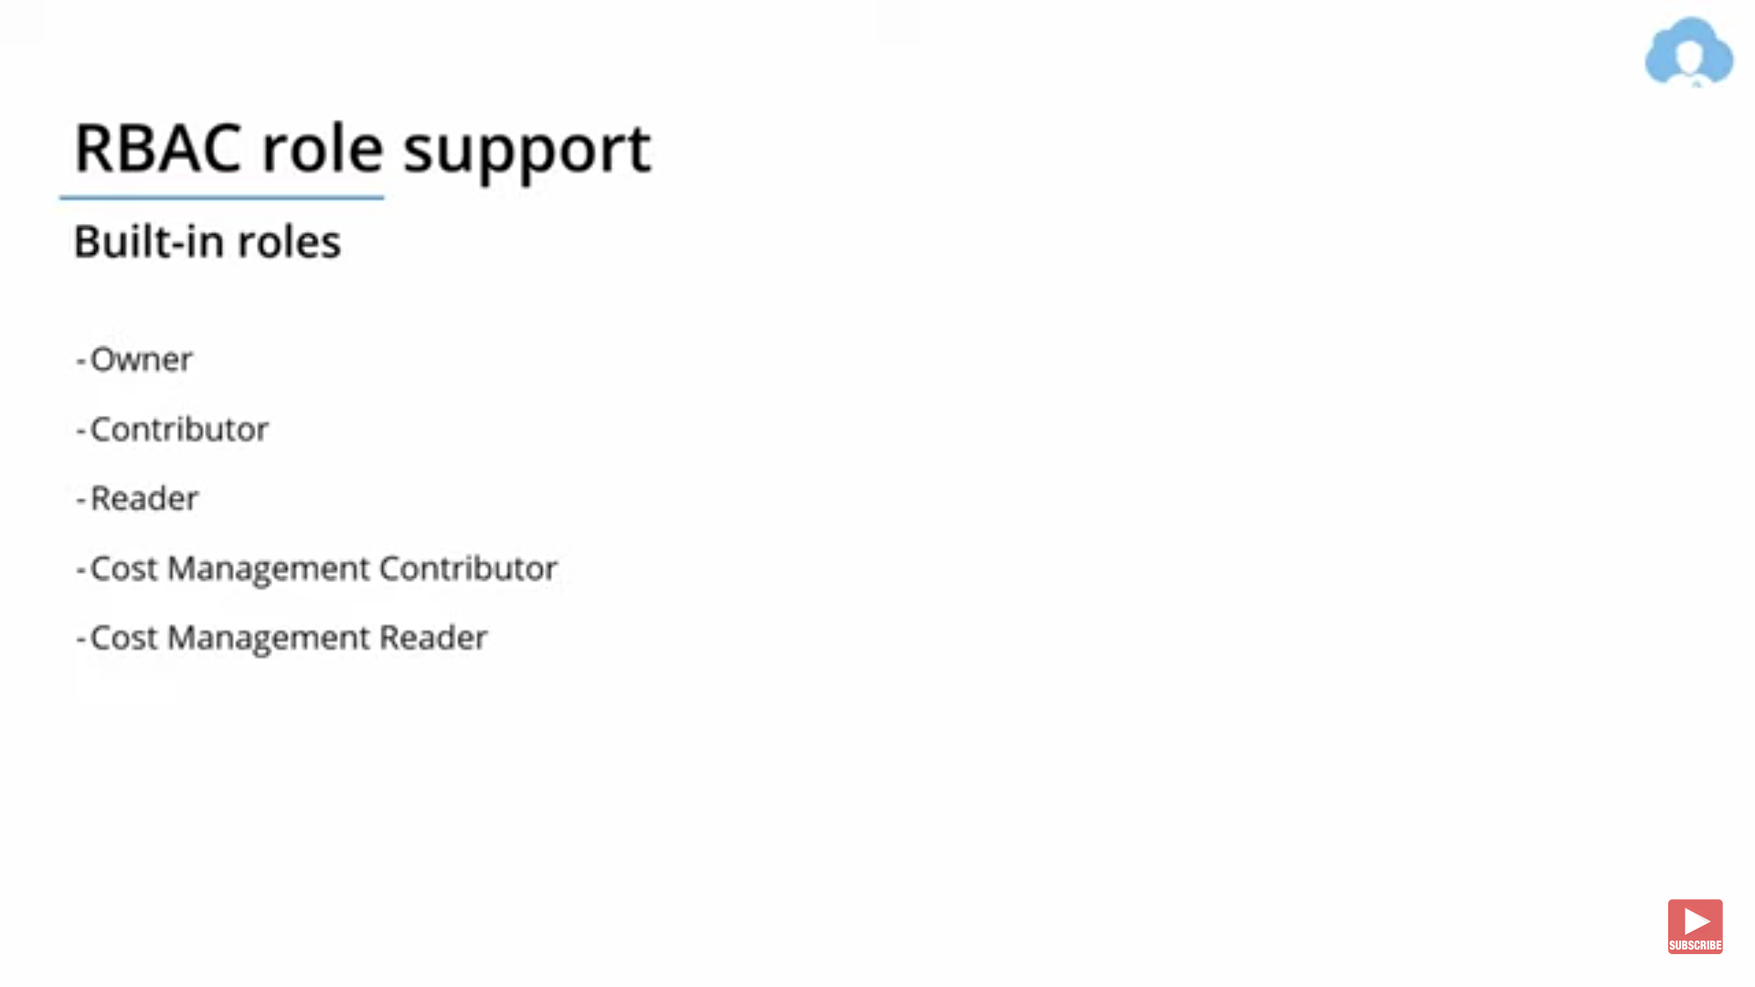

## Billing and Management hierarchy

<https://www.youtube.com/watch?v=n3TLRaYJ1NY>

### Billing and entity hierarchy

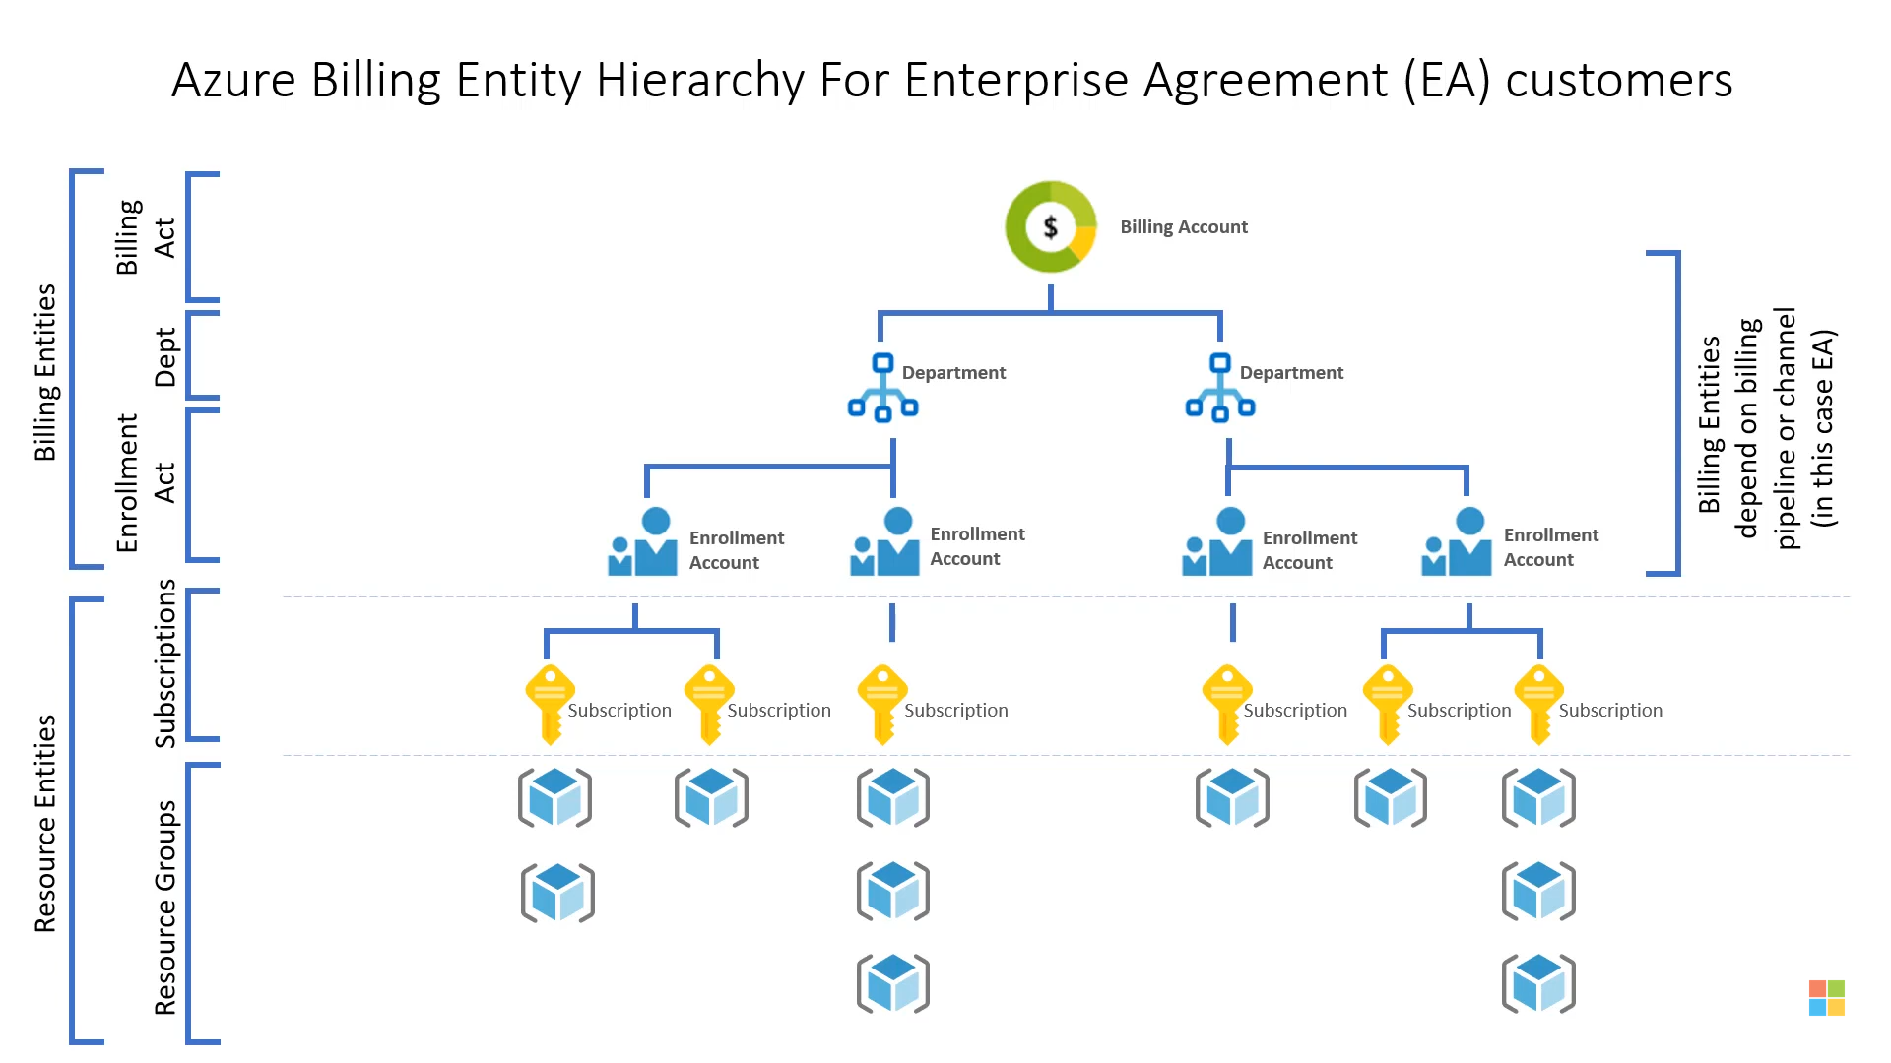

### Management group hierarchy

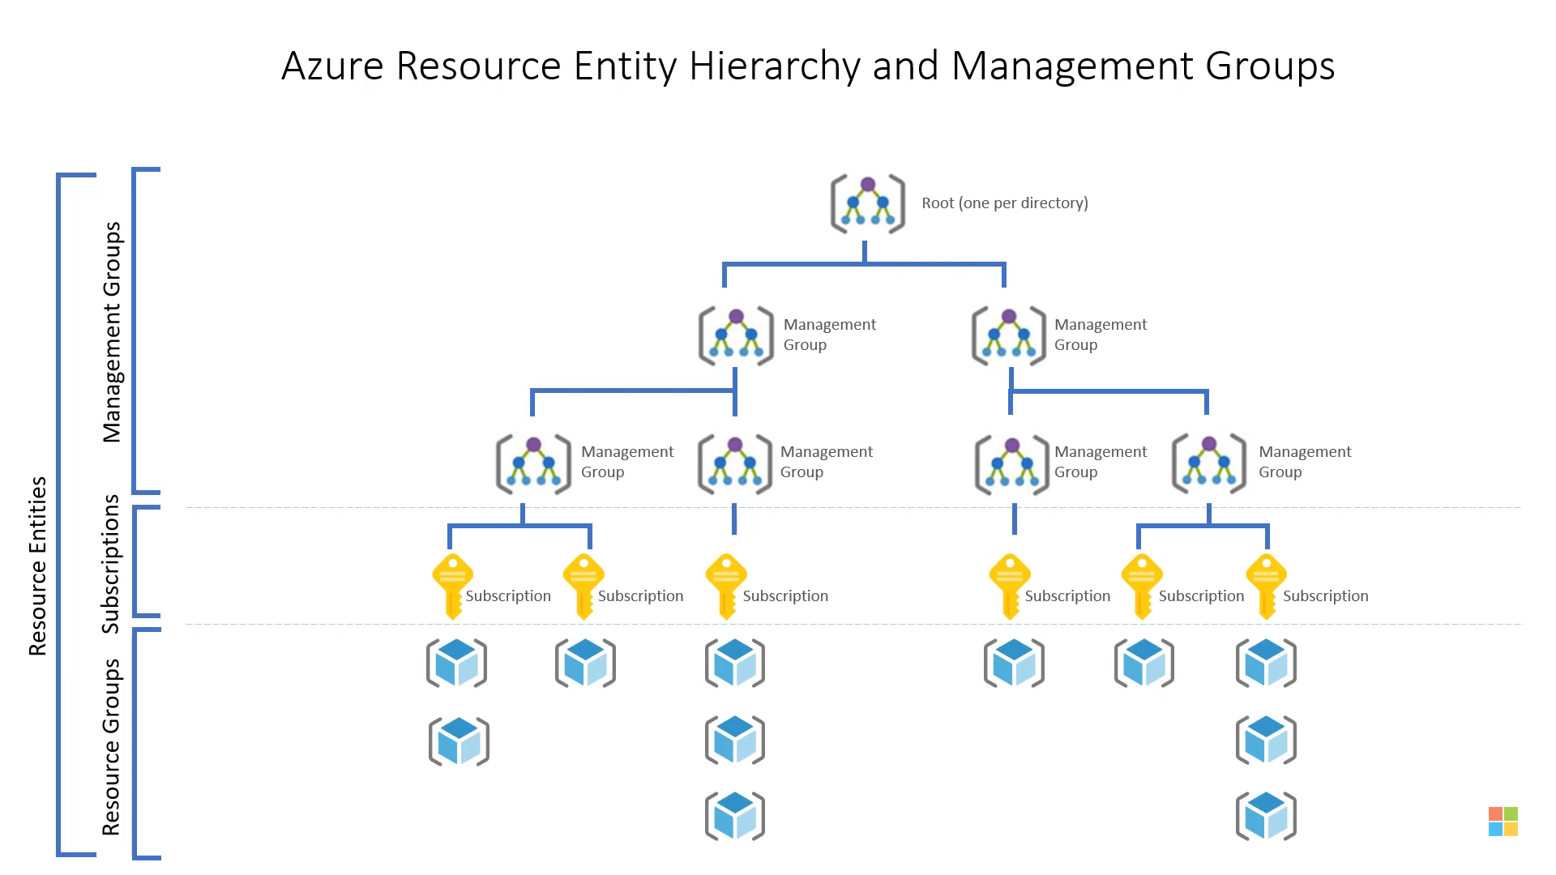

## Access Control

<https://www.youtube.com/watch?v=_uQzQ9puPyM>

## Cost Analysis

## Cost Alerts

There are three types of cost alerts: budget alerts, credit alerts, and department spending quota alerts

<https://docs.microsoft.com/en-us/azure/cost-management-billing/costs/cost-mgt-alerts-monitor-usage-spending>

### Budget alerts

Budget alerts notify you when spending, based on usage or cost, reaches or exceeds the amount defined in the [alert condition of the budget](https://docs.microsoft.com/en-us/azure/cost-management-billing/costs/tutorial-acm-create-budgets).

### Credit alerts

Credit alerts notify you when your Azure credit monetary commitments are consumed. Monetary commitments are for organizations with Enterprise Agreements.

### Department spending quota alerts

Department spending quota alerts notify you when department spending reaches a fixed threshold of the quota. Spending quotas are configured in the EA (Enterprise Agreement) portal.

## Budgets

### Manage costs with Azure Budgets

<https://docs.microsoft.com/en-us/azure/cost-management-billing/manage/cost-management-budget-scenario>

In addition to using the budgets API to notify you via email when a budget threshold is reached, you can use [Azure Monitor action groups](https://docs.microsoft.com/en-us/azure/monitoring-and-diagnostics/monitoring-action-groups) to trigger an orchestrated set of actions resulting from a budget event.

Some of the actions can be:

* Create an **Azure Automation Runbook to stop VM**s by using **webhooks**.
* Create an **Azure Logic App to be triggered** based on the budget threshold value and call the runbook with the right parameters.
* Create an Azure Monitor Action Group that will be configured to trigger the Azure Logic App when the budget threshold is met.
* Create the Azure budget with the wanted thresholds and wire it to the action group.

## Azure Advisor (Advisor Recommendations)

<https://docs.microsoft.com/en-us/azure/advisor/advisor-cost-recommendations>

Azure Advisor helps you optimize and reduce your overall Azure spend by identifying idle and underutilized resources. You can get cost recommendations from the **Cost** tab on the Advisor dashboard.

The Cost tab of Azure Advisor is available from Azure Monitor blade as well having a name Advisor Recommendations.

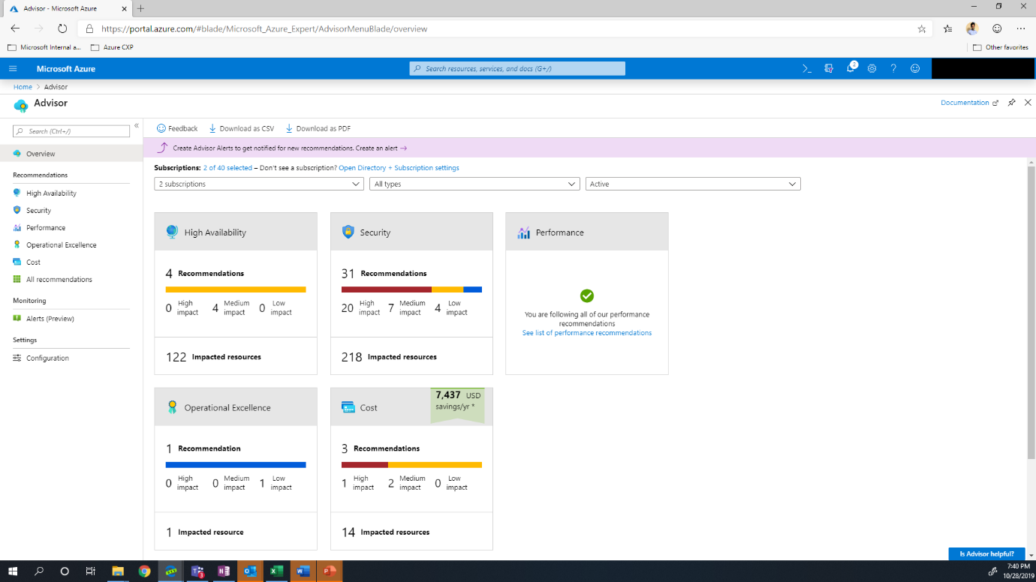

## Cloudyn

## Azure Invoices

<https://docs.microsoft.com/en-us/azure/cost-management-billing/understand/download-azure-invoice>

## Azure spending limit

<https://docs.microsoft.com/en-us/azure/cost-management-billing/manage/spending-limit>

The spending limit in Azure prevents spending over your credit amount. All new customers who sign up for an Azure free account or subscription types that include credits over multiple months have the spending limit turned on by default.

When your usage results in charges that exhaust your spending limit, **the services that you deployed are disabled for the rest of that billing period**.

Spending limit is not allowed to all subscriptions for more :

<https://azure.microsoft.com/en-us/support/legal/offer-details/>

# Recovery Services Vault (Backup & Site recovery)

In the Classic Azure Portal, **Site Recovery and Backup were separate services**. In the modern Azure Portal, these **2 services are contained within the Recovery Services Vault service**.

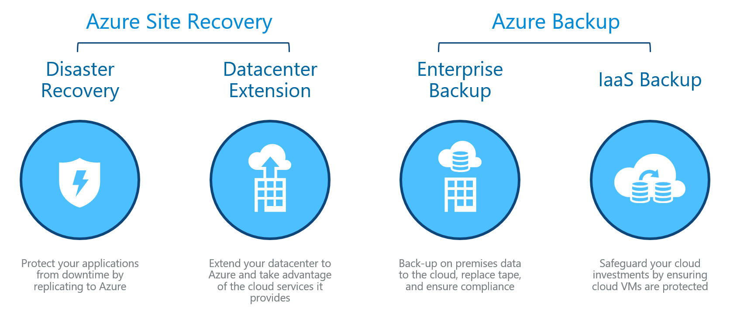

## Glossry:

### **RTO**:

Recovery Time Objectives, How much TIME will it take to recover

### **RPO**:

Recovery Point Objectives, How much DATA LOSS will happen until it recovers.

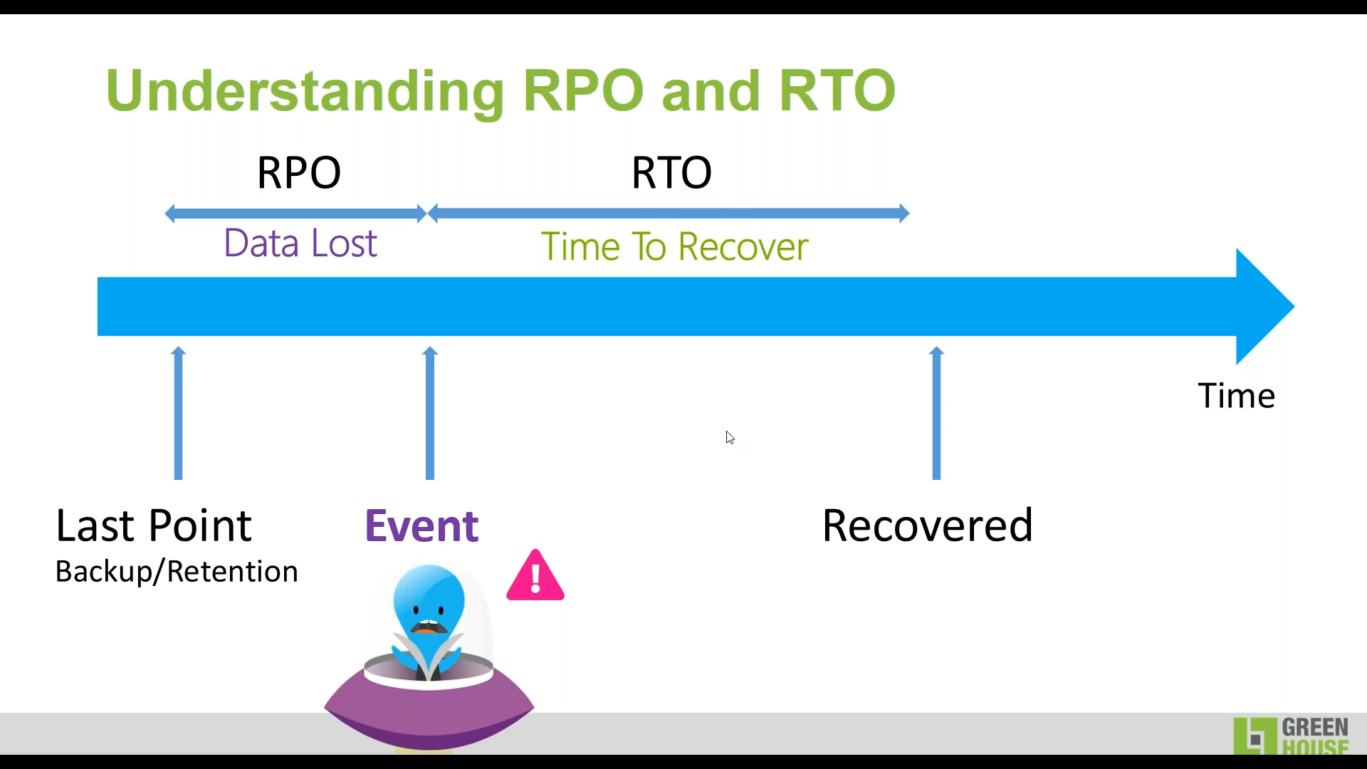

**Backup is NOT Disaster Recovery**.

## Business Continuity & Disaster Recovery (BCDR)

<https://adinermie.com/backup-not-disaster-recovery-need-fully-covered/>

### Disaster Recovery

When your sites, servers or applications have a catastrophic failure and you are required to run them in Azure or a secondary datacentre.

### Backup

When your data is corrupted or lost and you need to restore your data or infrastructure to the original location or a new location.

## Azure Backup vs. Azure Site Recovery

Azure Backup is used to protect and restore data at a more granular level. **So, if some files become corrupted, you can use Azure Backup to restore them**. But, if you wanted to replicate the configuration and data of a system to another datacentre, then you would use Azure Site Recovery.

Azure Backup protects data on-premises and in the cloud. Azure Site Recovery coordinates replication, failover, and failback.

**Disaster recovery** solution needs to keep your data safe and recoverable (**Backup**) and keep your workloads available (**Site Recovery**) when **outages occur**.

| **Concept** | **Details** | **Backup** | **Disaster Recovery (DR)** |
| --- | --- | --- | --- |
| Recovery point objective (RPO) | The amount of acceptable data loss if a recovery needs to be done. | Backup solutions have wide variability in their acceptable RPO. Virtual machine backups usually have an RPO of one day, while database backups have RPOs as low as 15 minutes. | Disaster recovery solutions have low RPOs. The DR copy can be behind by a few seconds or a few minutes. |
| Recovery time objective (RTO) | The amount of time that it takes to complete a recovery or restore. | Because of the larger RPO, the amount of data that a backup solution needs to process is typically much higher, which leads to longer RTOs. For example, it can take days to restore data from tapes, depending on the time it takes to transport the tape from an off-site location. | Disaster recovery solutions have smaller RTOs because they are more in sync with the source. Fewer changes need to be processed. |
| Retention | How long data needs to be stored | For scenarios that require operational recovery (data corruption, inadvertent file deletion, OS failure), backup data is typically retained for 30 days or less. From a compliance standpoint, data might need to be stored for months or even years. Backup data is ideally suited for archiving in such cases. | Disaster recovery needs only operational recovery data, which typically takes a few hours or up to a day. Because of the fine-grained data capture used in DR solutions, using DR data for long-term retention is not recommended. |

One can create recovery vault in different region.

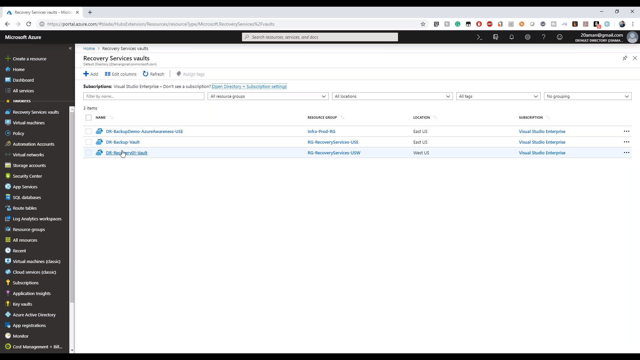

## Create Recovery Services Vault

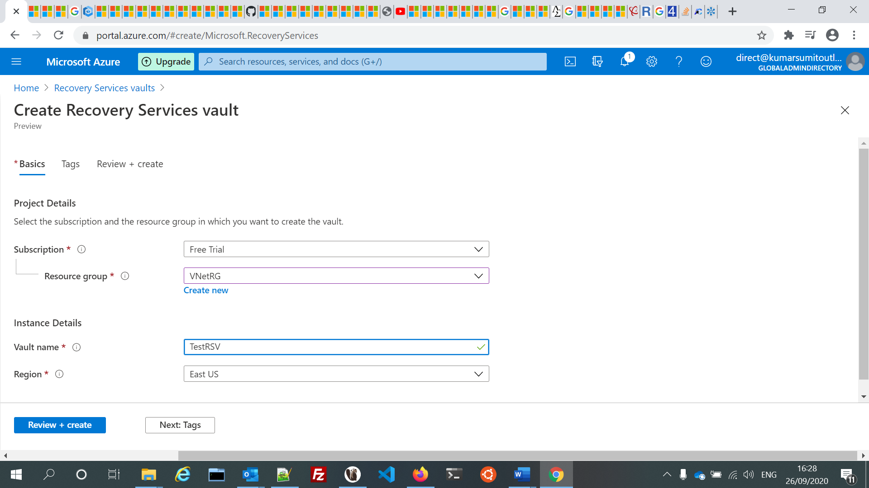

Default **Backup** configuration for Storage Replication Type is set to **Geo-redundant (GRS)**.

Default Security settings for **Soft Delete** is enabled.

After creating vault, it is highly recommended that you review default vault properties before protecting items.

### Backup

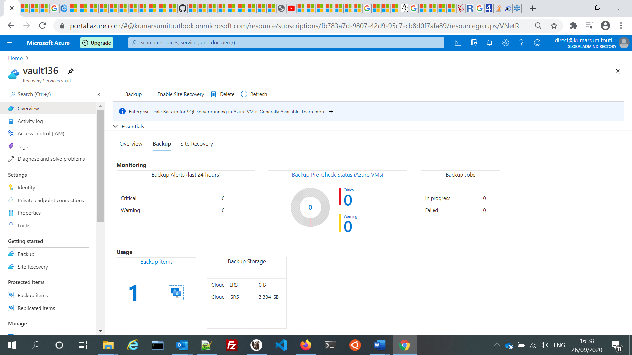

### Site Recovery

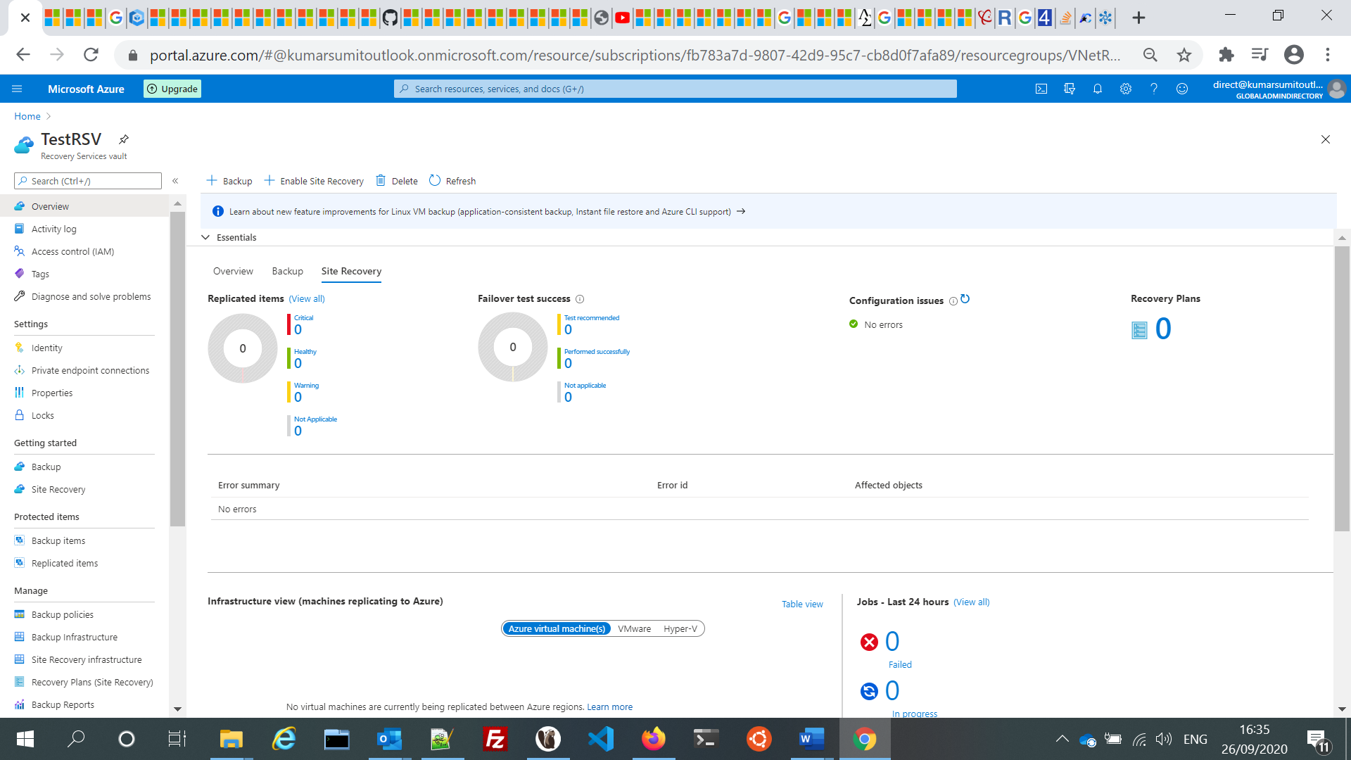

## Azure Paired Regions

<https://docs.microsoft.com/en-us/azure/best-practices-availability-paired-regions>

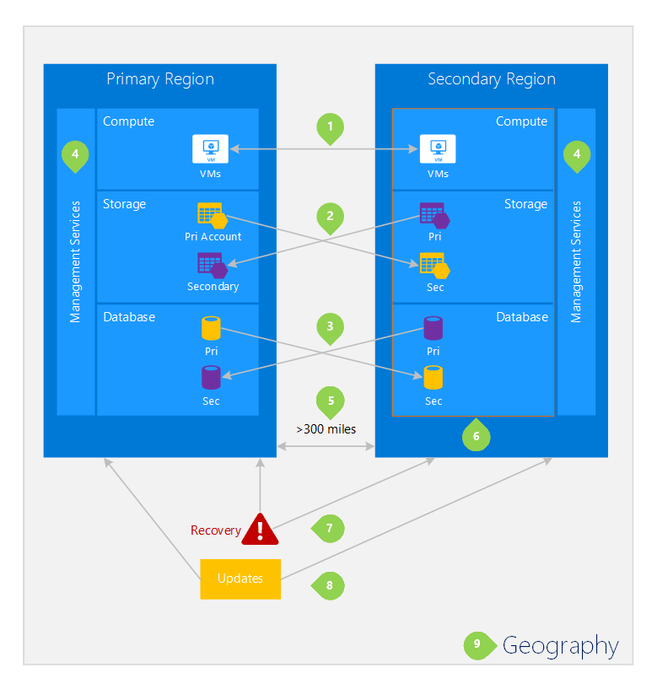

## Region

<https://docs.microsoft.com/en-us/azure/backup/backup-create-rs-vault>

To create a vault to protect any data source, the vault must be in the same region as the data source. If you have data sources in multiple regions, create a Recovery Services vault for each region. Create the vault in the first location before you create the vault for another location.

# Azure Backup

<https://docs.microsoft.com/en-us/azure/backup/backup-overview>

<https://www.youtube.com/watch?v=NpAc1XFdkJM>

<https://www.youtube.com/watch?v=JEveC534tQk>

Azure Backup (AB) supports backups across your **heterogeneous environment**, including VMware virtual machines.

* Azure Backup is part of OMS add-on as well as sold standalone
* First party SaaS service running in public Azure
* Backs up Windows Server, SCDPM, IaaS VM to Azure
* Supports file/folder, VMs (Linux & Windows), SQL Server, Exchange Server, SharePoint Server
* Flexible long term retention policy
* Granular recovery

With Azure Backup, **the data is encrypted using AES256 and is transmitted over HTTPS**. The data is also encrypted at rest, and you store and keep the encryption passphrase locally, it is never sent or stored in Azure.

**AB Use Cases**

* Accidental deletion
  + In the case that someone accidentally deletes business critical data, or that data become corrupted
* Patch Testing
  + Take a backup (and restore) if patch testing fails or causes application issues
* Alternative location recovery
  + Create a copy of your workload in an alternative location, whether for disaster recovery purposes or testing
* Security
  + Secure your data from the growing threat of ransomware attacks

## What can I back up?

* **On-premises** - Back up files, folders, system state using the [Microsoft Azure Recovery Services (MARS) agent](https://docs.microsoft.com/en-us/azure/backup/backup-support-matrix-mars-agent). Or use the **DPM (Data Protection Manager) or Azure Backup Server (MABS)** agent to protect **on-premises** VMs ([Hyper-V](https://docs.microsoft.com/en-us/azure/backup/back-up-hyper-v-virtual-machines-mabs) and [VMware](https://docs.microsoft.com/en-us/azure/backup/backup-azure-backup-server-vmware)) and other [on-premises workloads](https://docs.microsoft.com/en-us/azure/backup/backup-mabs-protection-matrix)
* **Azure VMs** - [Back up entire Windows/Linux VMs](https://docs.microsoft.com/en-us/azure/backup/backup-azure-vms-introduction) (using backup extensions) or back up files, folders, and system state using the [MARS agent](https://docs.microsoft.com/en-us/azure/backup/backup-azure-manage-mars).
* **Azure Files shares** - [Back up Azure File shares to a storage account](https://docs.microsoft.com/en-us/azure/backup/backup-afs)
* **SQL Server in Azure VMs** - [Back up SQL Server databases running on Azure VMs](https://docs.microsoft.com/en-us/azure/backup/backup-azure-sql-database)
* **SAP HANA databases in Azure VMs** - [Backup SAP HANA databases running on Azure VMs](https://docs.microsoft.com/en-us/azure/backup/backup-azure-sap-hana-database)

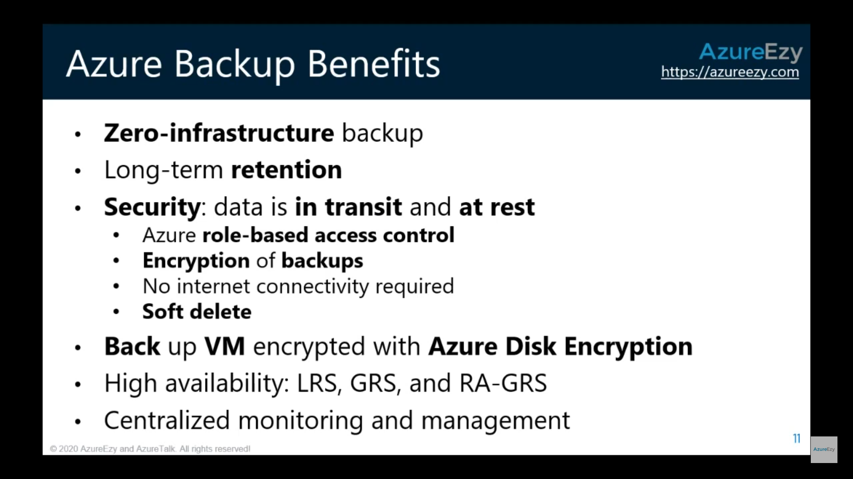

## MARS (Microsoft Azure Recovery Service)

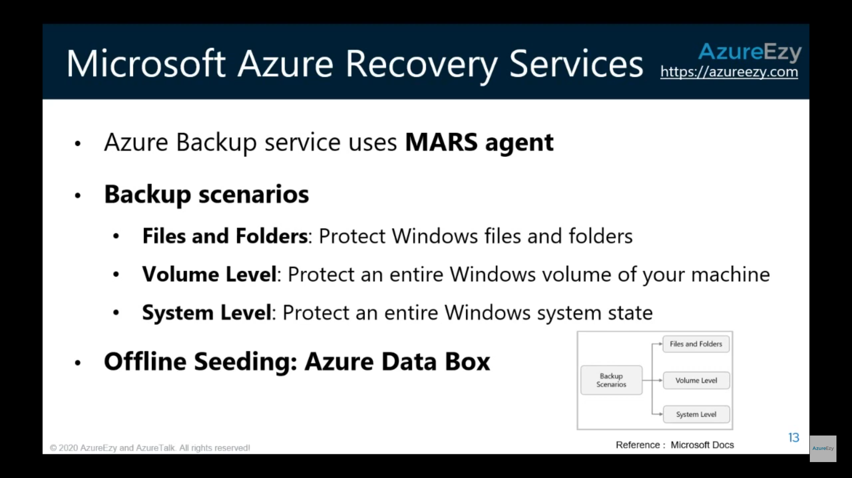

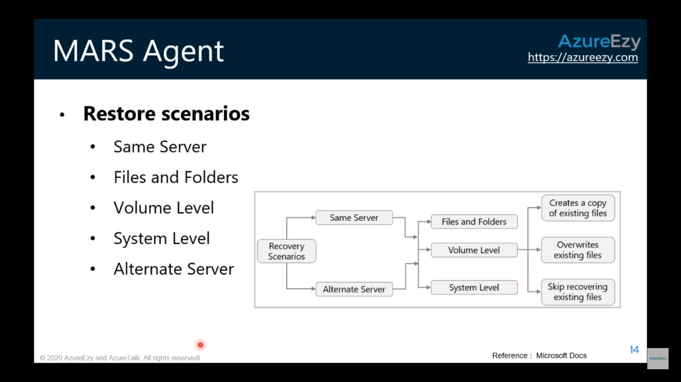

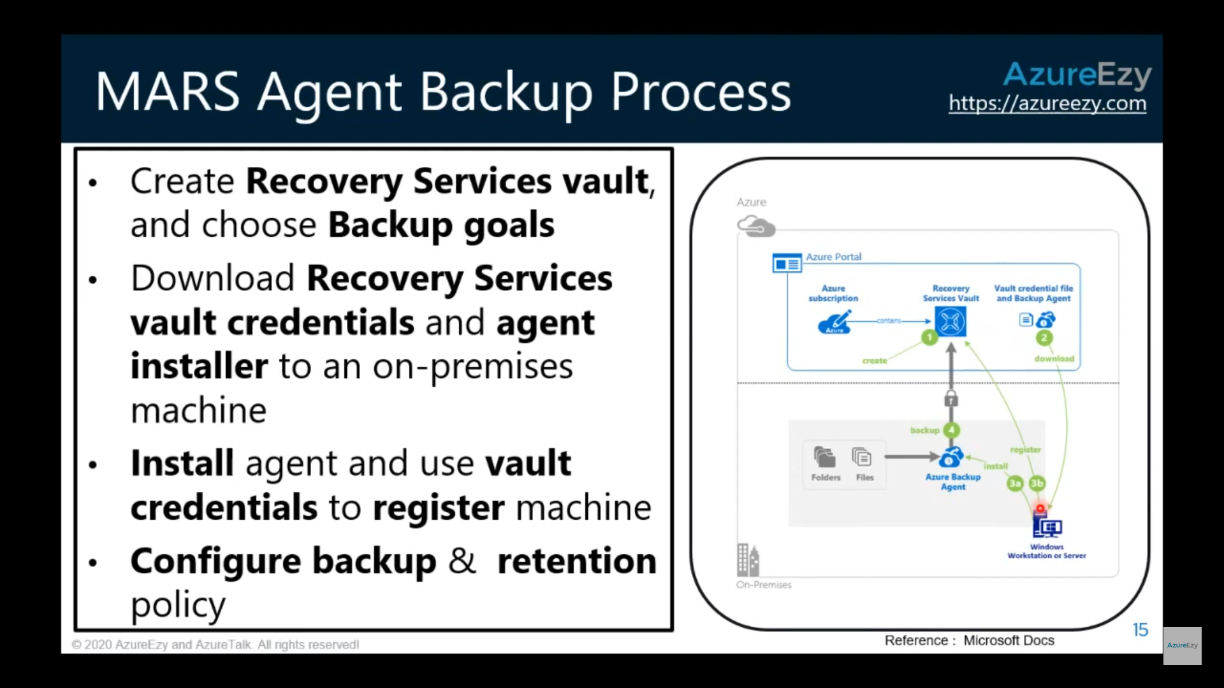

## MABS (Microsoft Azure Backup Server)

On on-prem systems MABS/DPM is used to backup data to Azure or locally.

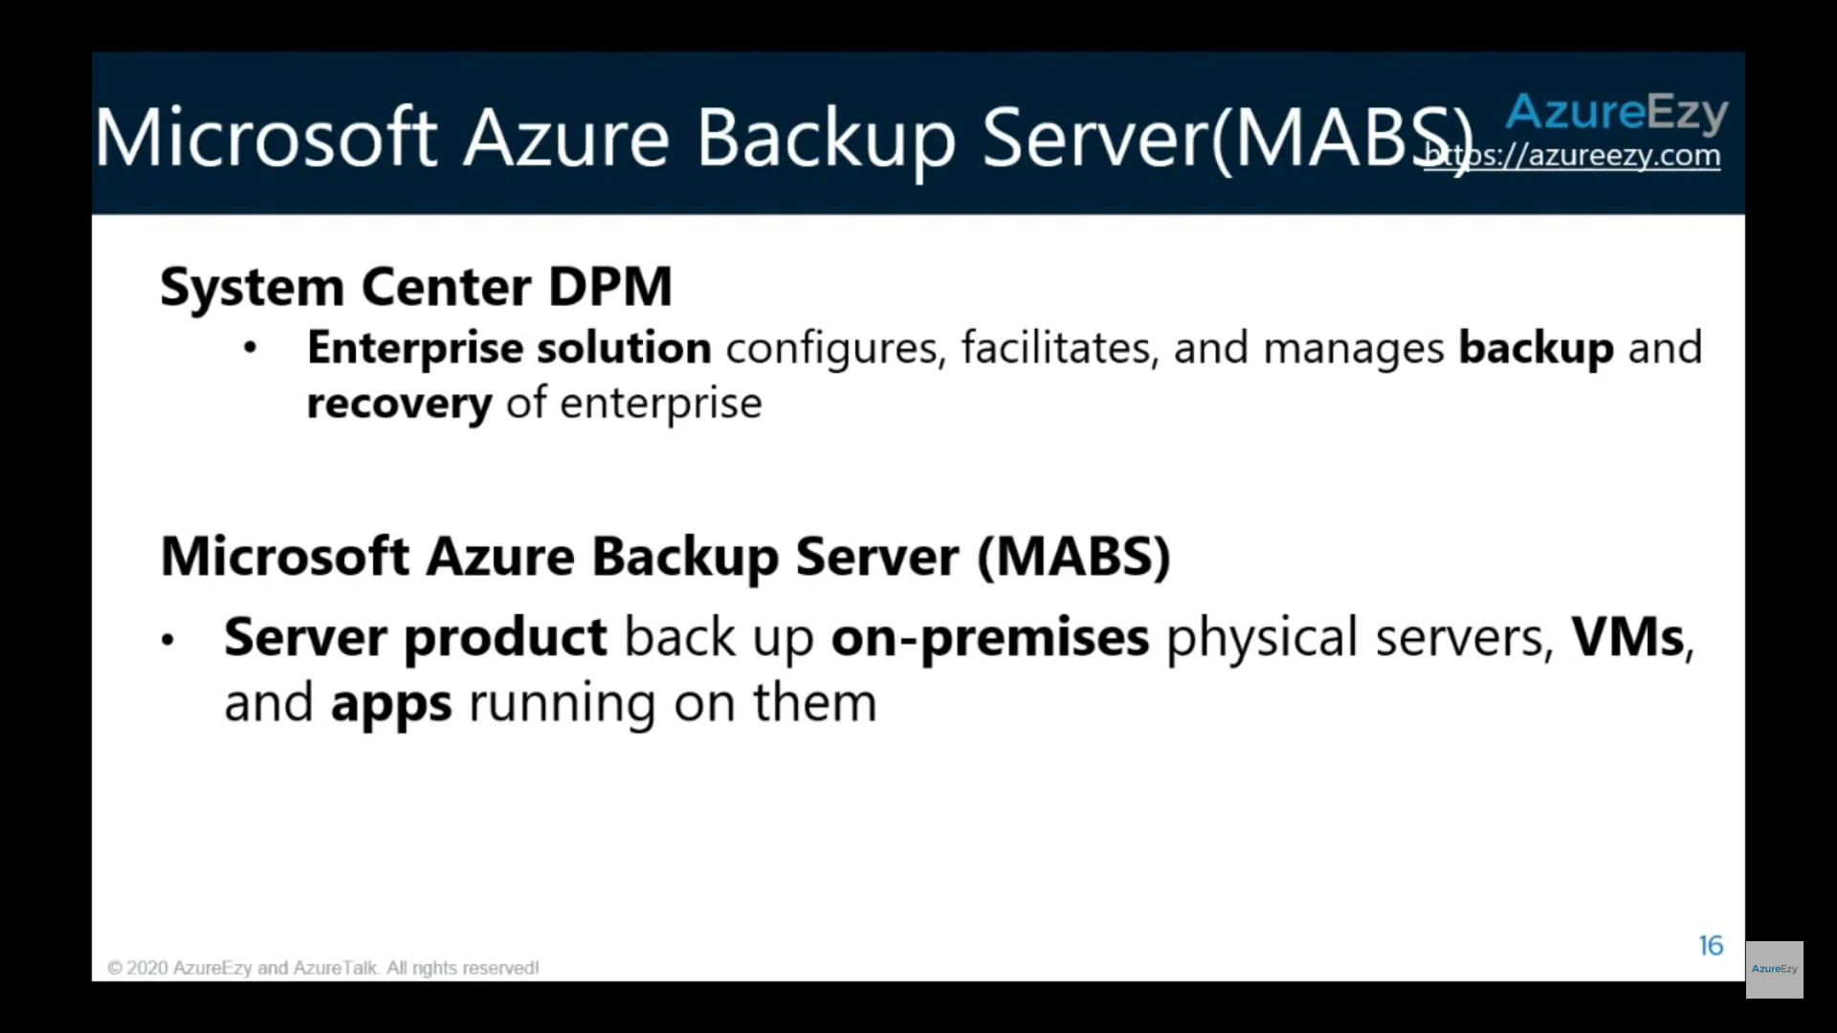

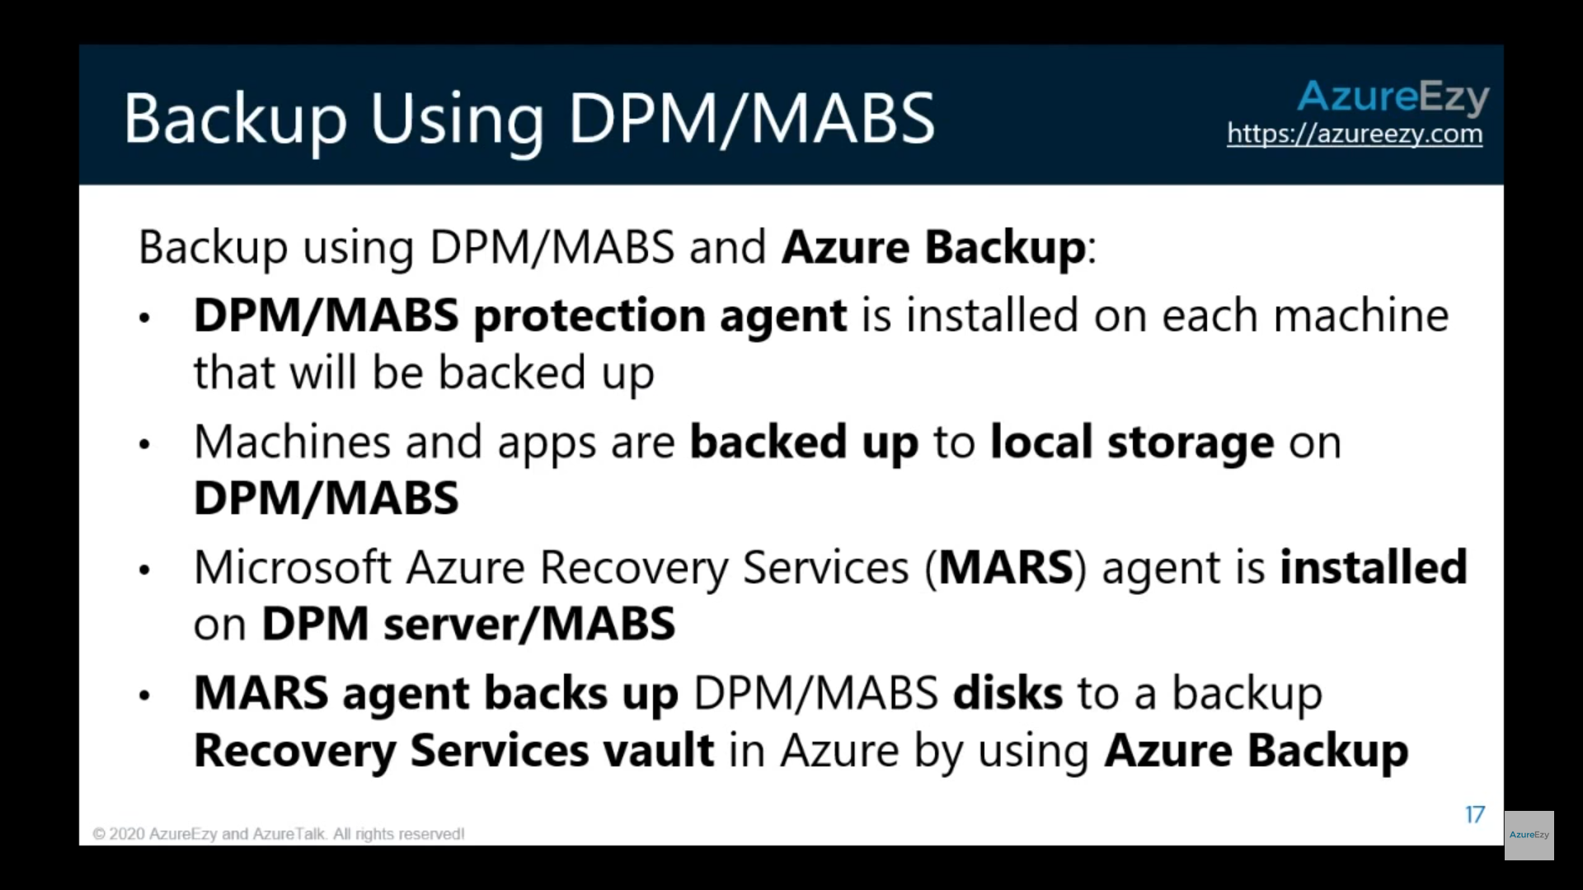

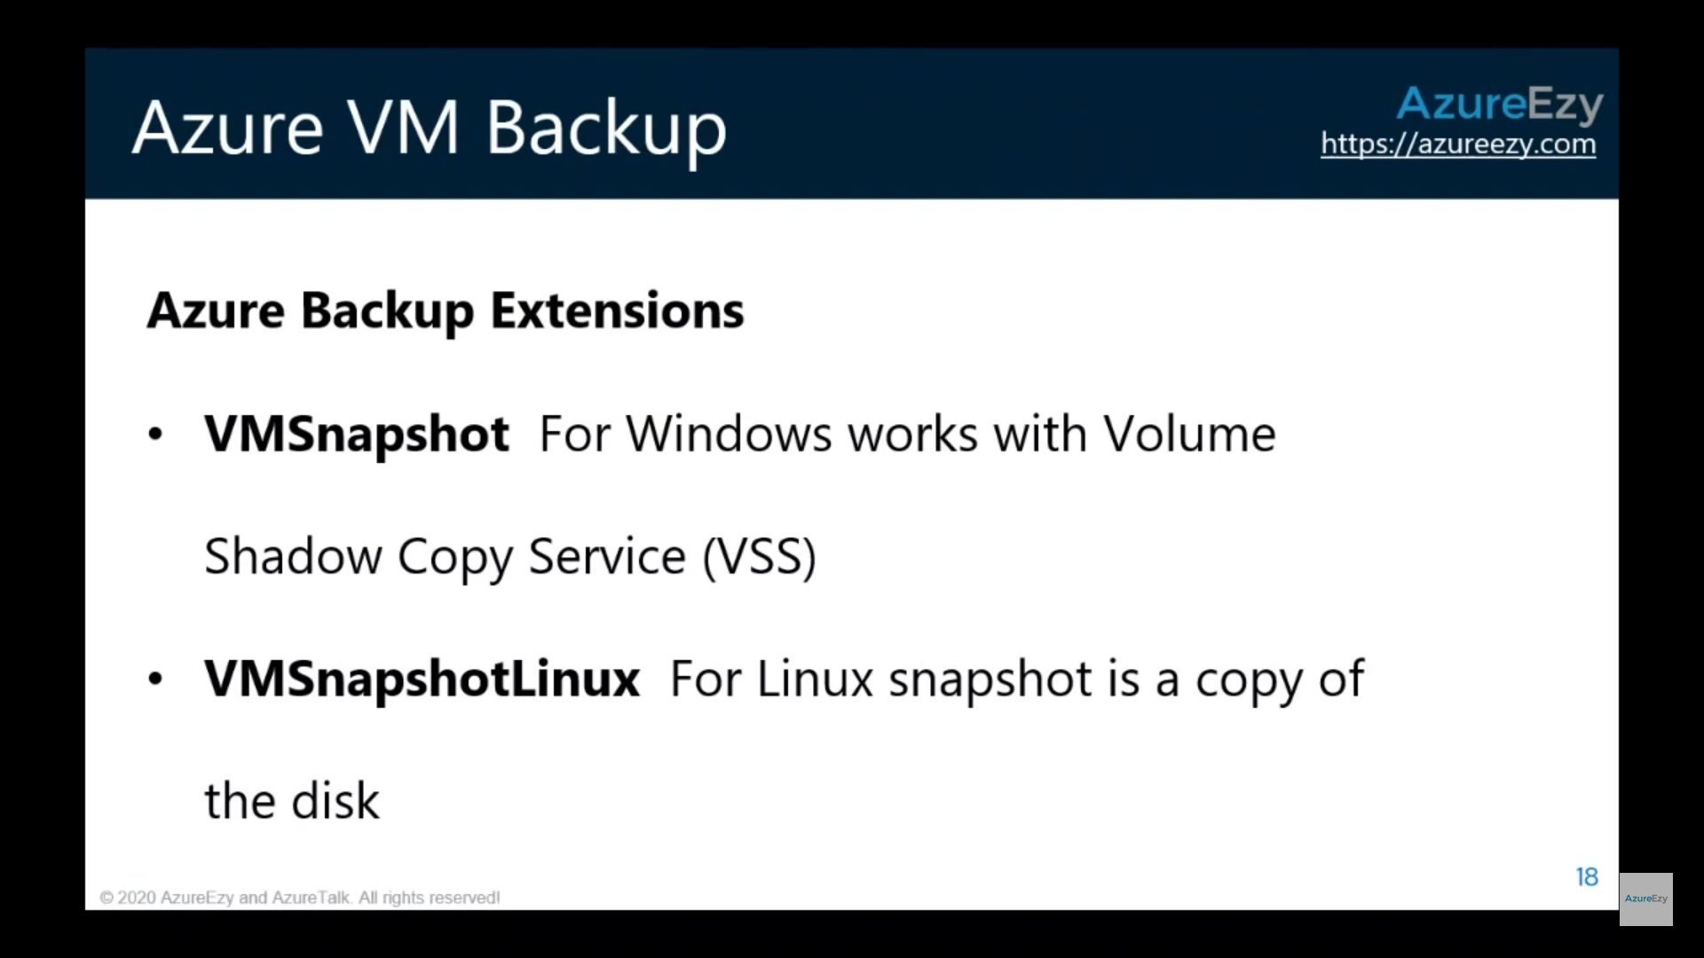

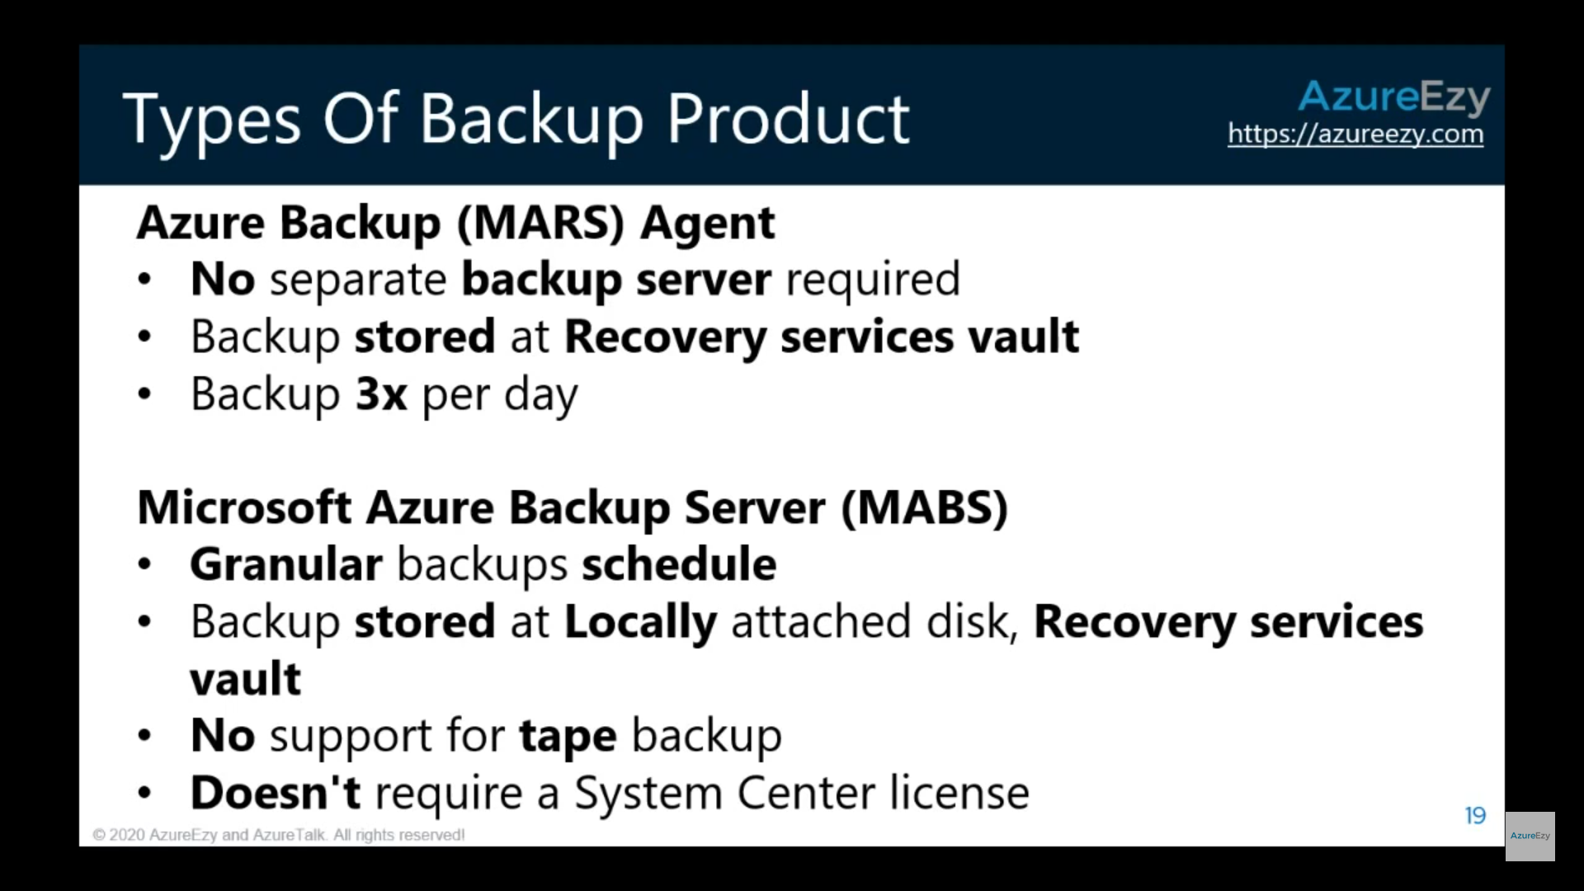

## Backup Consistency

### Crash Consistent

### App consistent

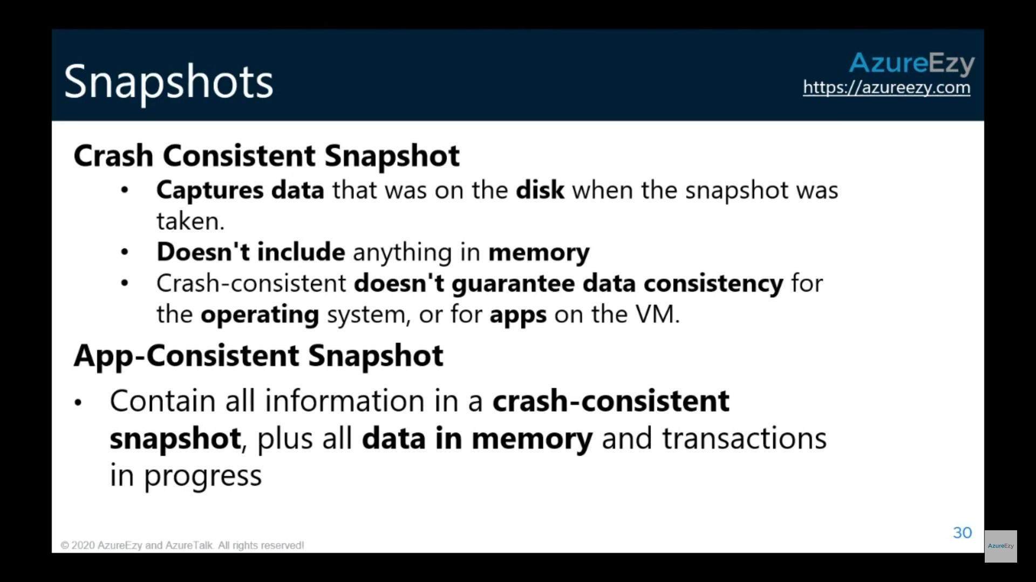

## Instant Restore

<https://docs.microsoft.com/en-us/azure/backup/backup-instant-restore-capability>

Currently, the backup job consists of two phases:

* Taking a VM snapshot.
* Transferring a VM snapshot to the Azure Recovery Services vault.

A recovery point is considered created only after phases 1 and 2 are completed.

As a part of this upgrade, a recovery point is created as soon as the snapshot is finished and this recovery point of snapshot type can be used to perform a restore using the same restore flow. You can identify this recovery point in the Azure portal by using “snapshot” as the recovery point type, and after the snapshot is transferred to the vault, the recovery point type changes to “snapshot and vault”.

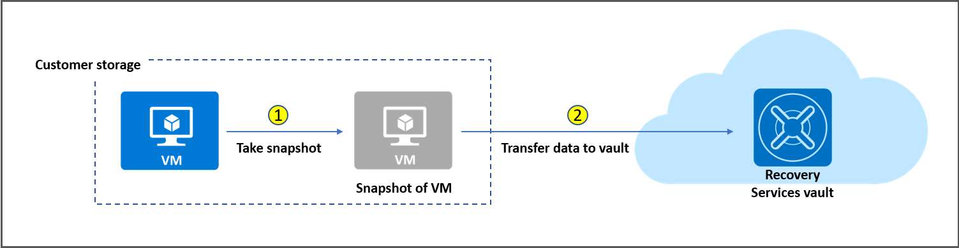

**By default, snapshots are retained for two days**. This feature allows restore operation from these snapshots there by cutting down the restore times. **It reduces the time required to transform and copy data back from the vault**.

## Creating Backup from VM

While creating VM, one can enable Backup by default by choosing “**Backup Policy**”.

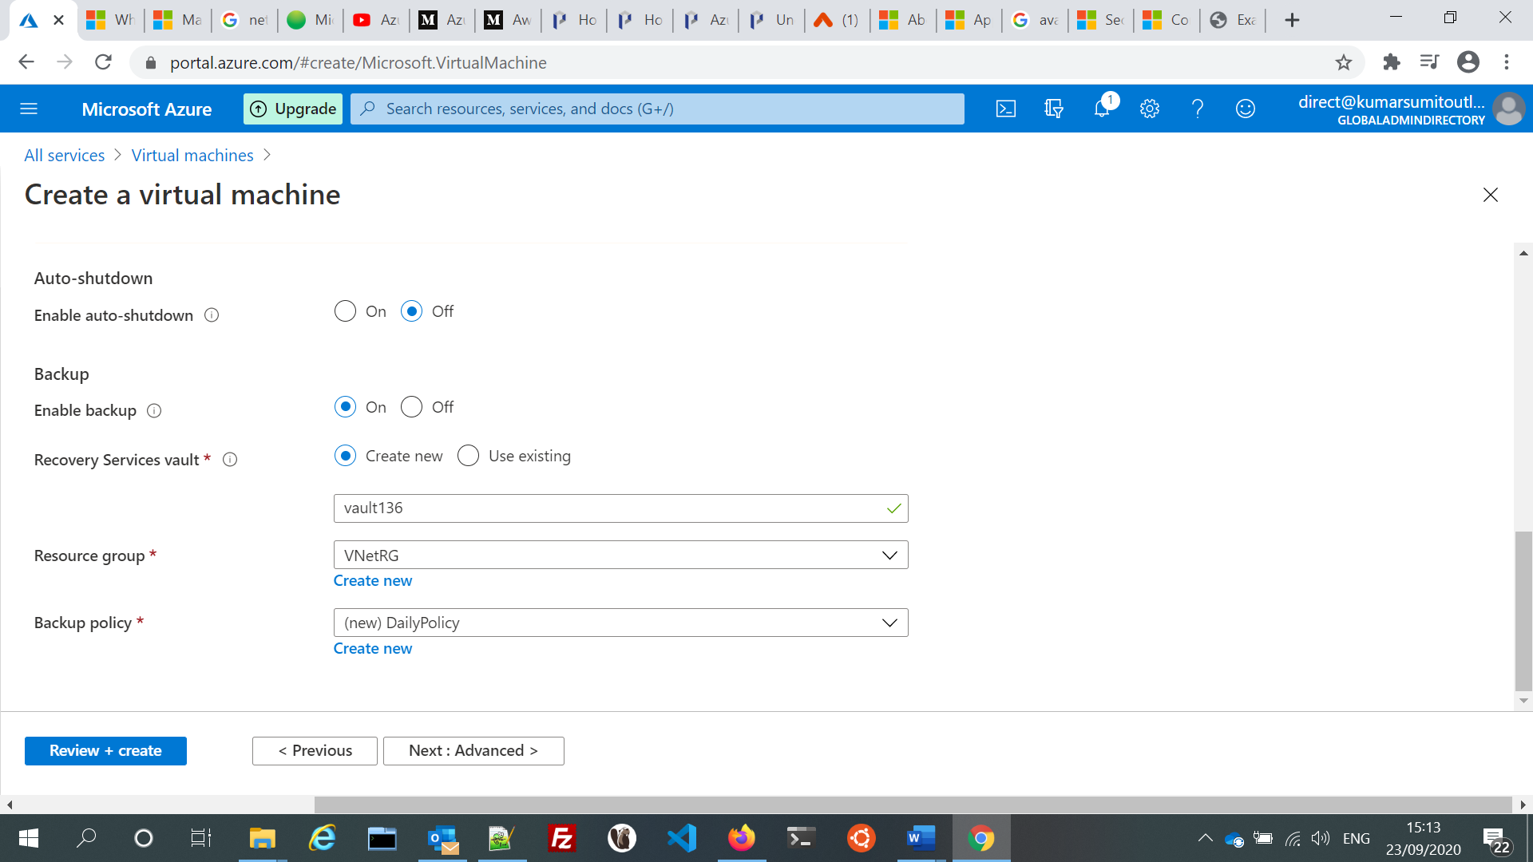

VM Backup process

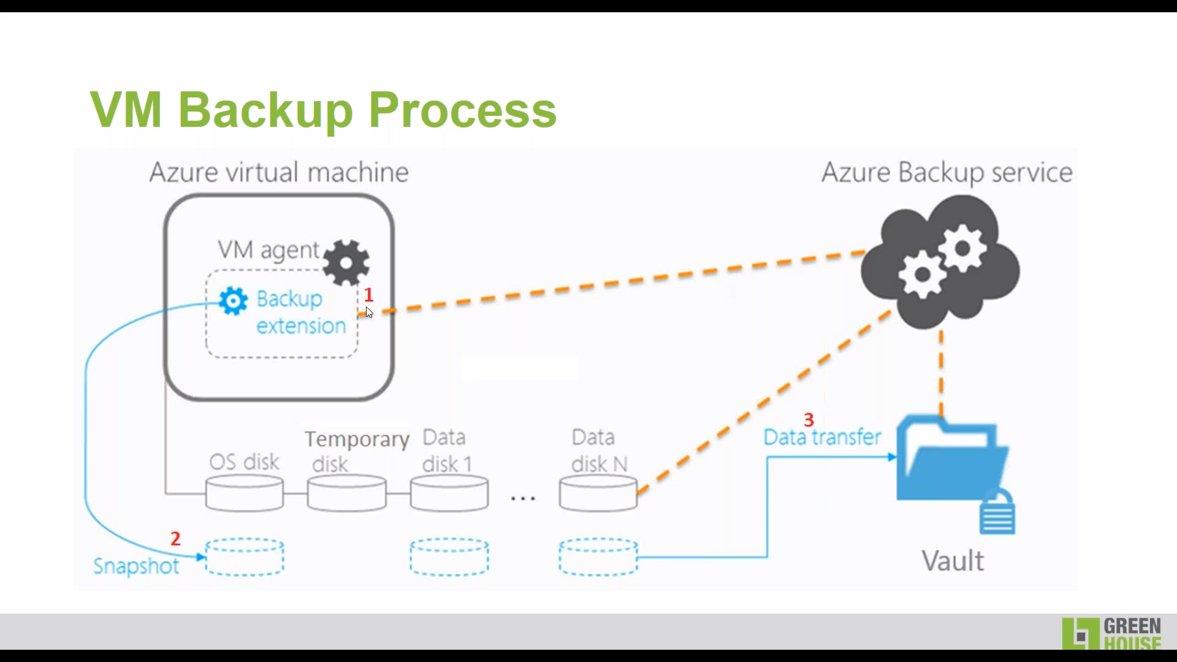

**Only those VMs are visible which are in same region for creating backup from Vault page**.

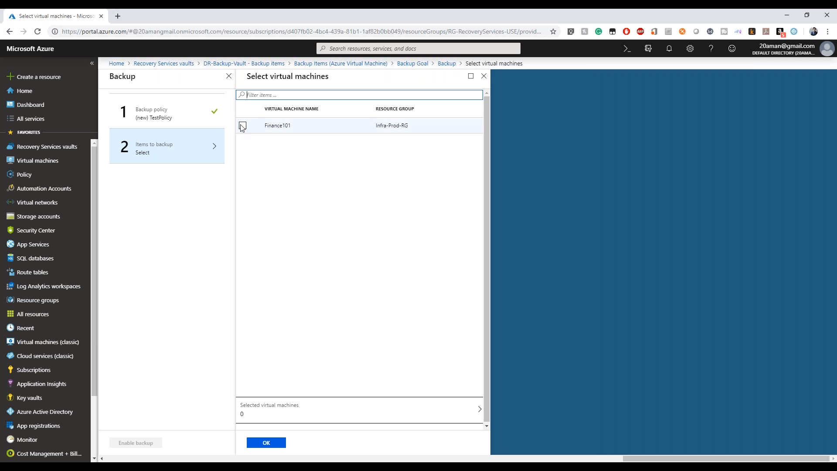

## Restore VM

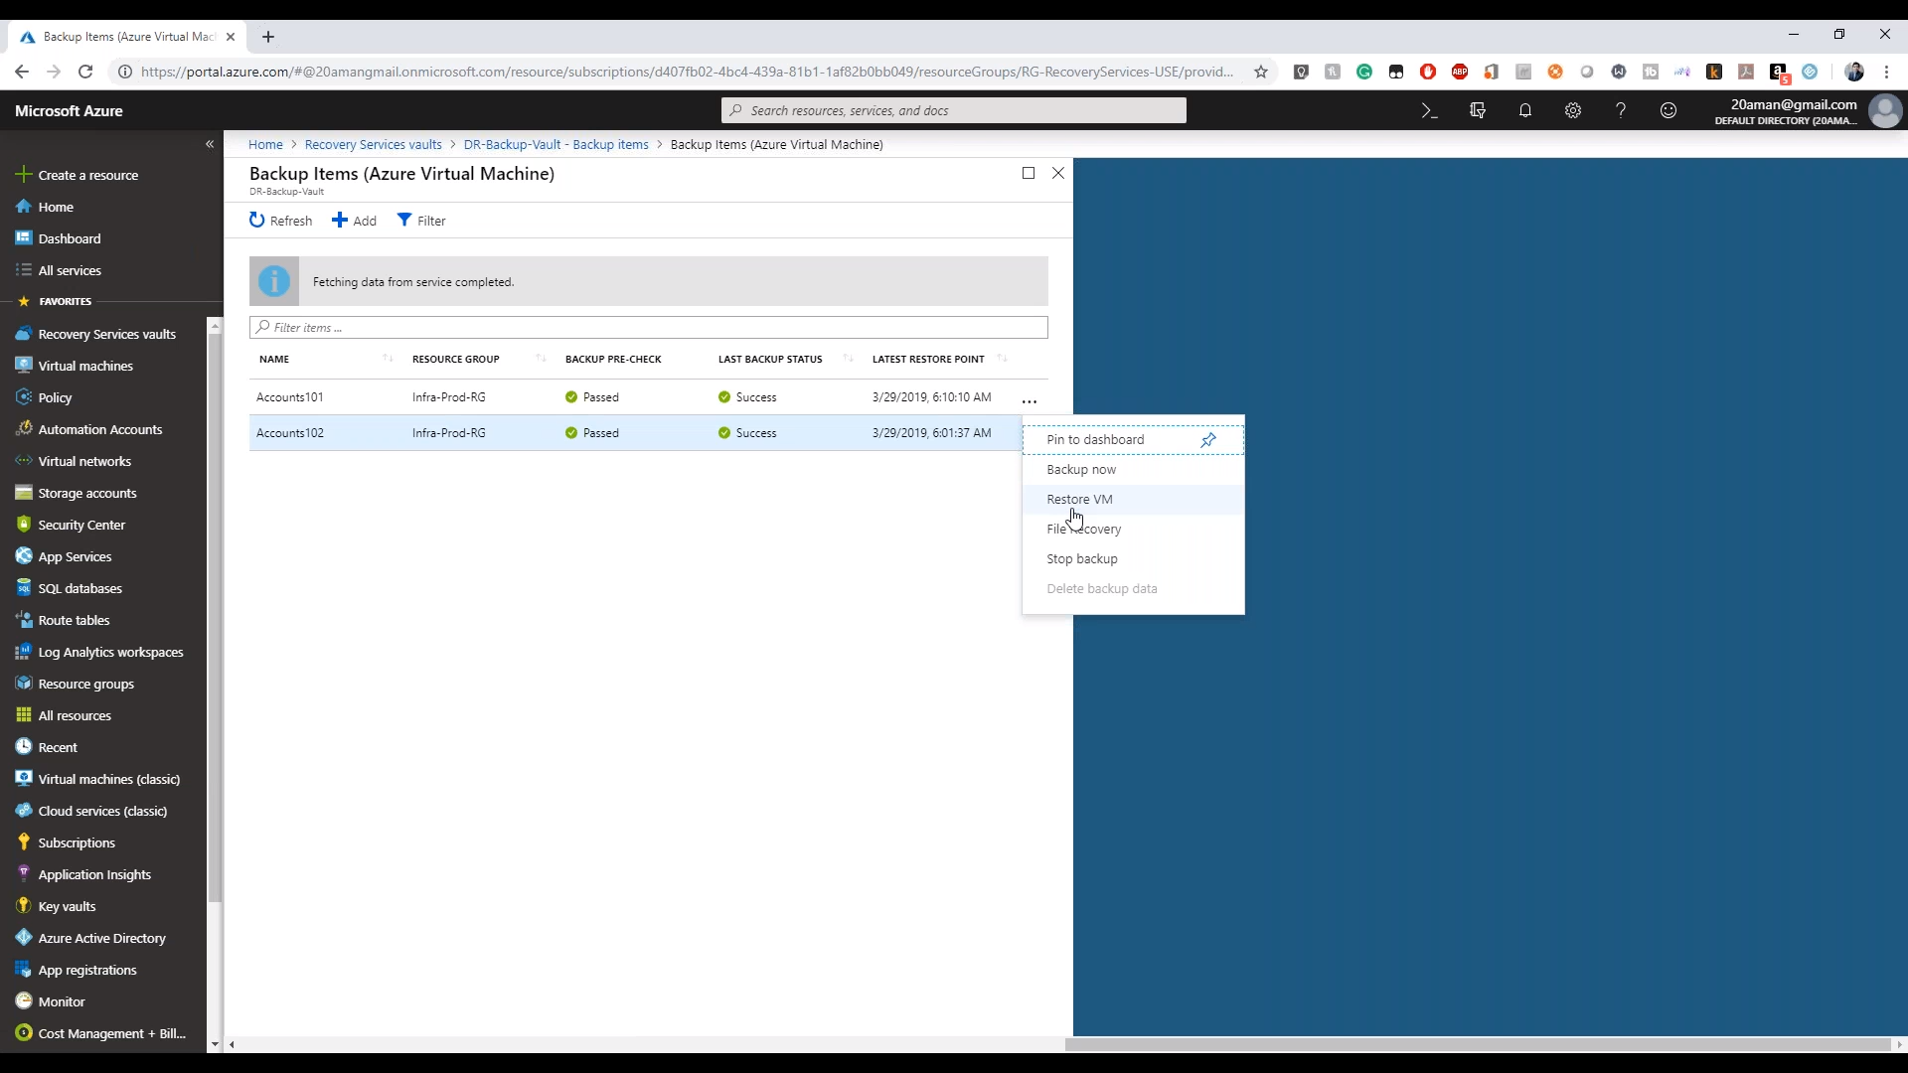

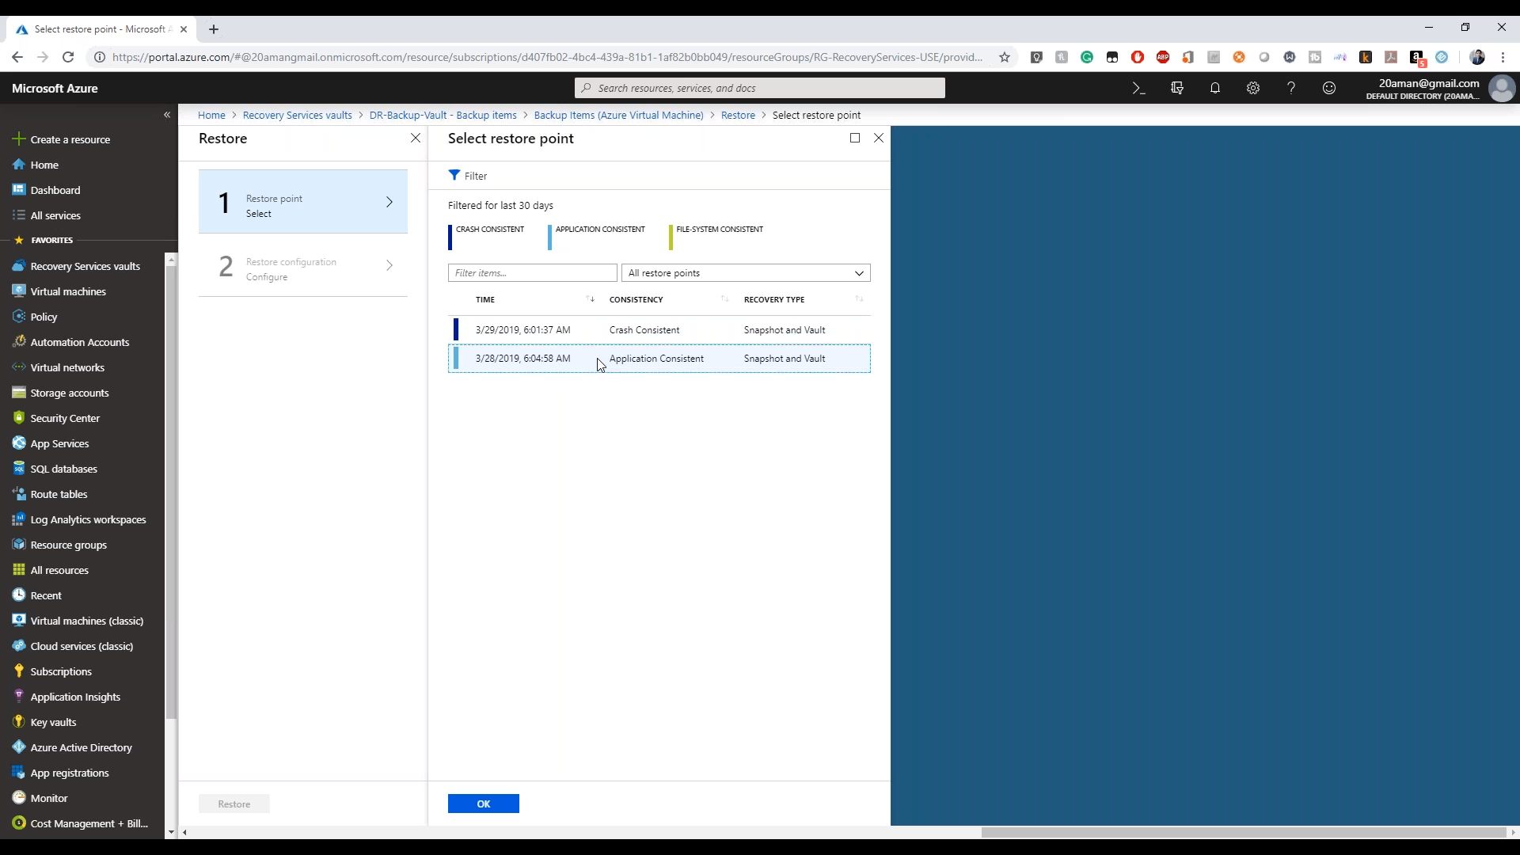

After this one can choose if the **restore type (VM, Resotre Disk)** and if they want it in **new VM or replace the existing VM**

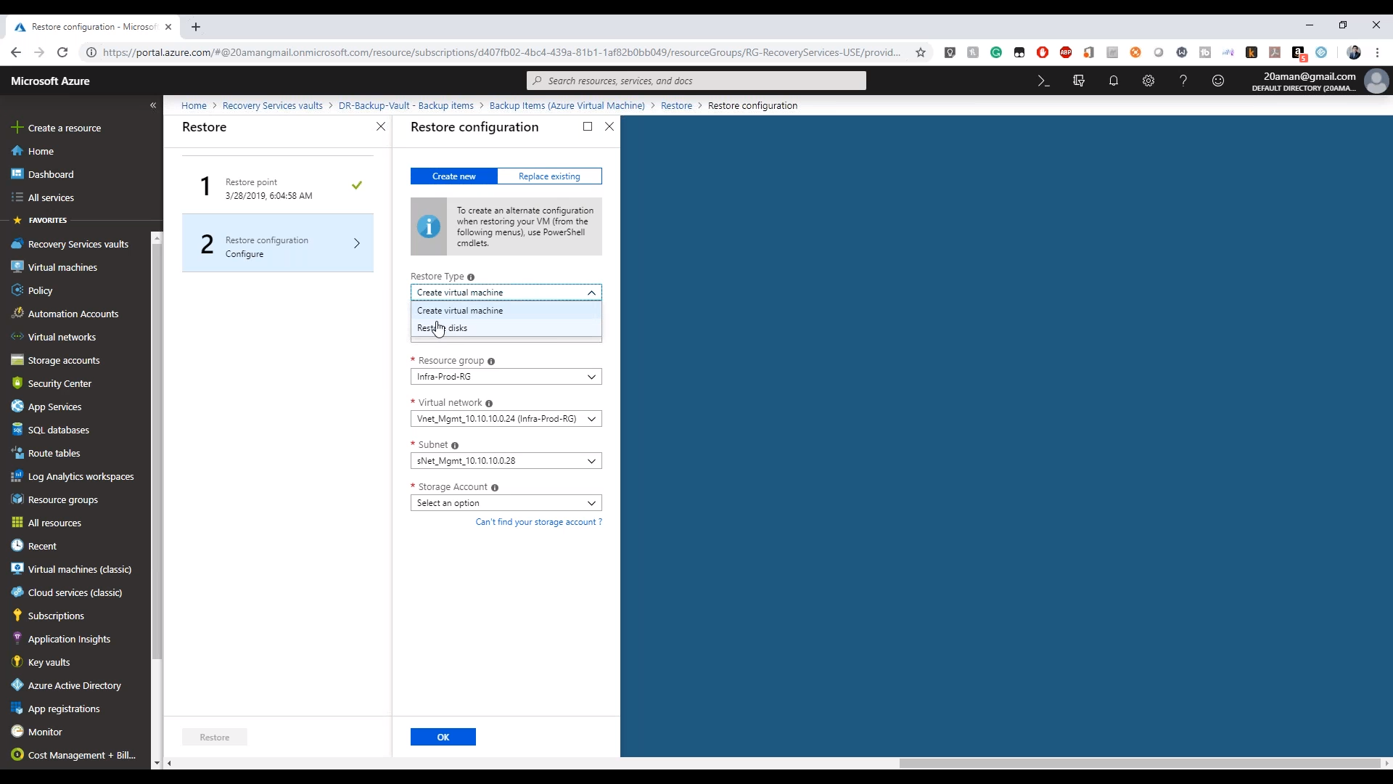

## RBAC and Privileged Identity Management

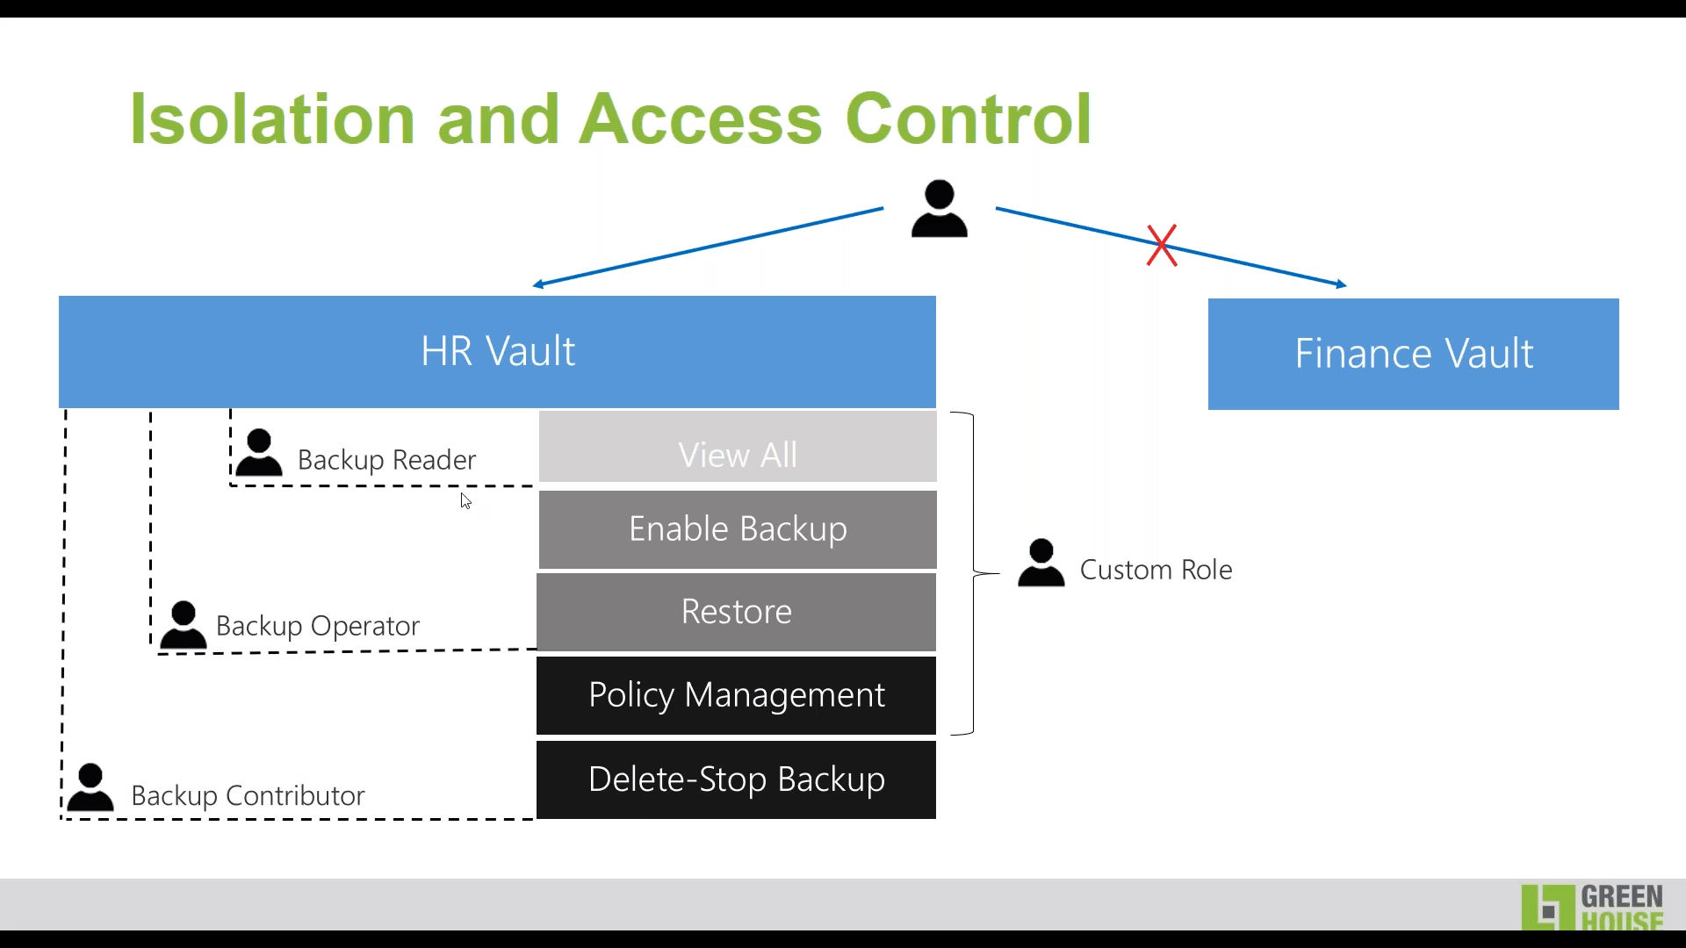

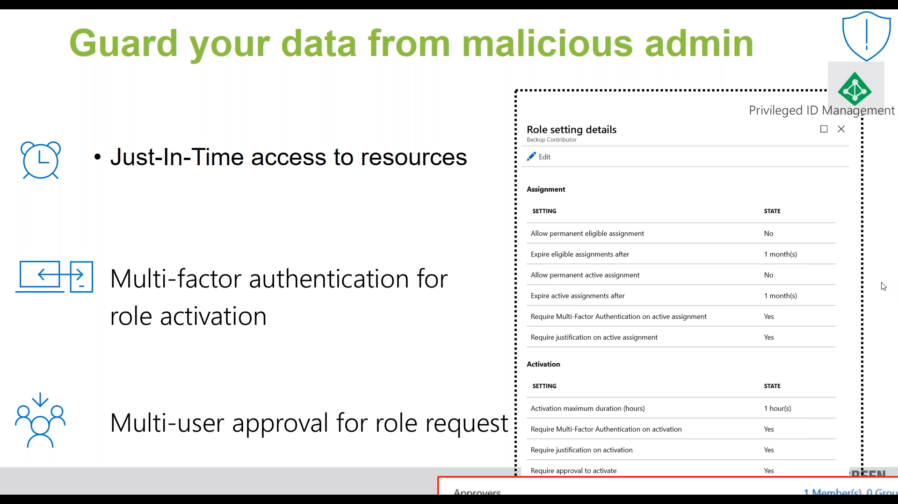

## Security and Alerts

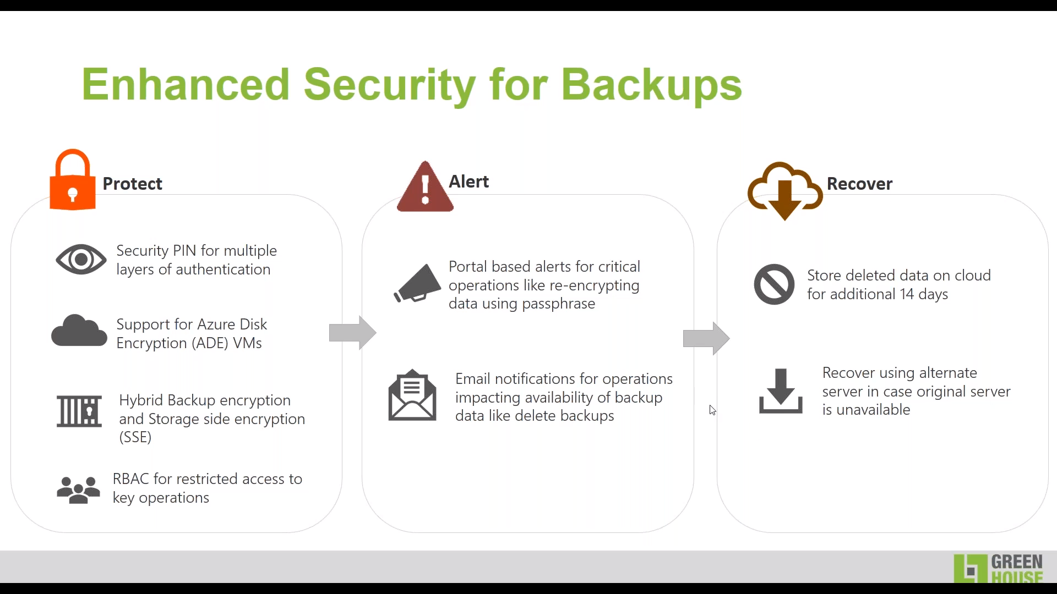

# Azure Site Recovery

<https://docs.microsoft.com/en-us/azure/site-recovery/site-recovery-overview>

<https://www.youtube.com/watch?v=NpAc1XFdkJM>

## Glossry:

RTO : Recovery Time Objectives, How much TIME will it take to recover

RPO: Recovery Point Objectives, How much DATA LOSS will happen until it recovers.



This is a DR tool but earlier it used to be used for migration as well. Now Azure Migrate is the preferred tool for migration.

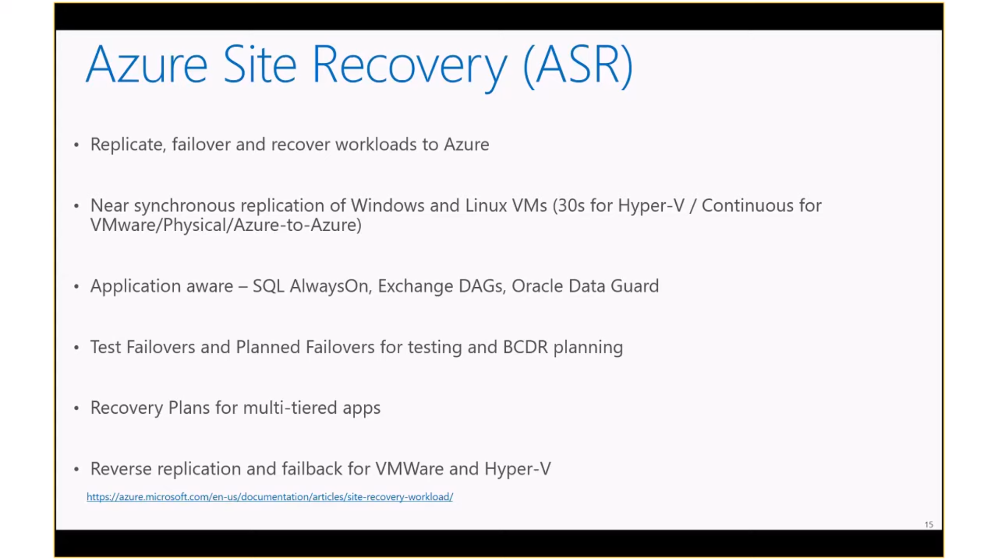

Azure Site Recovery (ASR) supports multiple scenarios, including Disaster Recovery, Migration, and Dev/Test.

* Automated VM level Replication and Failover
  + Continuous log based replication (Not snapshots!)
* RPO of seconds and RTO of minutes
  + 30 seconds, 5 mins, 15 minutes
* Planned and unplanned failover
* Orchestrated Recovery Plans for Disaster Recovery
* Failback support
* No impact DR Drills with Test Failover
* Migrate to Azure from anywhere
* [Azure to Azure DR (NEW)](http://adinermie.com/azure-azure-a2a-disaster-recovery-asr/)
* Create on-demand test copies in Azure

 With Azure Site Recovery, the data being transmitted is never inspected or intercepted. Only the metadata is used for orchestrating replication and failover. Both encryption-in-transit and encryption-at-rest (in Azure) are supported.

BitLocker must be disabled before you enable replication for a machine in ASR and OS disk should be less than 2 TB for VMware environment. In case of Hyper -V data disk can be of size upto 4 TB

**ASR Use Cases**

* Disaster Recovery
  + Single click Application recovery
  + Compliance Assurance without impacting Production
  + Disaster Avoidance – Hurricane warning
  + Failover during real disasters – Fire, Earthquake, etc.
* Migration
  + No impact on production during replication – Just minutes of downtime during cutover
  + Test before migration using Test failover
  + Free Migration
* Dev/Test environment
  + Using Test Failover get an identical copy of your production environment
  + Use this for testing different scenarios like Patch Tuesday, New release testing
  + Deploy new patches/bits to production with confidence.

ASR has three functions:

* Backup
* Recovery
* Migration

## Enable Replication

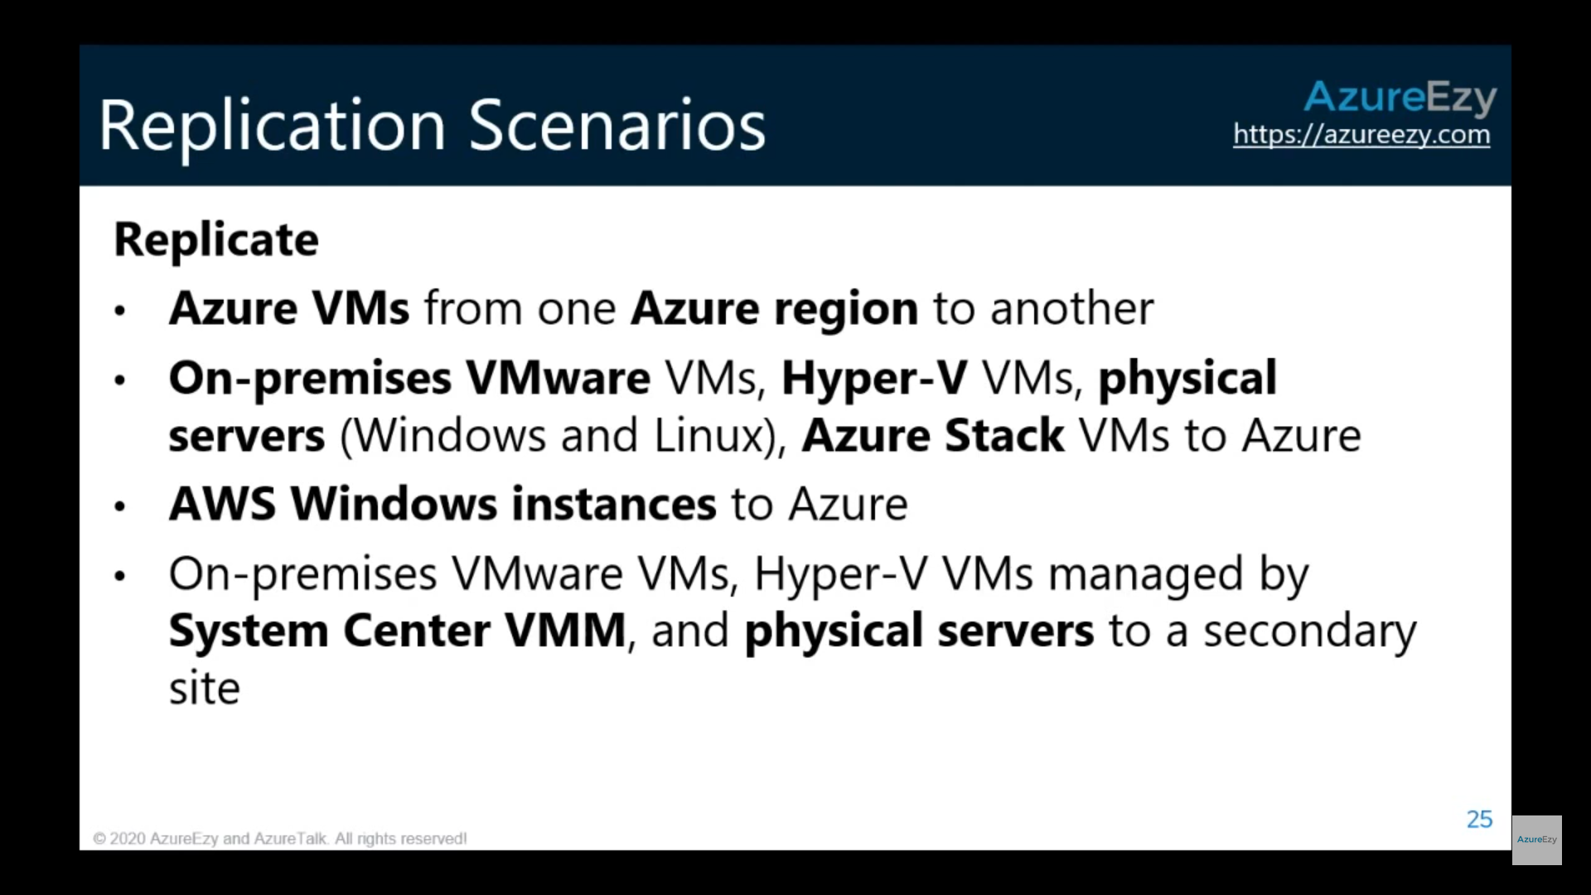

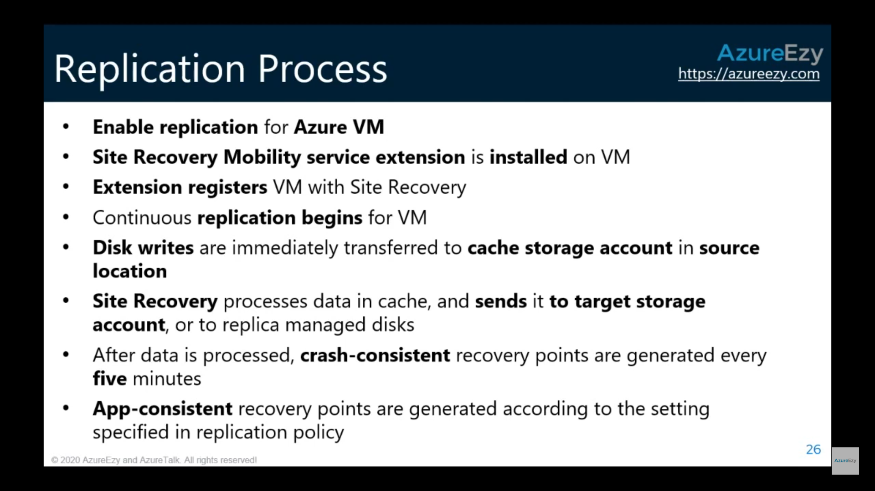

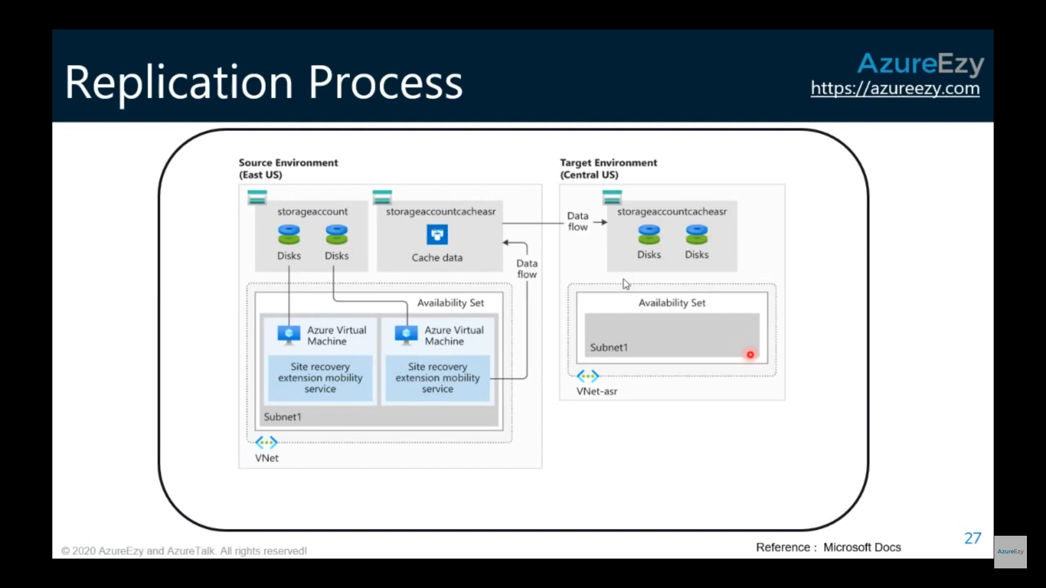

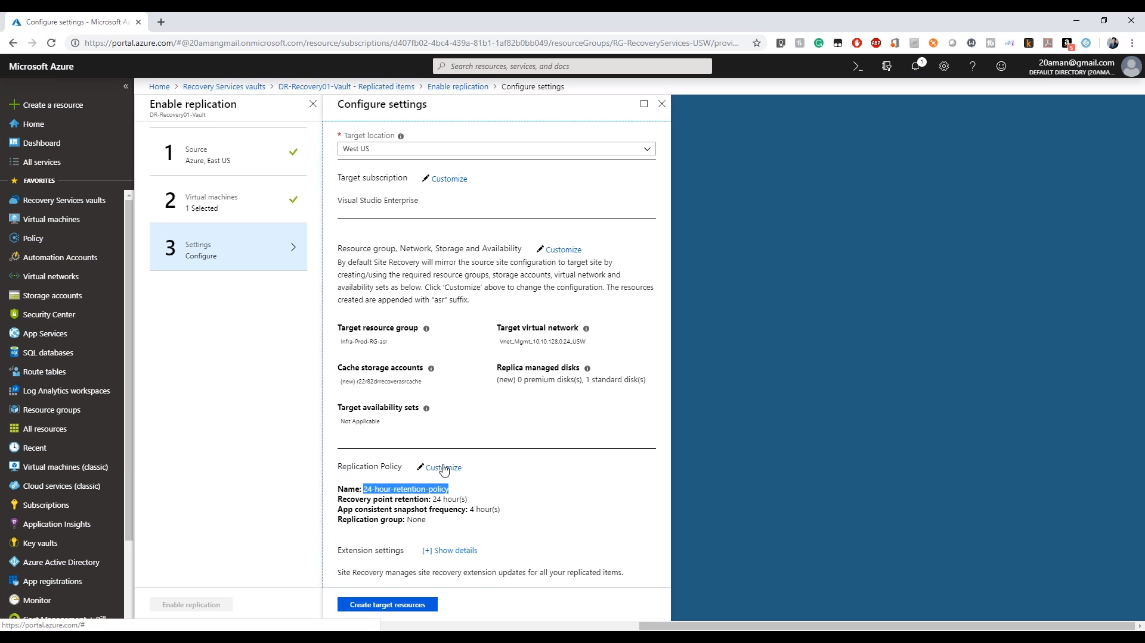

Notice the target location, where on can choose the location where ASR will create the vault.

Also, requirements like:

* Target resource group
* Target virtual network
* Target availability sets
* **Cache storage accounts**
* Replica managed Disks

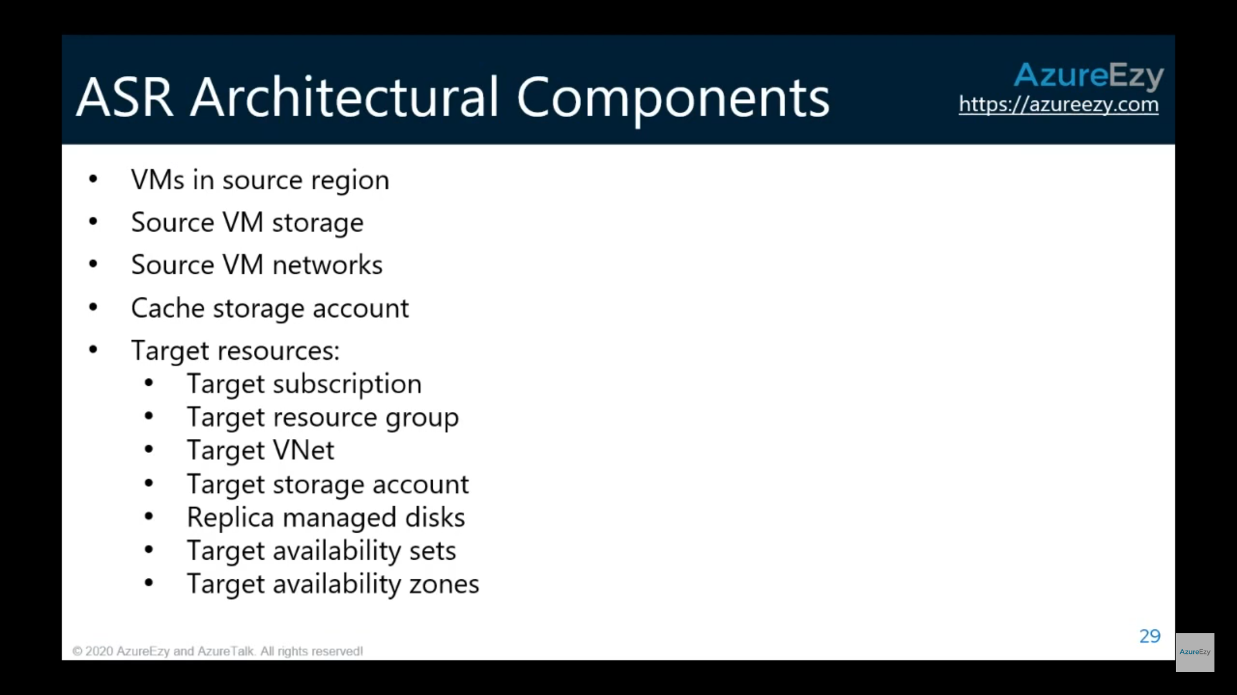

Overview of replicated service

**Note that the VM is in eastUS and replicated disks are in westUS**

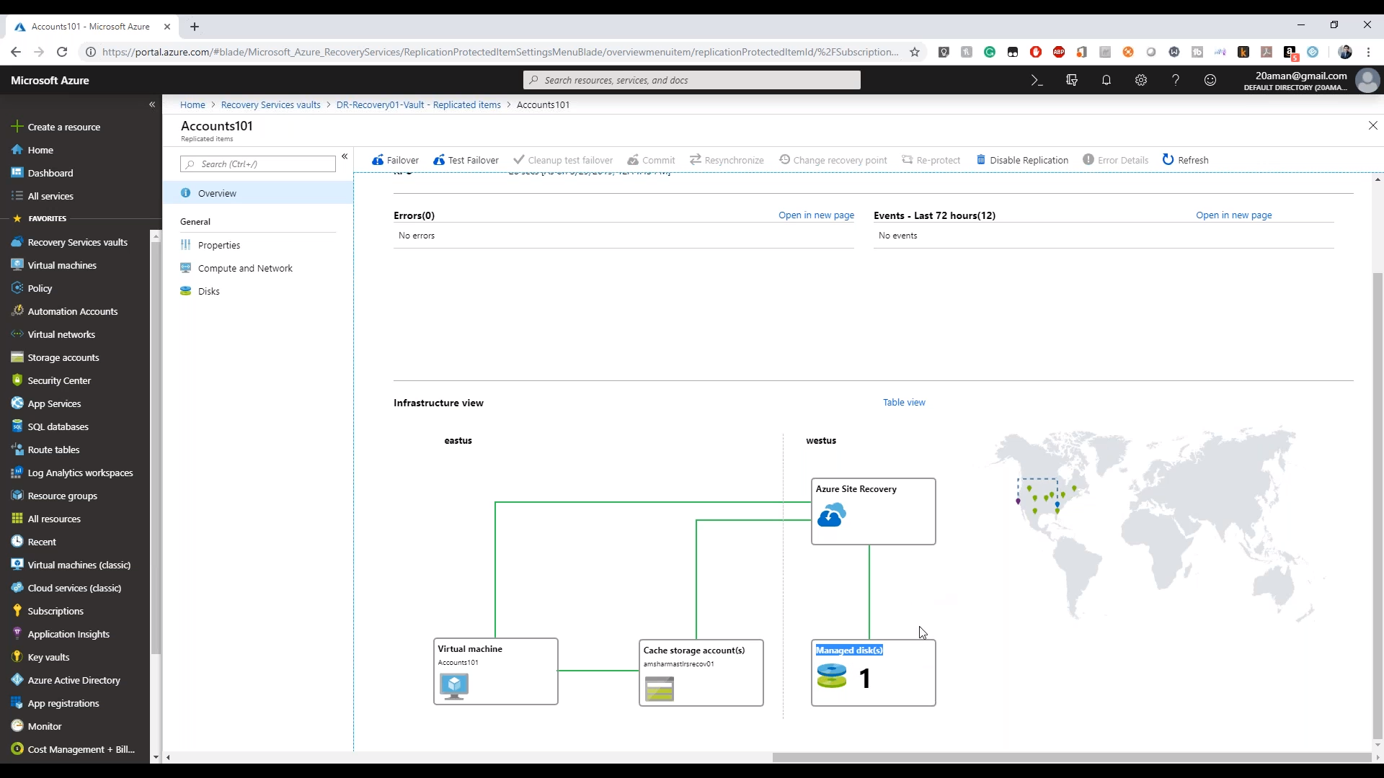

## Failover/Test Failover

Form the overview page one can choose Failover or Test Failover

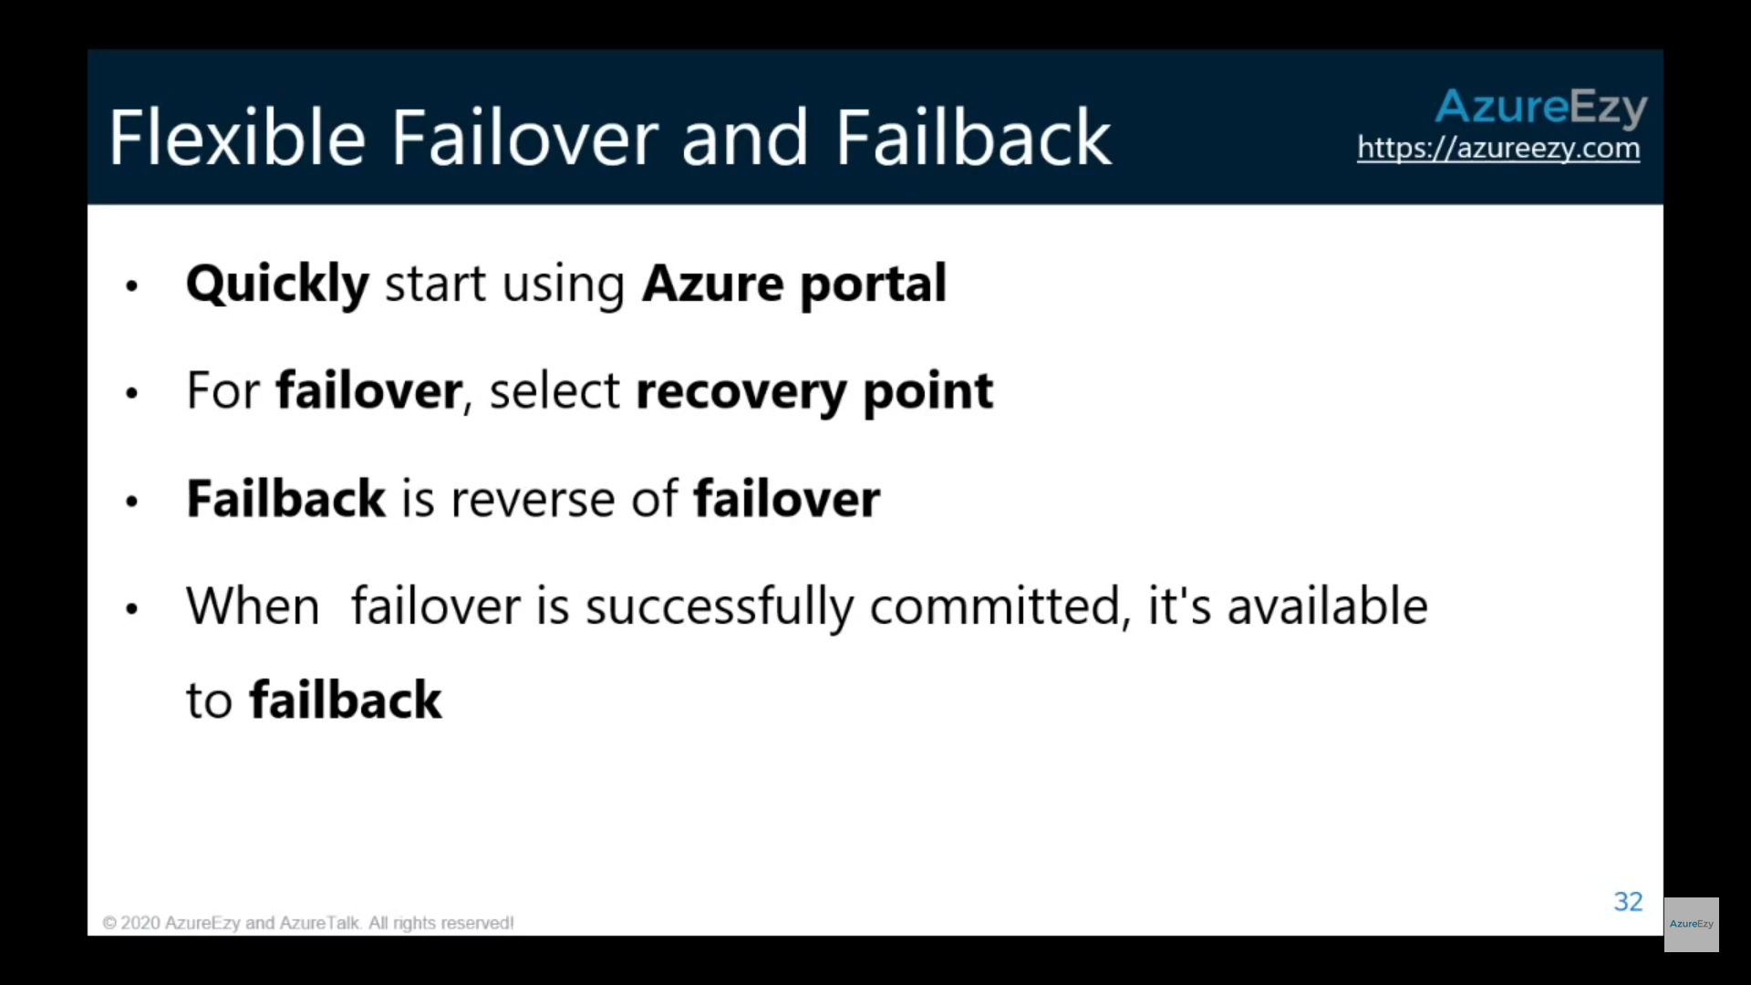

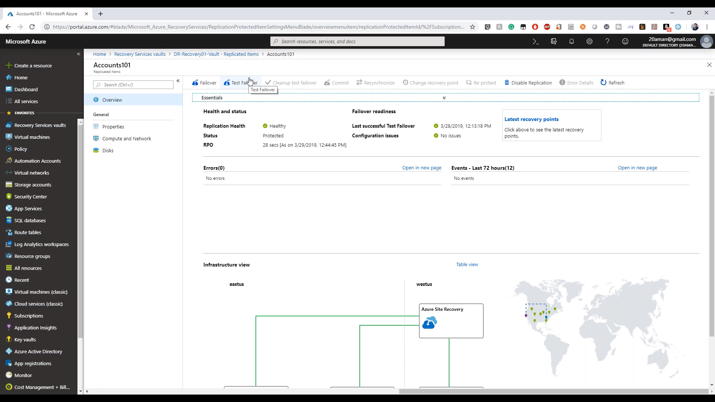

Notice that failover can happen from different regions.

Also, you have four **recovery points**:

* Latest
* Latest processed
* Latest app consistent
* Custom

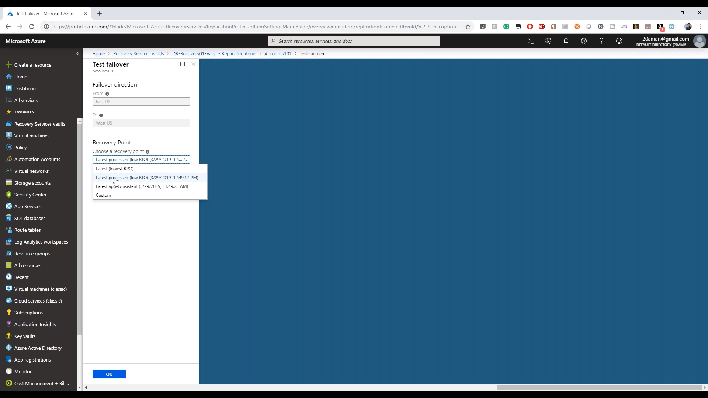

<https://docs.microsoft.com/en-us/azure/site-recovery/migrate-tutorial-on-premises-azure>

The correct steps are as follows: Create a recovery services vault. Select a replication goal. Set up the source and target environment. Setup a replication policy. Enable replication. Run a migration test. Run a onetime failover to Azure.

the recovery service vault has to be in the same region as the virtual machines.

<https://docs.microsoft.com/bs-cyrl-ba/azure/backup/backup-create-rs-vault>

## Disaster recovery of on-premises VMs

<https://docs.microsoft.com/en-us/azure/site-recovery/hyper-v-azure-tutorial>

Microsoft Azure Site Recovery Provider is required to be installed on-prem for recovery.

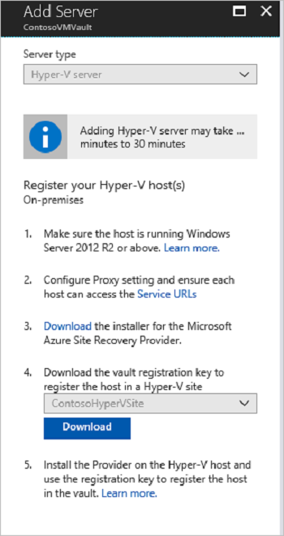

# Azure Migrate

<https://docs.microsoft.com/en-us/azure/migrate/migrate-services-overview>

<https://www.youtube.com/watch?v=JEveC534tQk>

This is agentless service. Azure Migrate tools include Server Assessment and Azure Migrate: Server Migration. Azure Migrate also integrates with other Azure services and tools, and with independent software vendor (ISV) offerings.

In the Azure Migrate hub, you can assess and migrate:

* **Servers**: Assess on-premises servers and migrate them to Azure virtual machines or Azure VMware Solution (AVS) (Preview).
* **Databases**: Assess on-premises databases and migrate them to Azure SQL Database or to SQL Managed Instance.
* **Web applications**: Assess on-premises web applications and migrate them to Azure App Service by using the Azure App Service Migration Assistant.
* **Virtual desktops**: Assess your on-premises virtual desktop infrastructure (VDI) and migrate it to Windows Virtual Desktop in Azure.
* **Data**: Migrate large amounts of data to Azure quickly and cost-effectively using Azure Data Box products.
* The Azure Migrate hub includes these tools:

| Integrated tools | | |
| --- | --- | --- |
| **Tool** | **Assess and migrate** | **Details** |
| **Azure Migrate: Server Assessment** | Assess servers. | Discover and assess on-premises VMware VMs, Hyper-V VMs, and physical servers in preparation for migration to Azure. |
| **Azure Migrate: Server Migration** | Migrate servers. | Migrate VMware VMs, Hyper-V VMs, physical servers, other virtualized machines, and public cloud VMs to Azure. |
| **Data Migration Assistant** | Assess SQL Server databases for migration to Azure SQL Database, Azure SQL Managed Instance, or Azure VMs running SQL Server. | Data Migration Assistant helps pinpoint potential problems blocking migration. It identifies unsupported features, new features that can benefit you after migration, and the right path for database migration. [Learn more](https://docs.microsoft.com/en-us/sql/dma/dma-overview?view=sql-server-2017). |
| **Azure Database Migration Service** | Migrate on-premises databases to Azure VMs running SQL Server, Azure SQL Database, or SQL Managed Instances. | [Learn more](https://docs.microsoft.com/en-us/azure/dms/dms-overview) about Database Migration Service. |
| **Movere** | Assess servers. | [Learn more](https://docs.microsoft.com/en-us/azure/migrate/migrate-services-overview#movere) about Movere. |
| **Web app migration assistant** | Assess on-premises web apps and migrate them to Azure. | Use Azure App Service Migration Assistant to assess on-premises websites for migration to Azure App Service.  Use Migration Assistant to migrate .NET and PHP web apps to Azure. [Learn more](https://appmigration.microsoft.com/) about Azure App Service Migration Assistant. |
| **Azure Data Box** | Migrate offline data. | Use Azure Data Box products to move large amounts of offline data to Azure. [Learn more](https://docs.microsoft.com/en-us/azure/databox/). |

<https://www.youtube.com/watch?v=0s2ZqHgieT0>

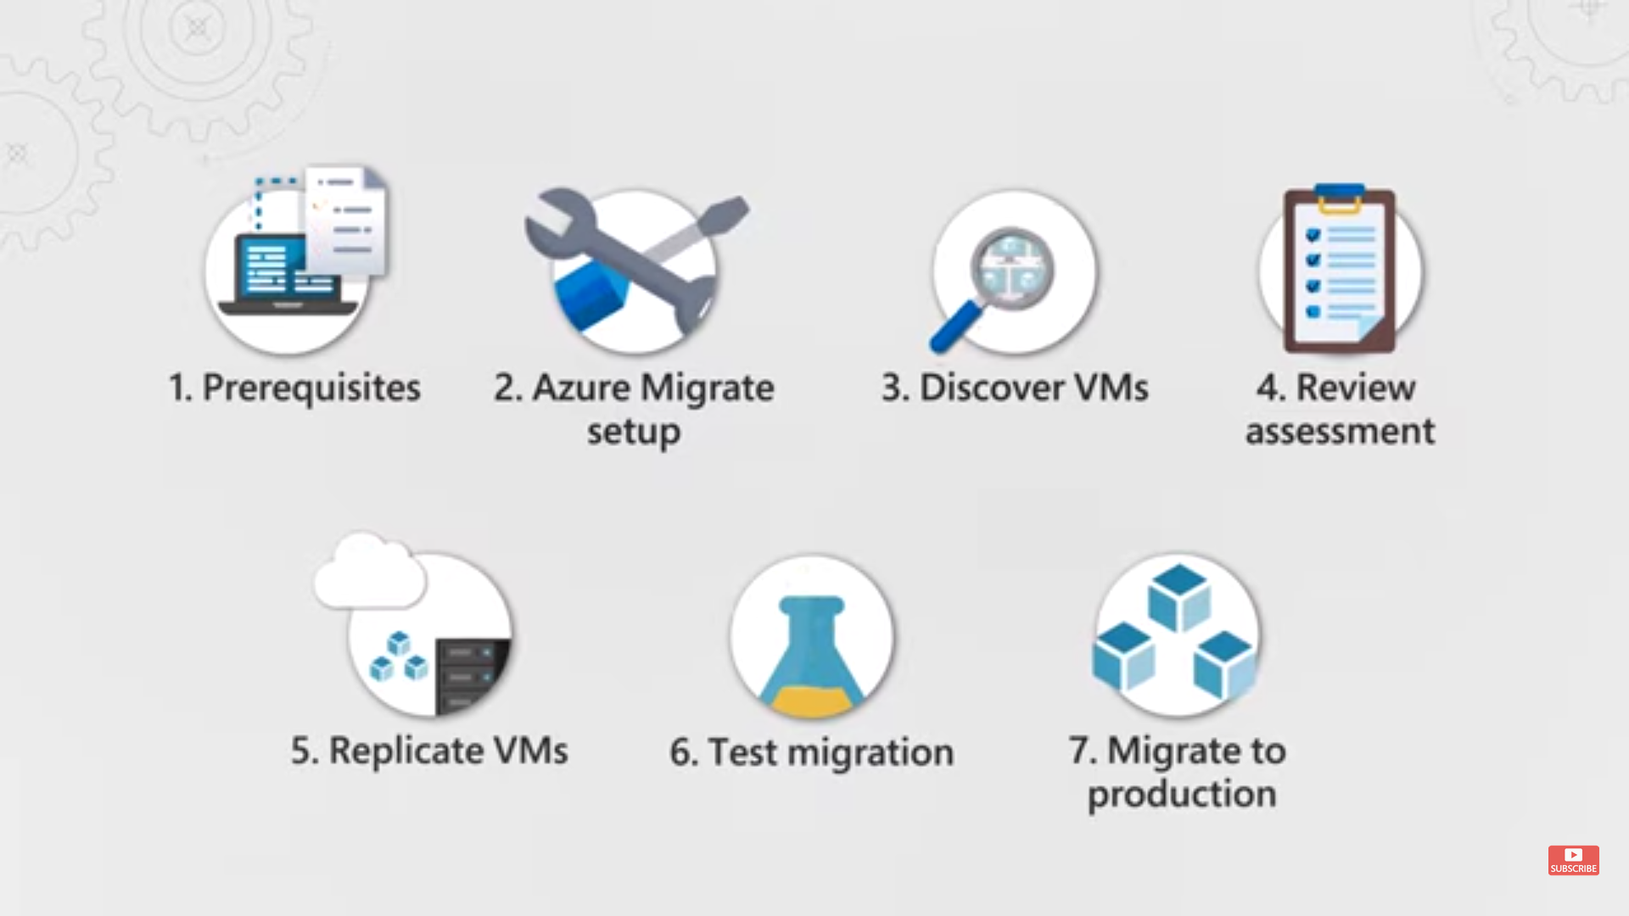

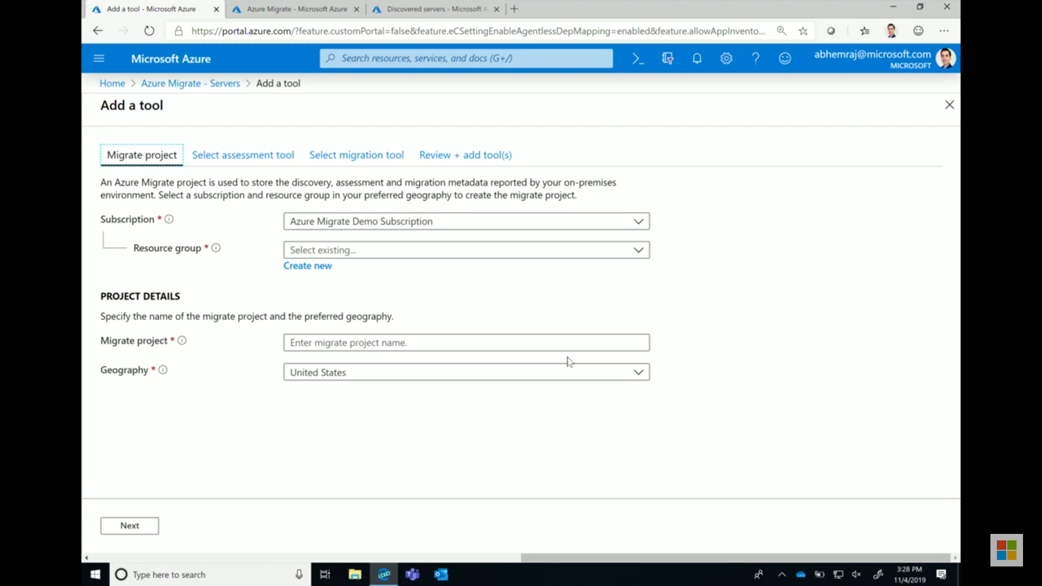

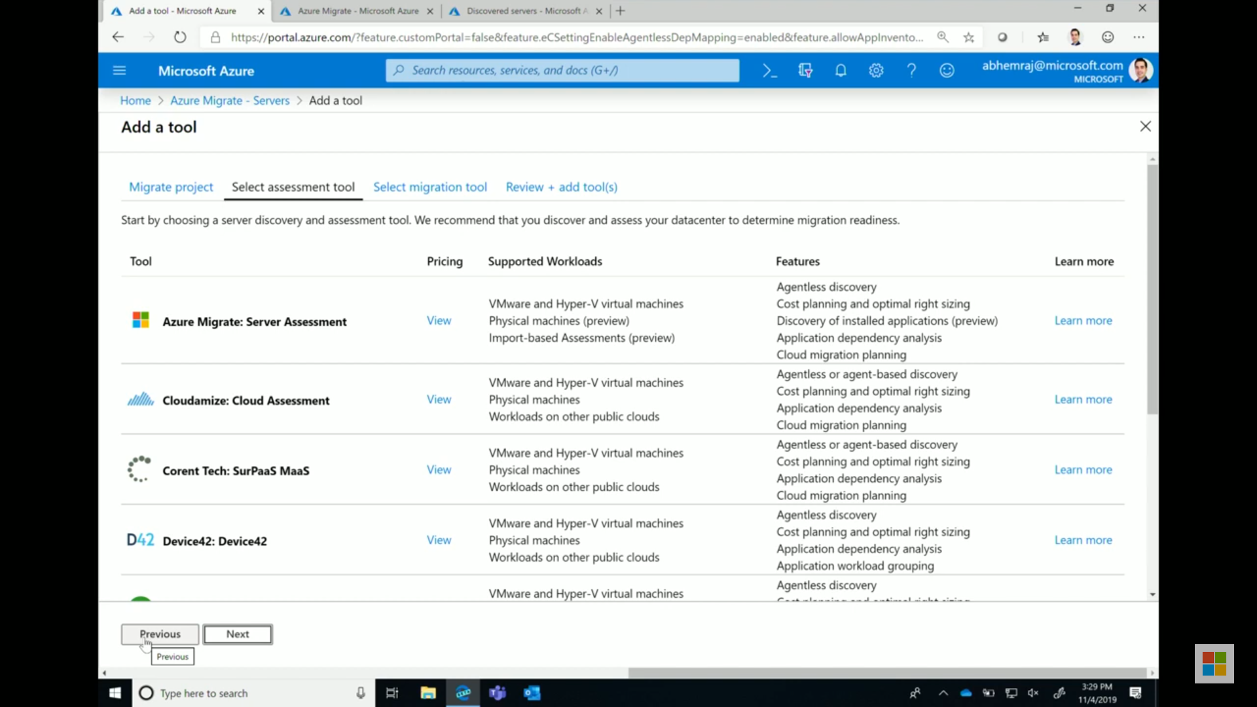

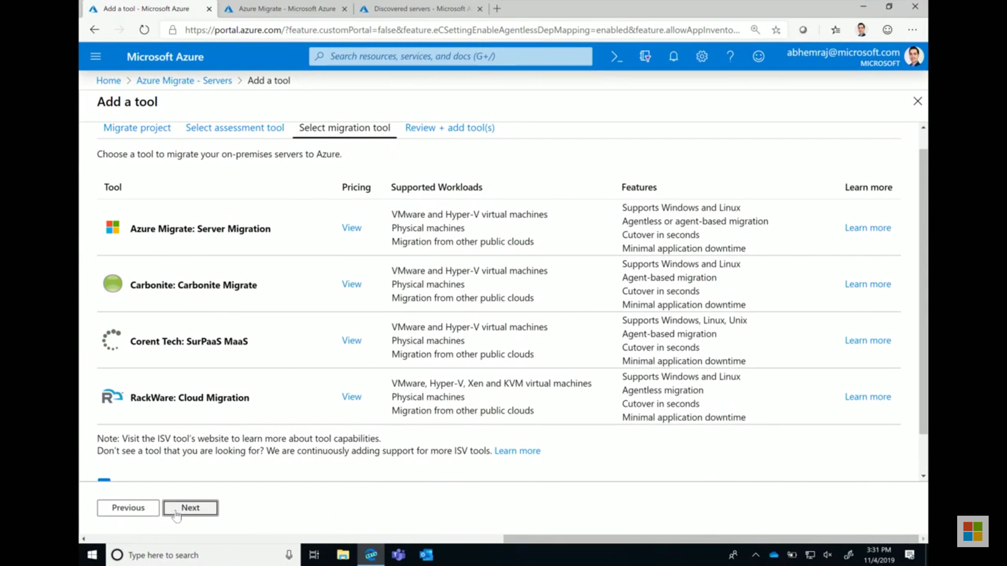

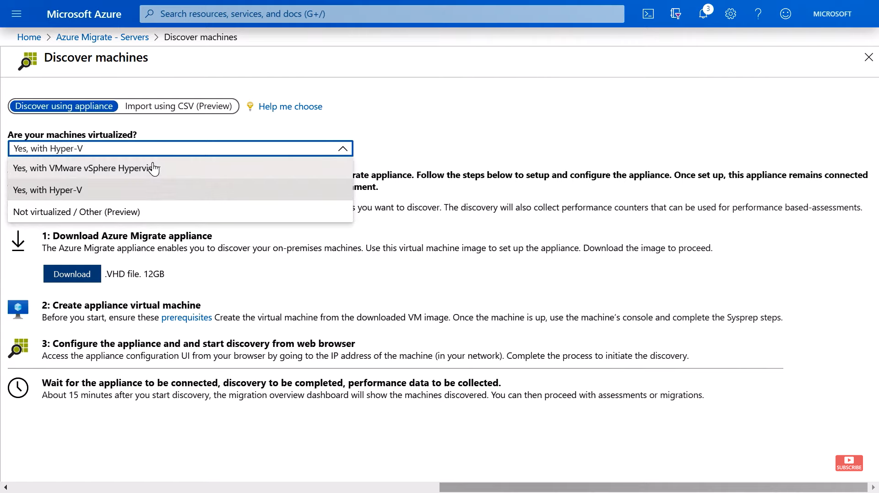

After this step import Azure Migrate Appliance in your VMSphere and it will not install any agent there but gather meta information from VM Sphere and prepare the report after discovering.

It will ask for Azure migrate credential and vCenter Server credential.

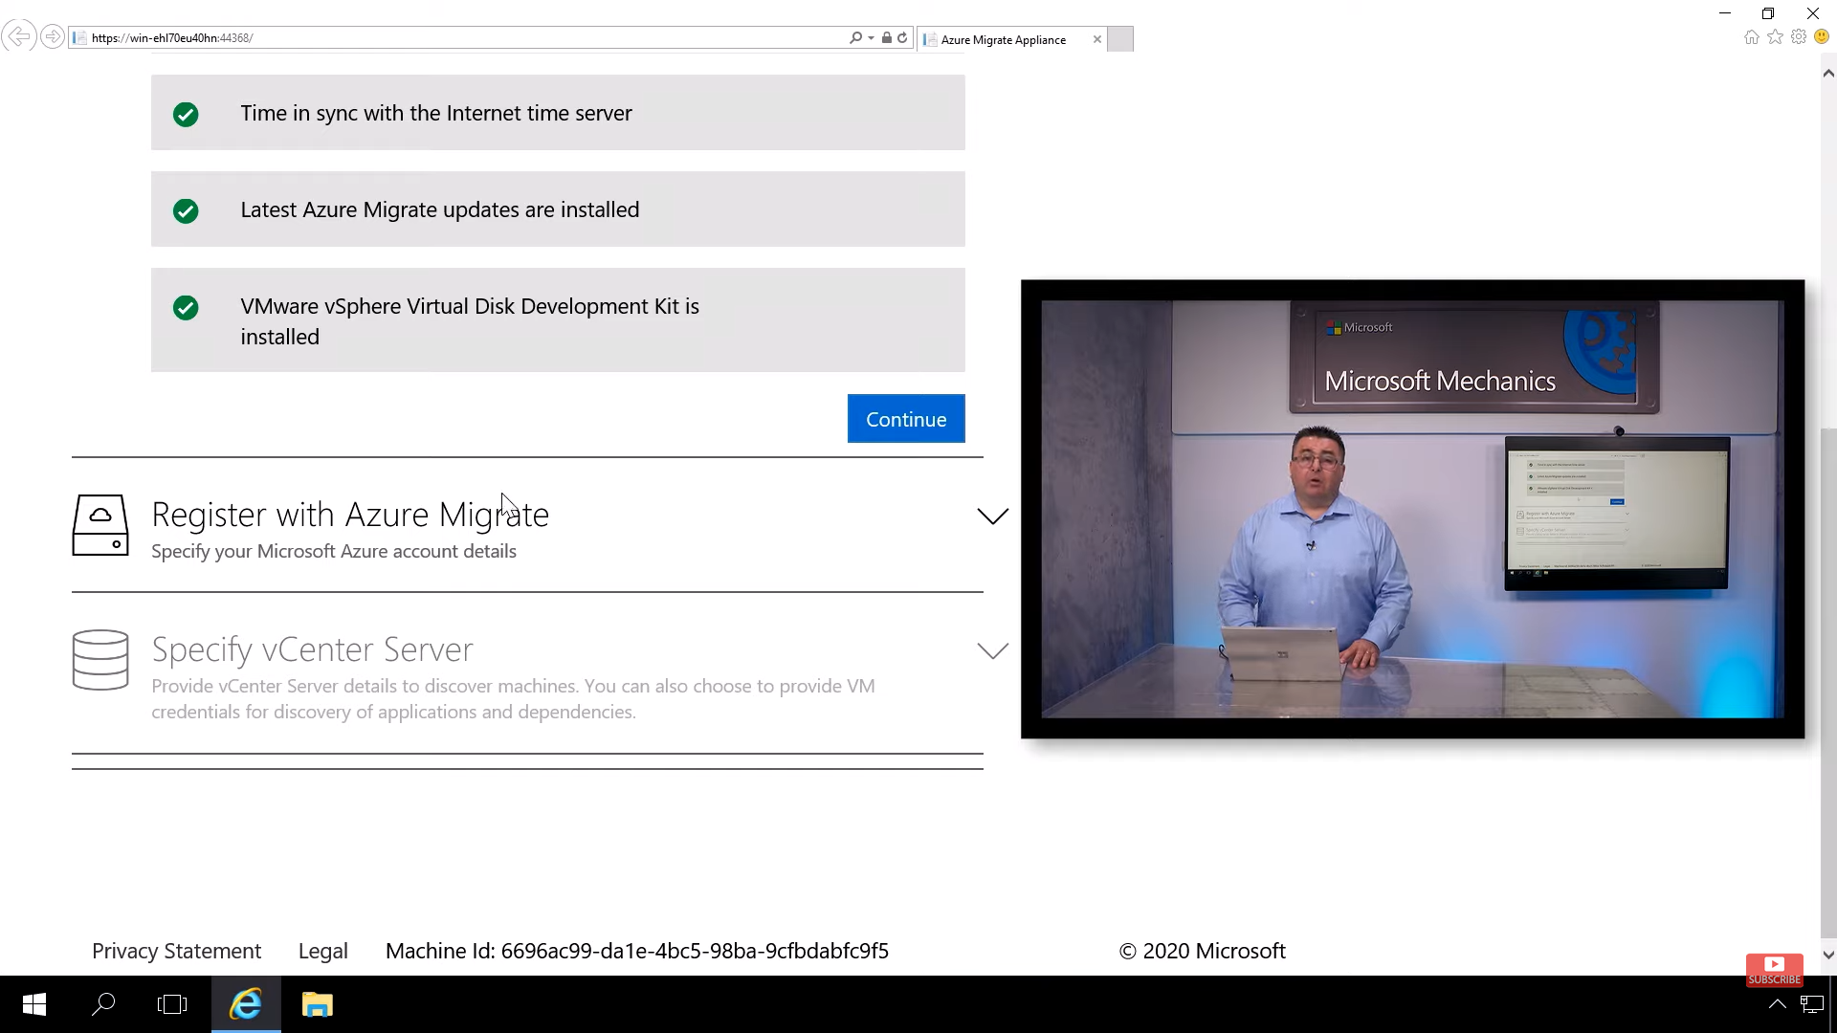

It will then do assessment and start sending information to Azure Migrate. Where you can click Assess option in assessment tools tab to group the list of machines you want to assess and later use the same assessment group in migrate option.

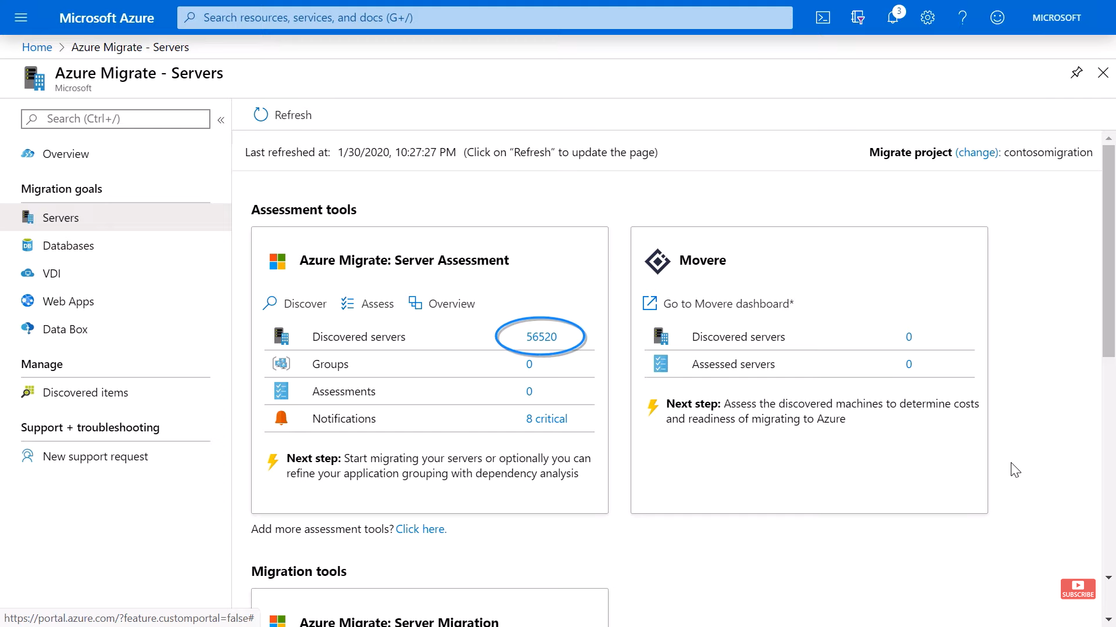

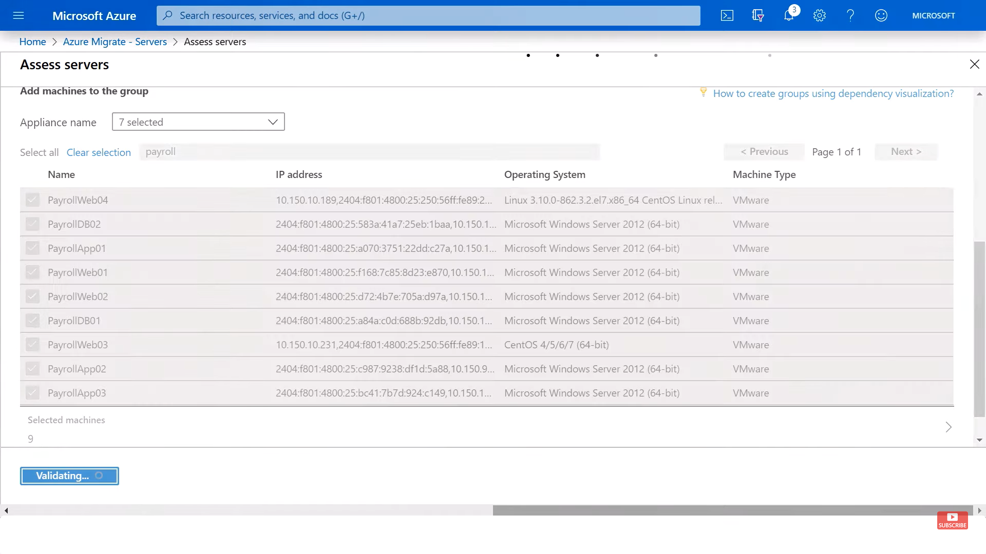

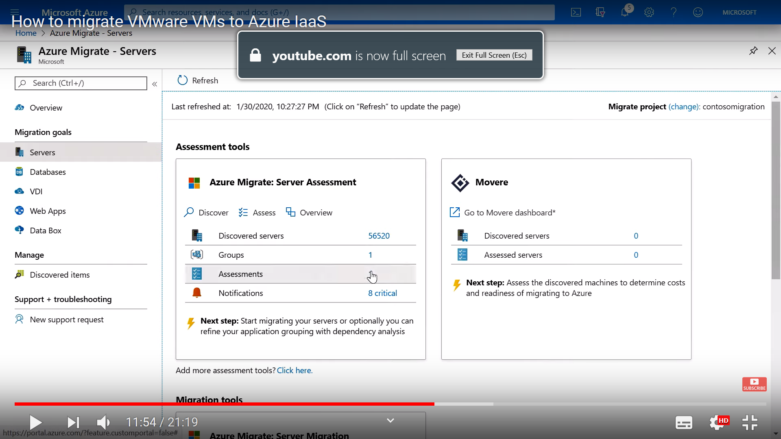

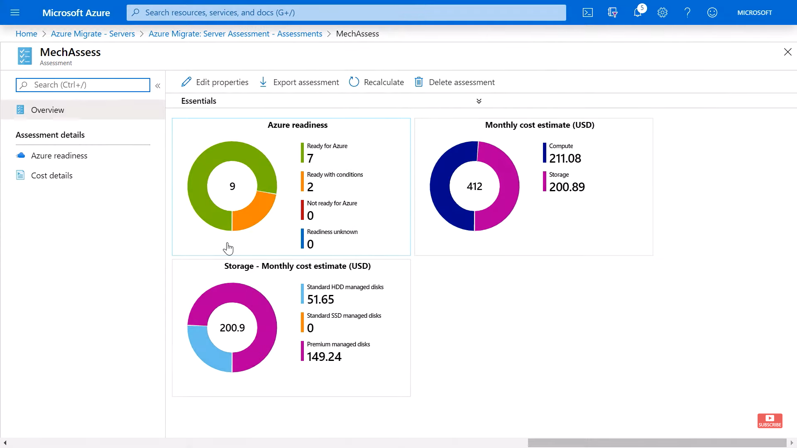

Before migration for windows system ensure **SAN Policy=OnlineAll**

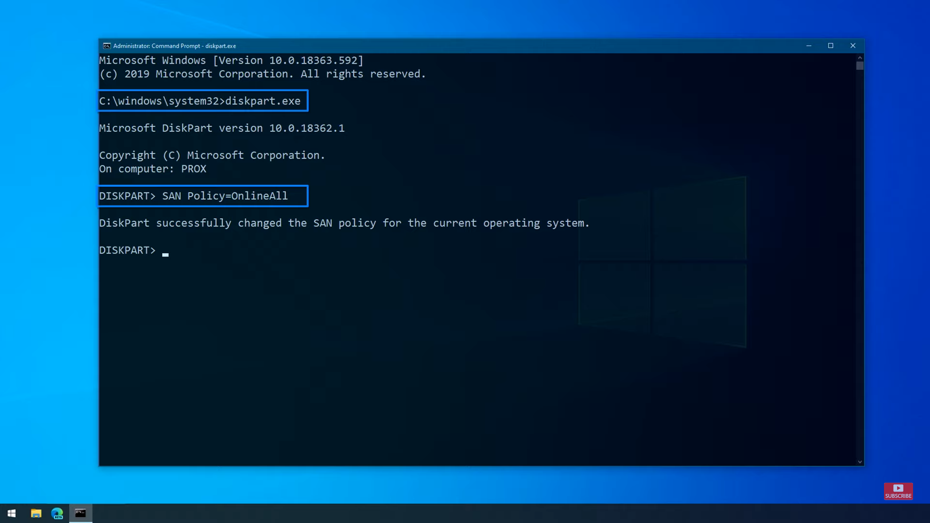

After this go to migration tool and follow the following steps:

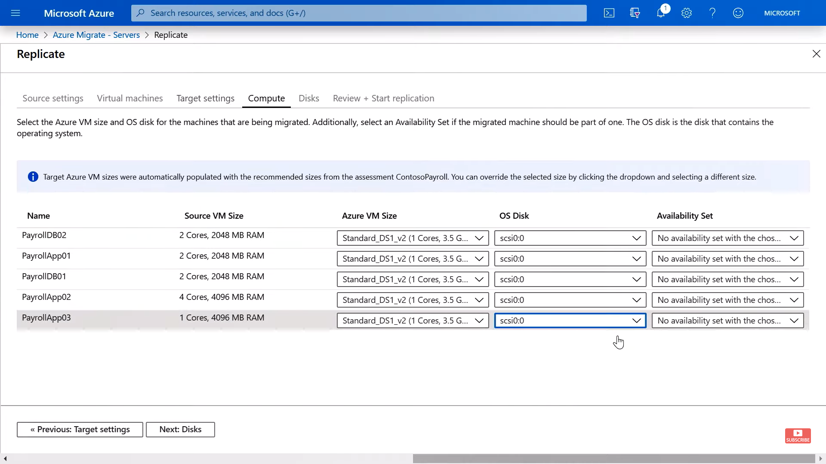

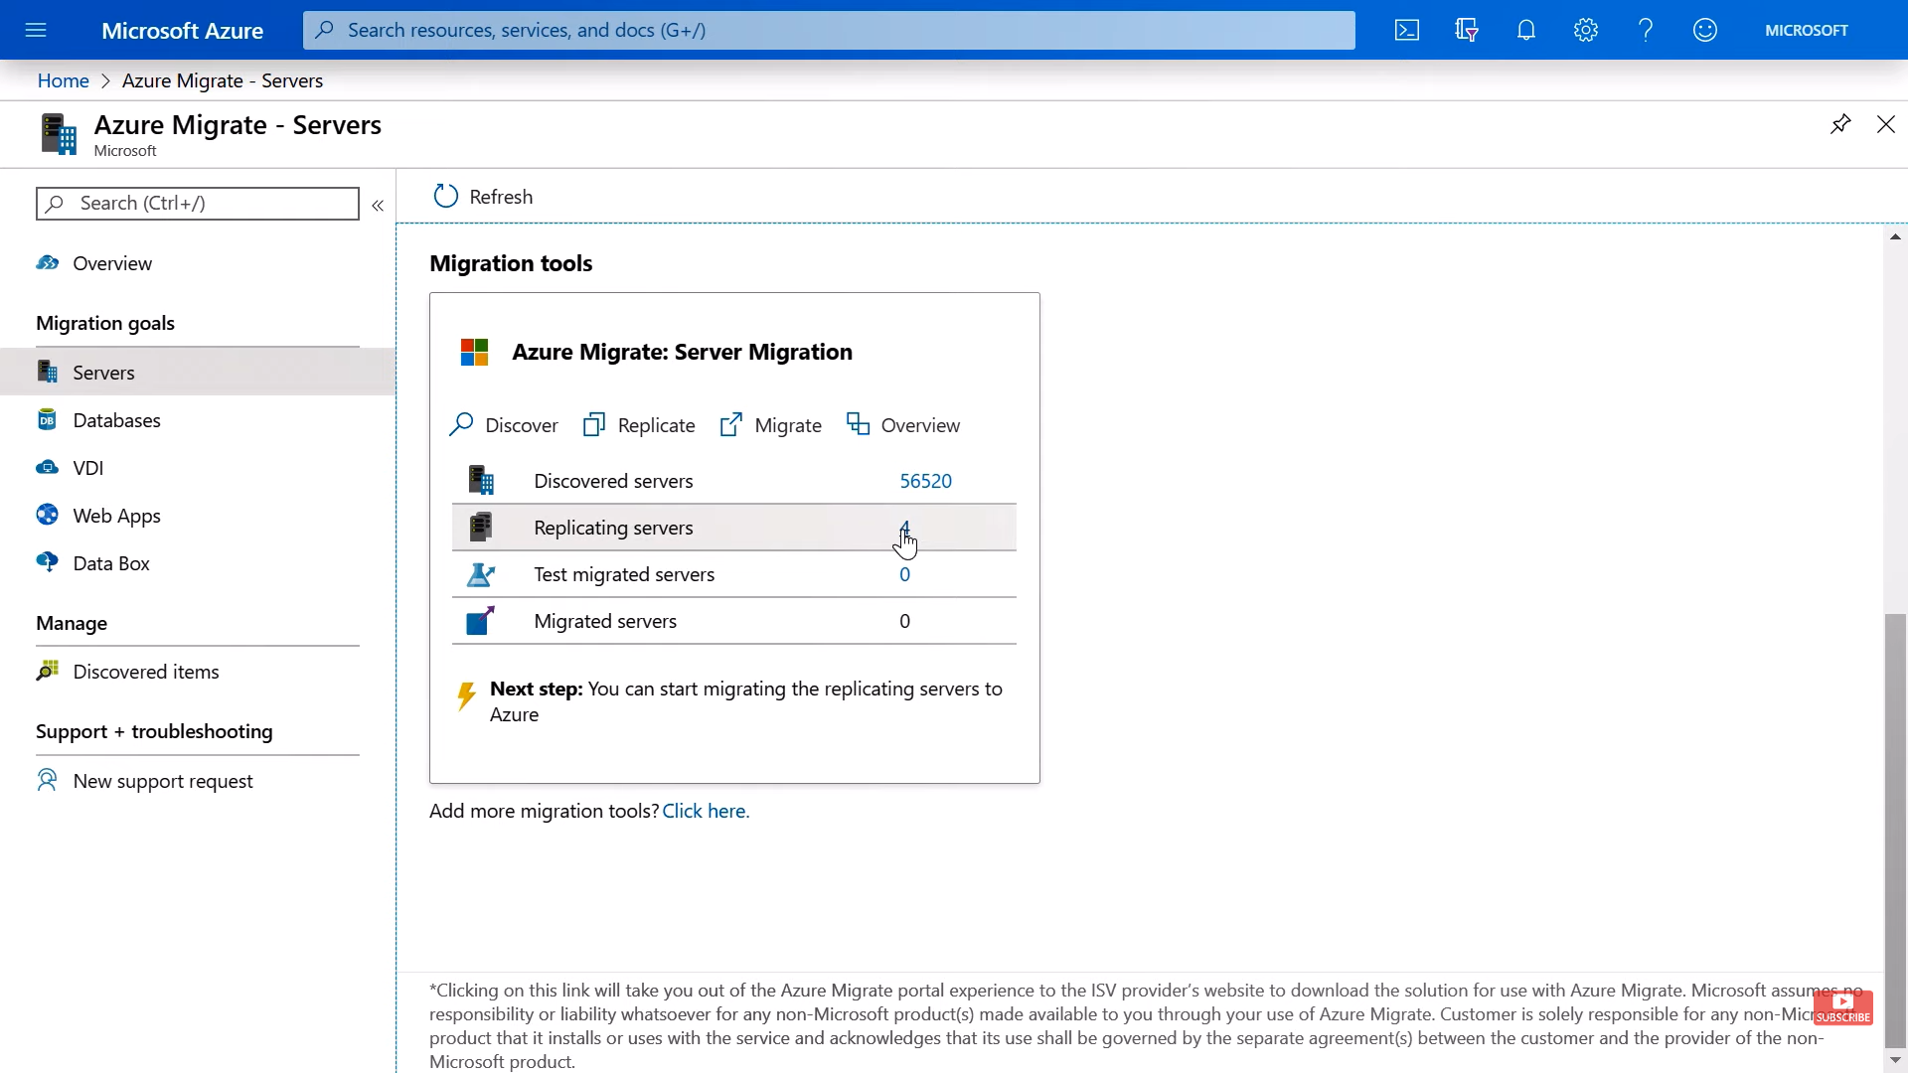

And then we can test the replicating machines. A postfix “-test” will get appened to each machine name and one test it working there once statisfied we can “clean up test migration” and use the “migrate” option to move to next stage.

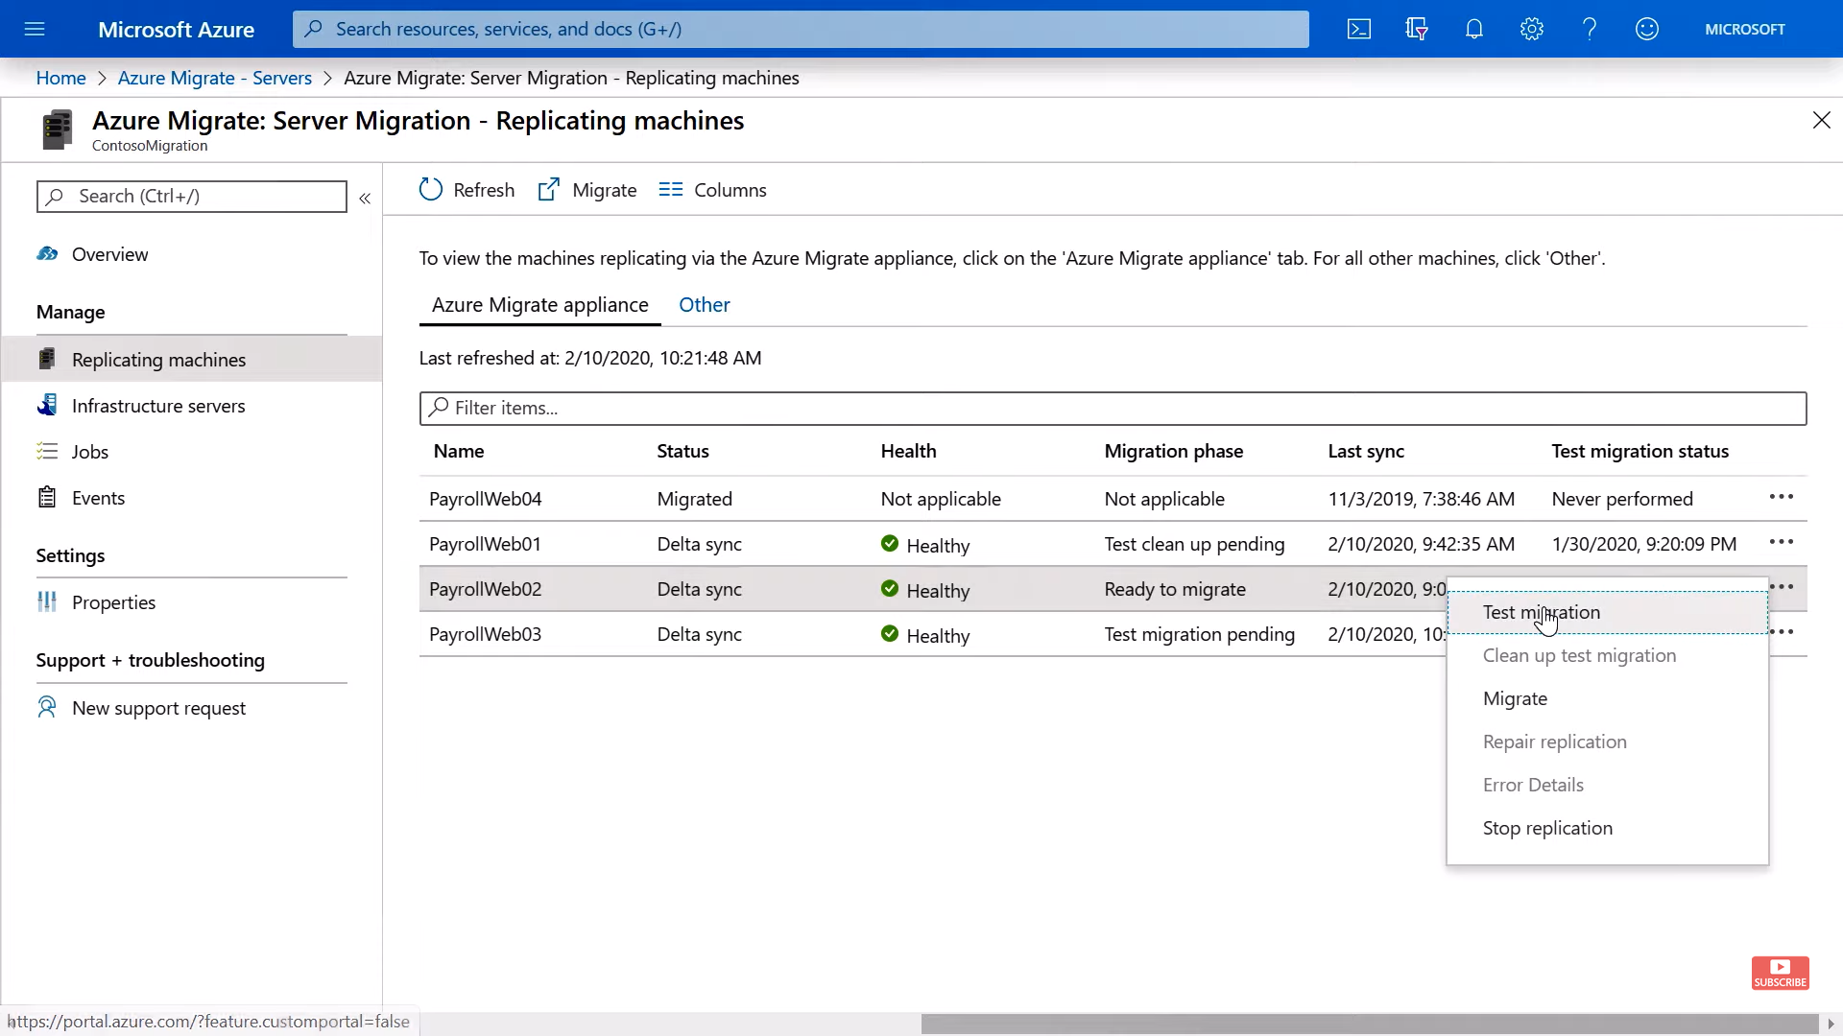

There are various options we can choose while migrating, for example we can use VMware tools and that will use Azure VMware Solutions to replicate our environment.

Or one can user server migration to migrate both web and DB server.

Or we can ser server migration to migrate server and DB migration to migrate DB to Azure SQL

Or even user Web App Migration to migrate Web Apps to App Service.

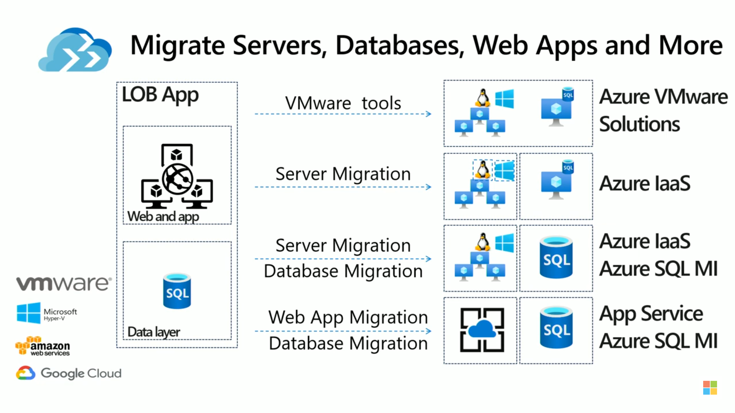

<https://docs.microsoft.com/en-us/azure/cloud-adoption-framework/>

Note:

1. Replication policy is required when we want to perform replication not while performing assessment.

# Azure File Recovery

<https://azure.microsoft.com/en-us/blog/instant-file-recovery-from-cloud-backups-using-azure-backup/>